Cypress:

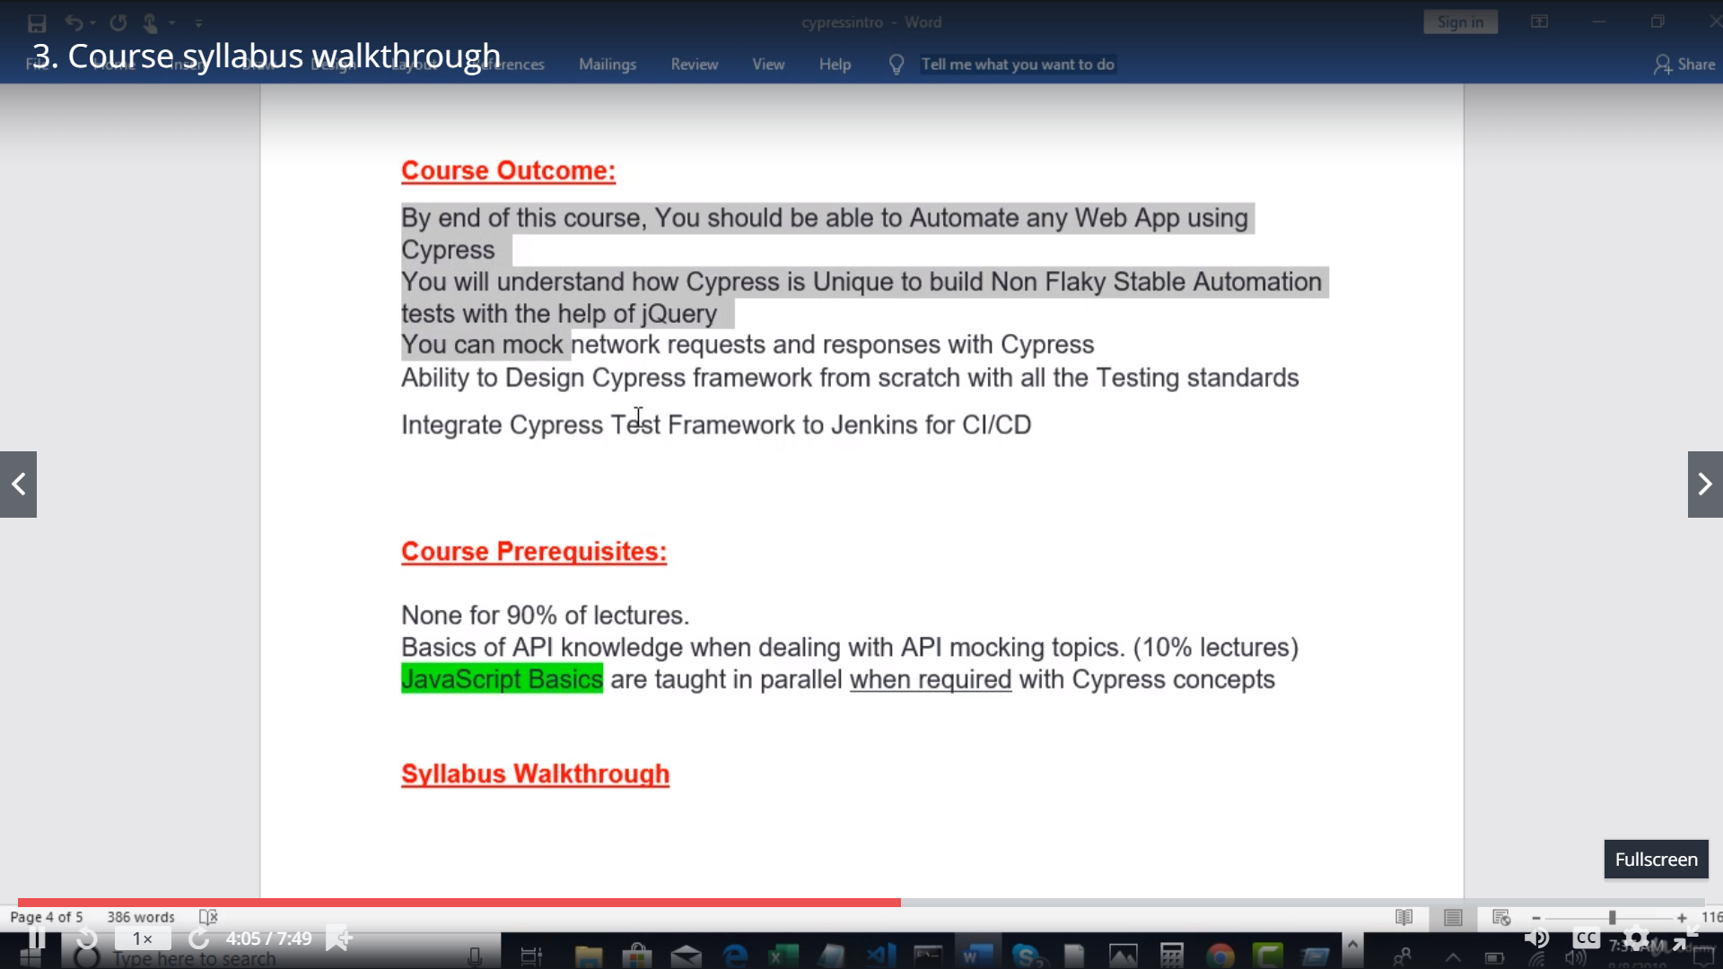

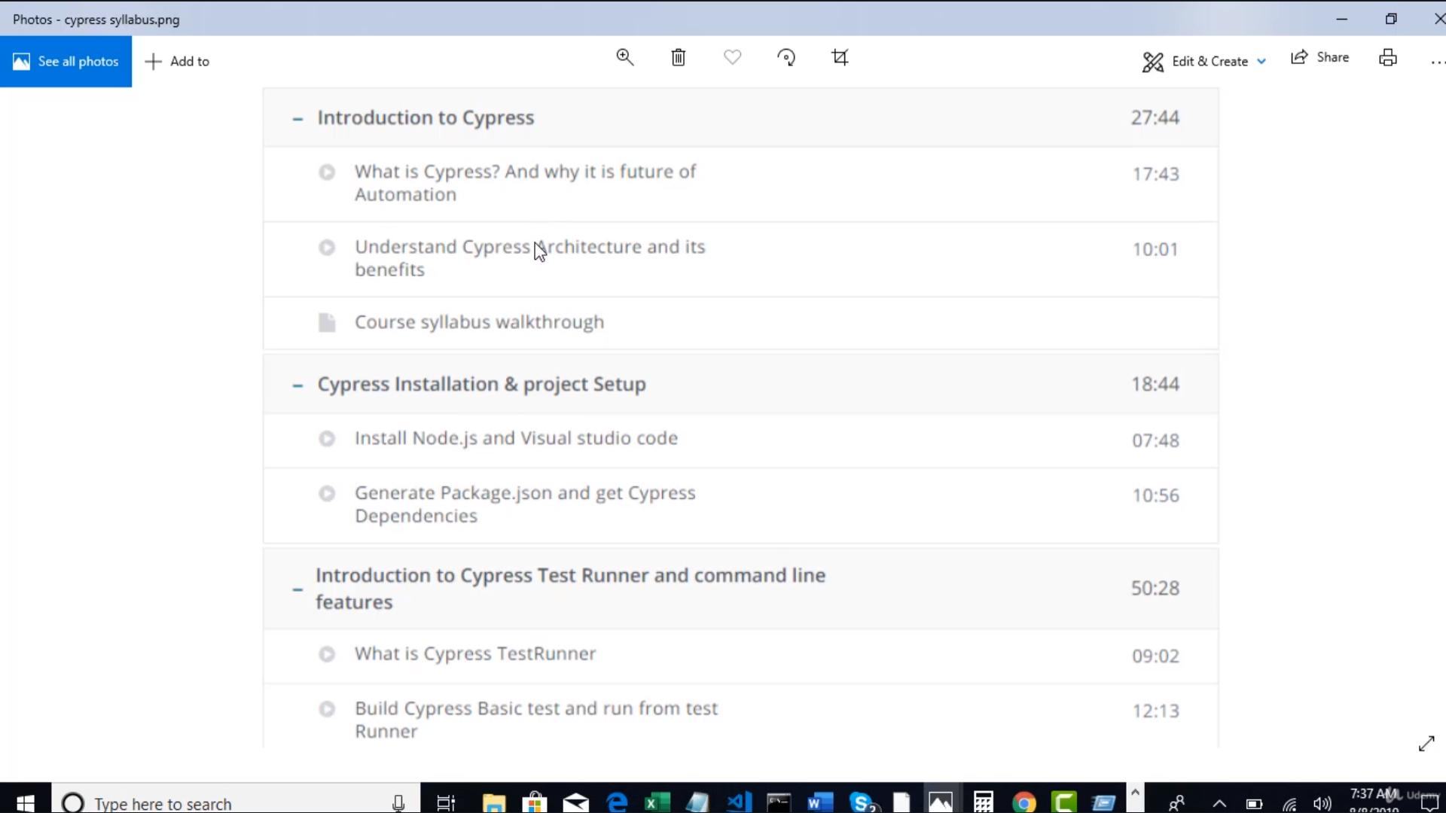

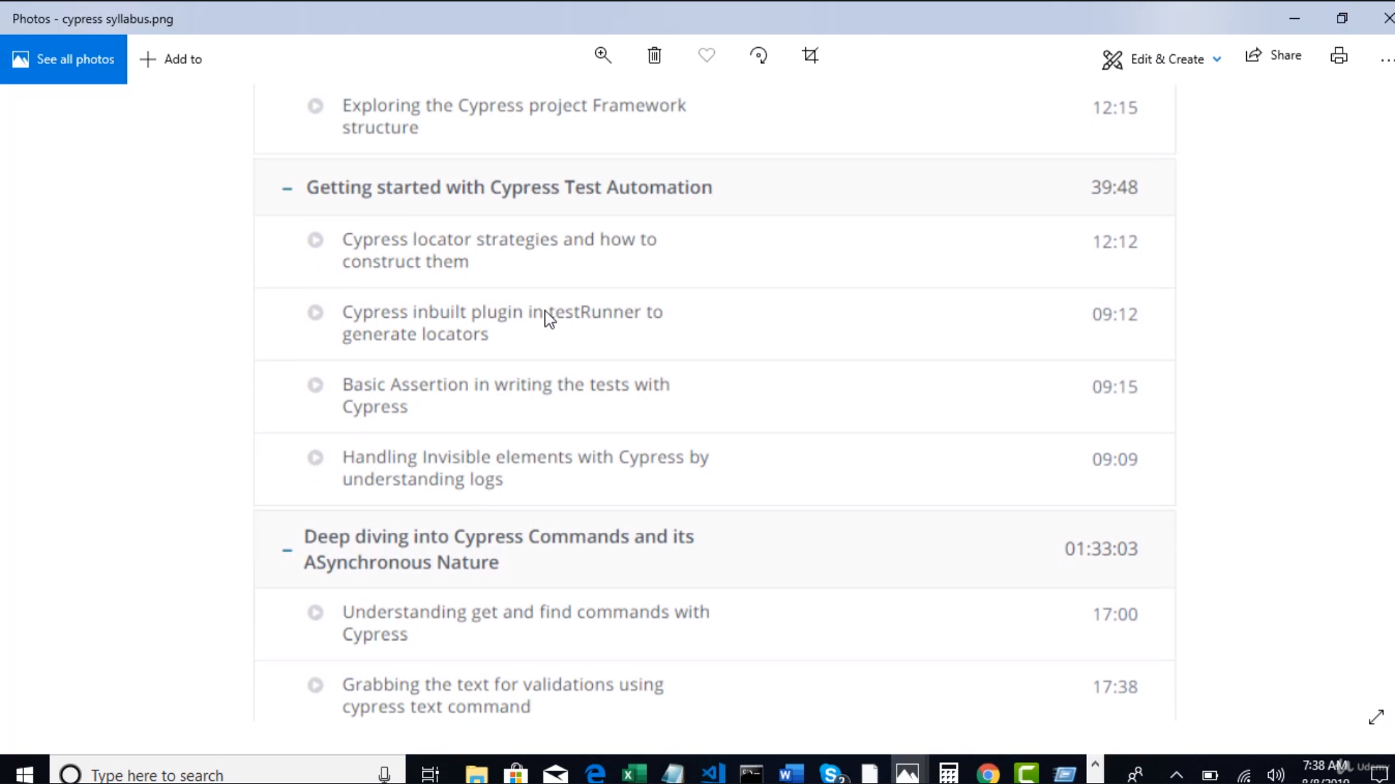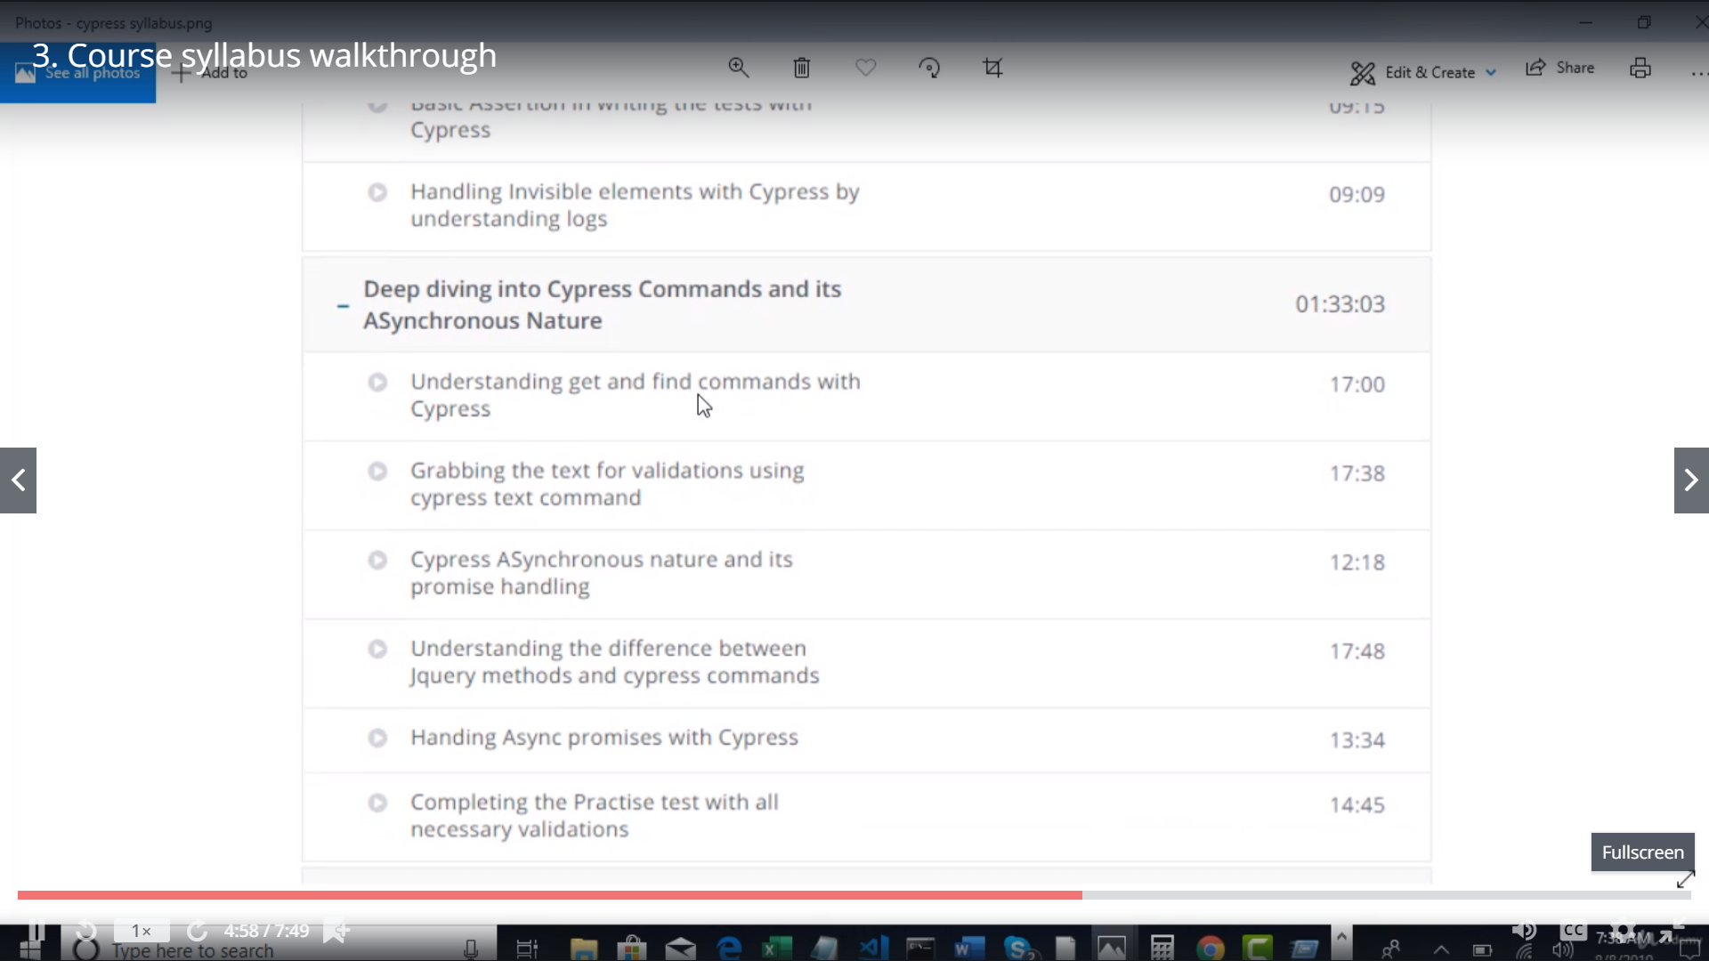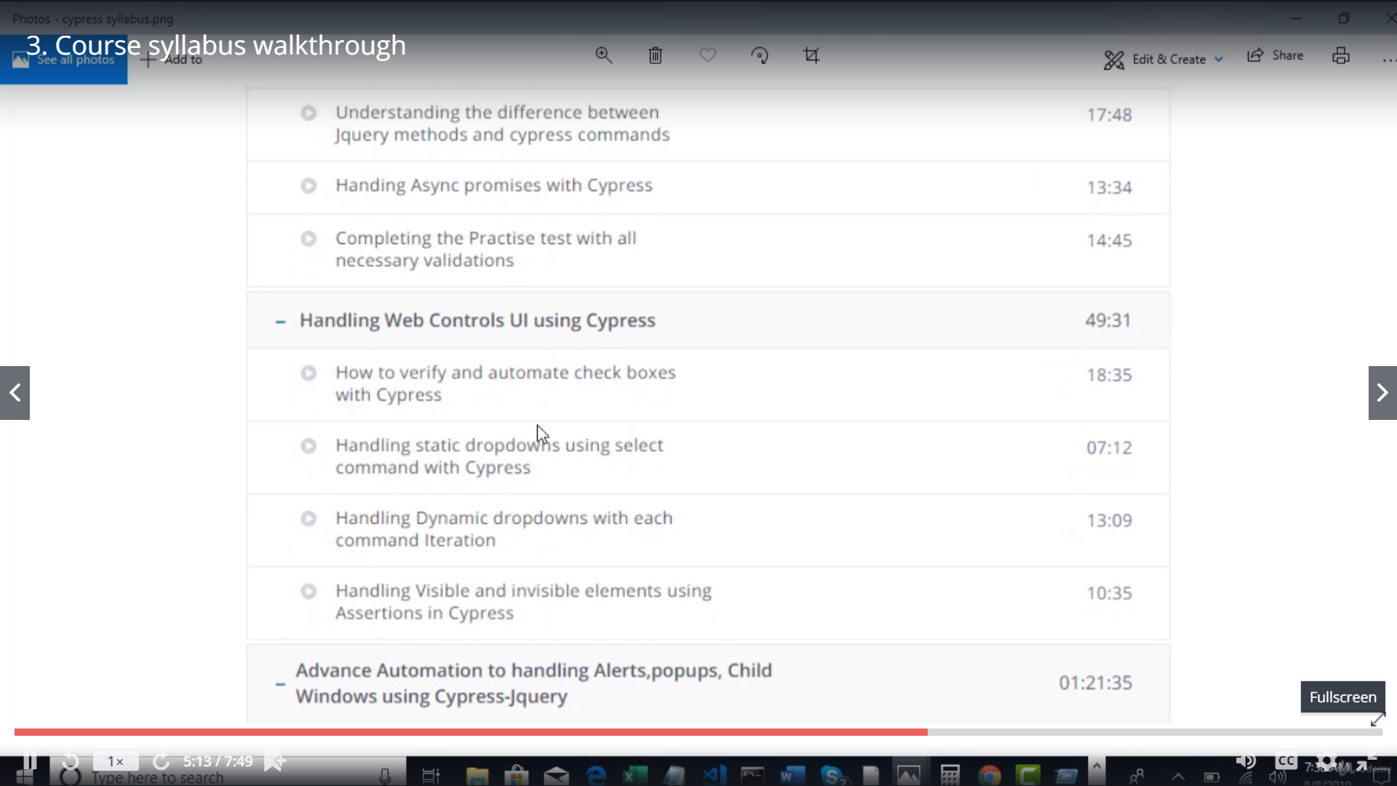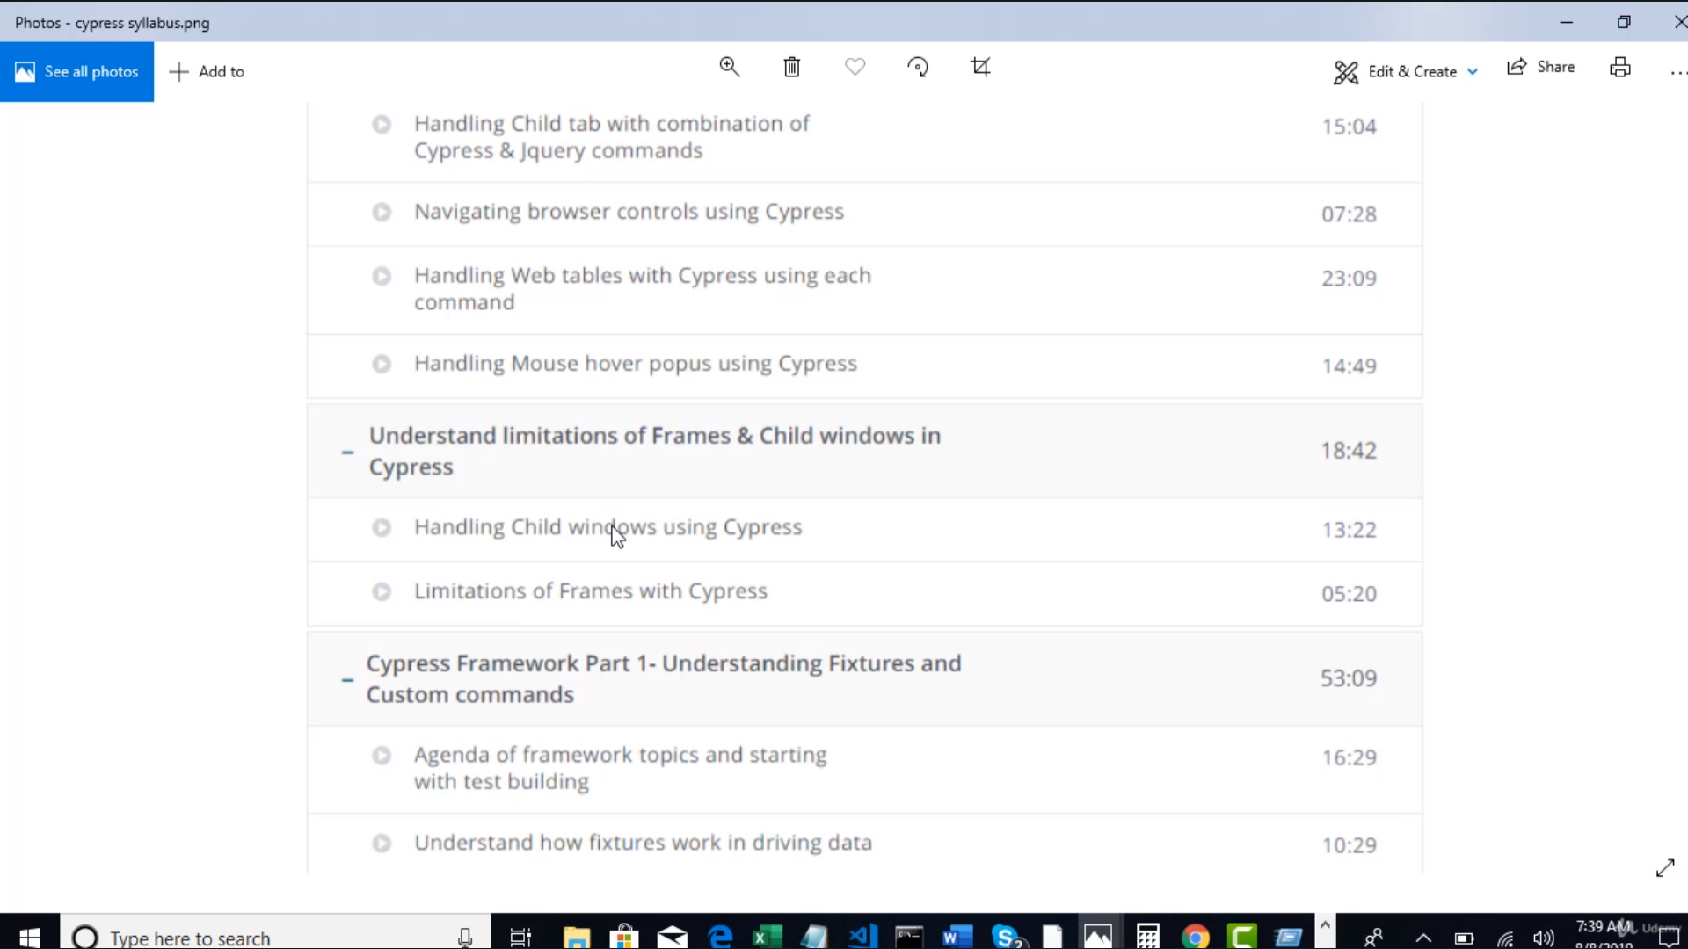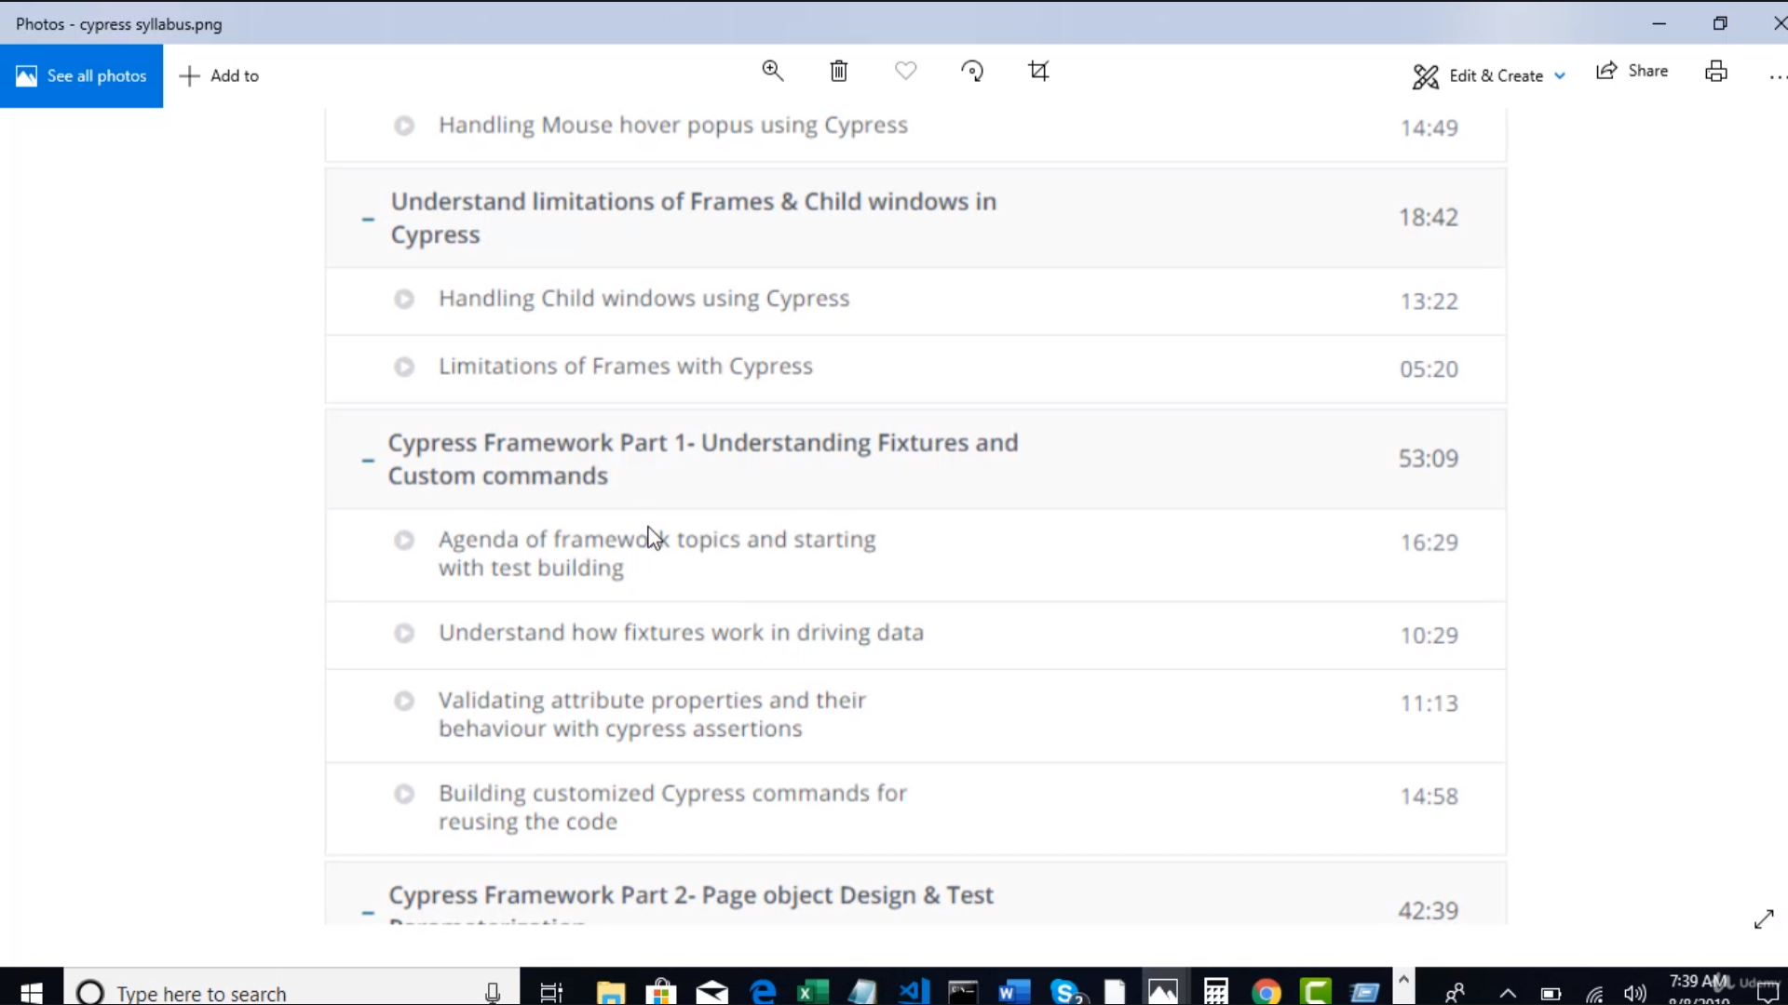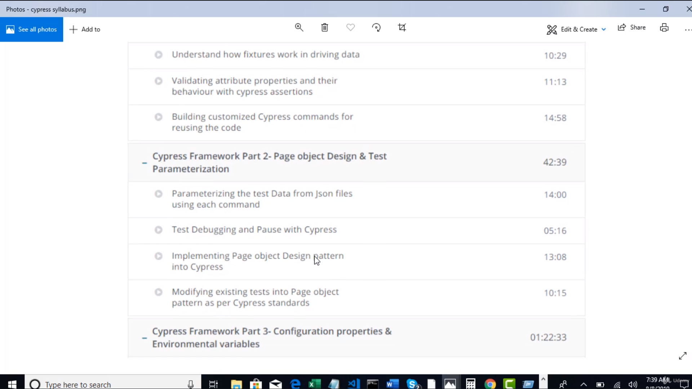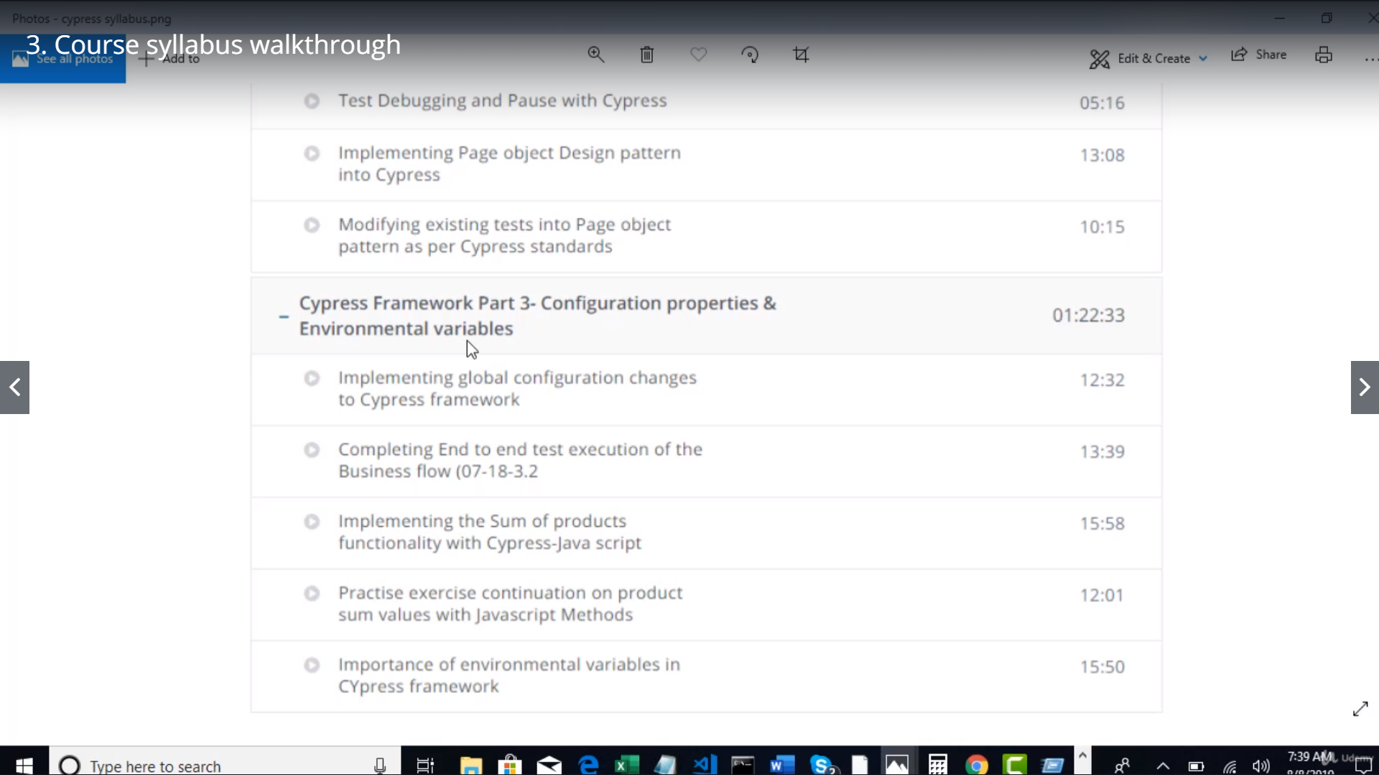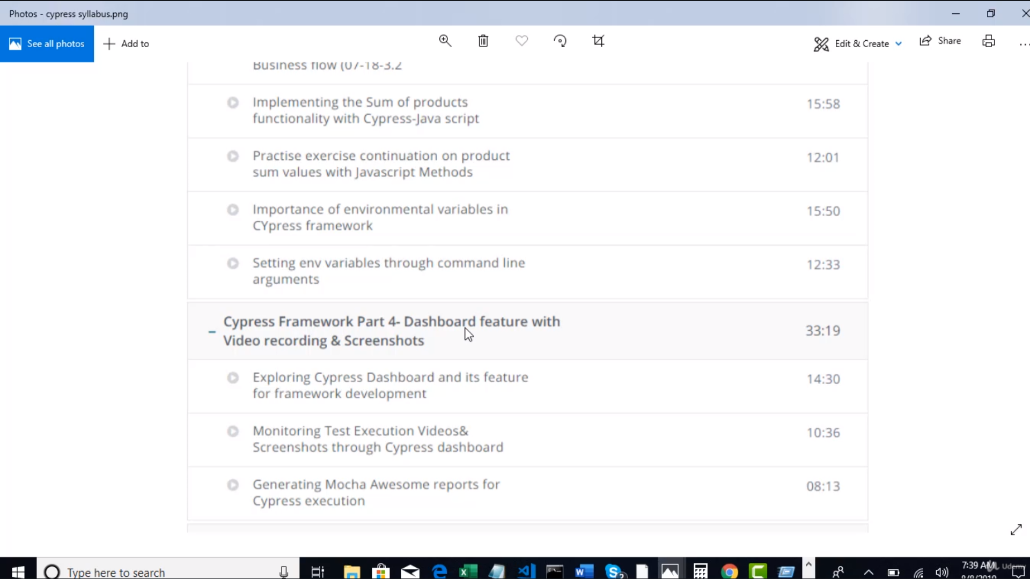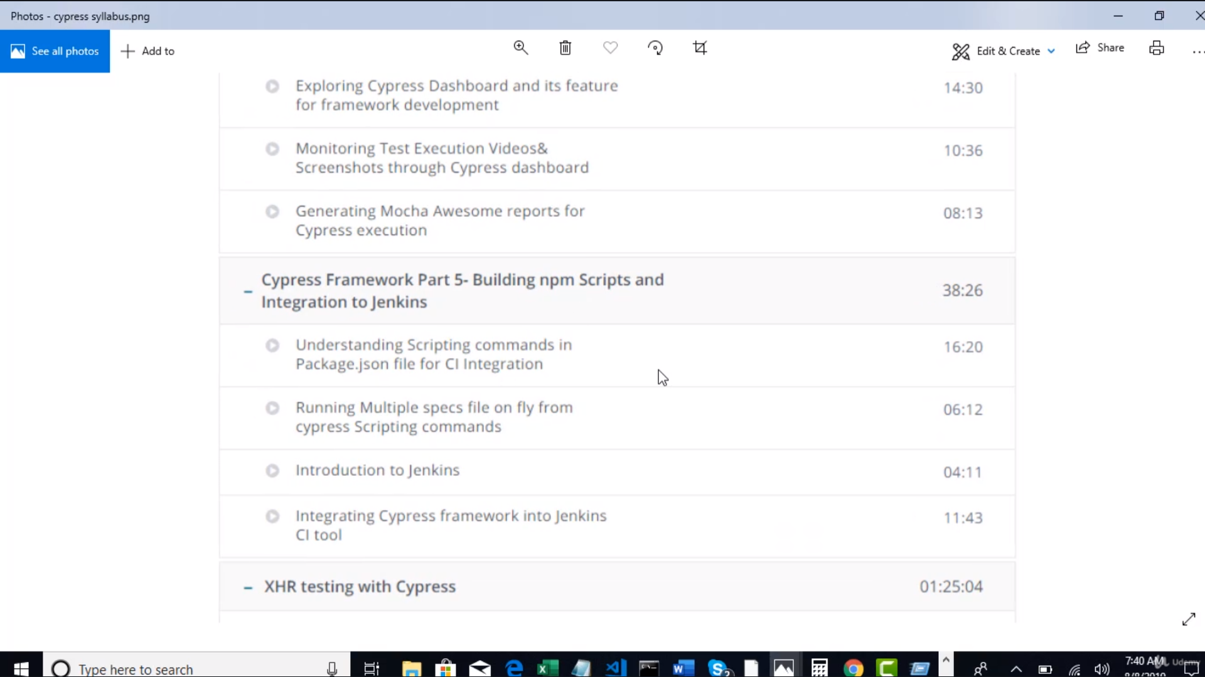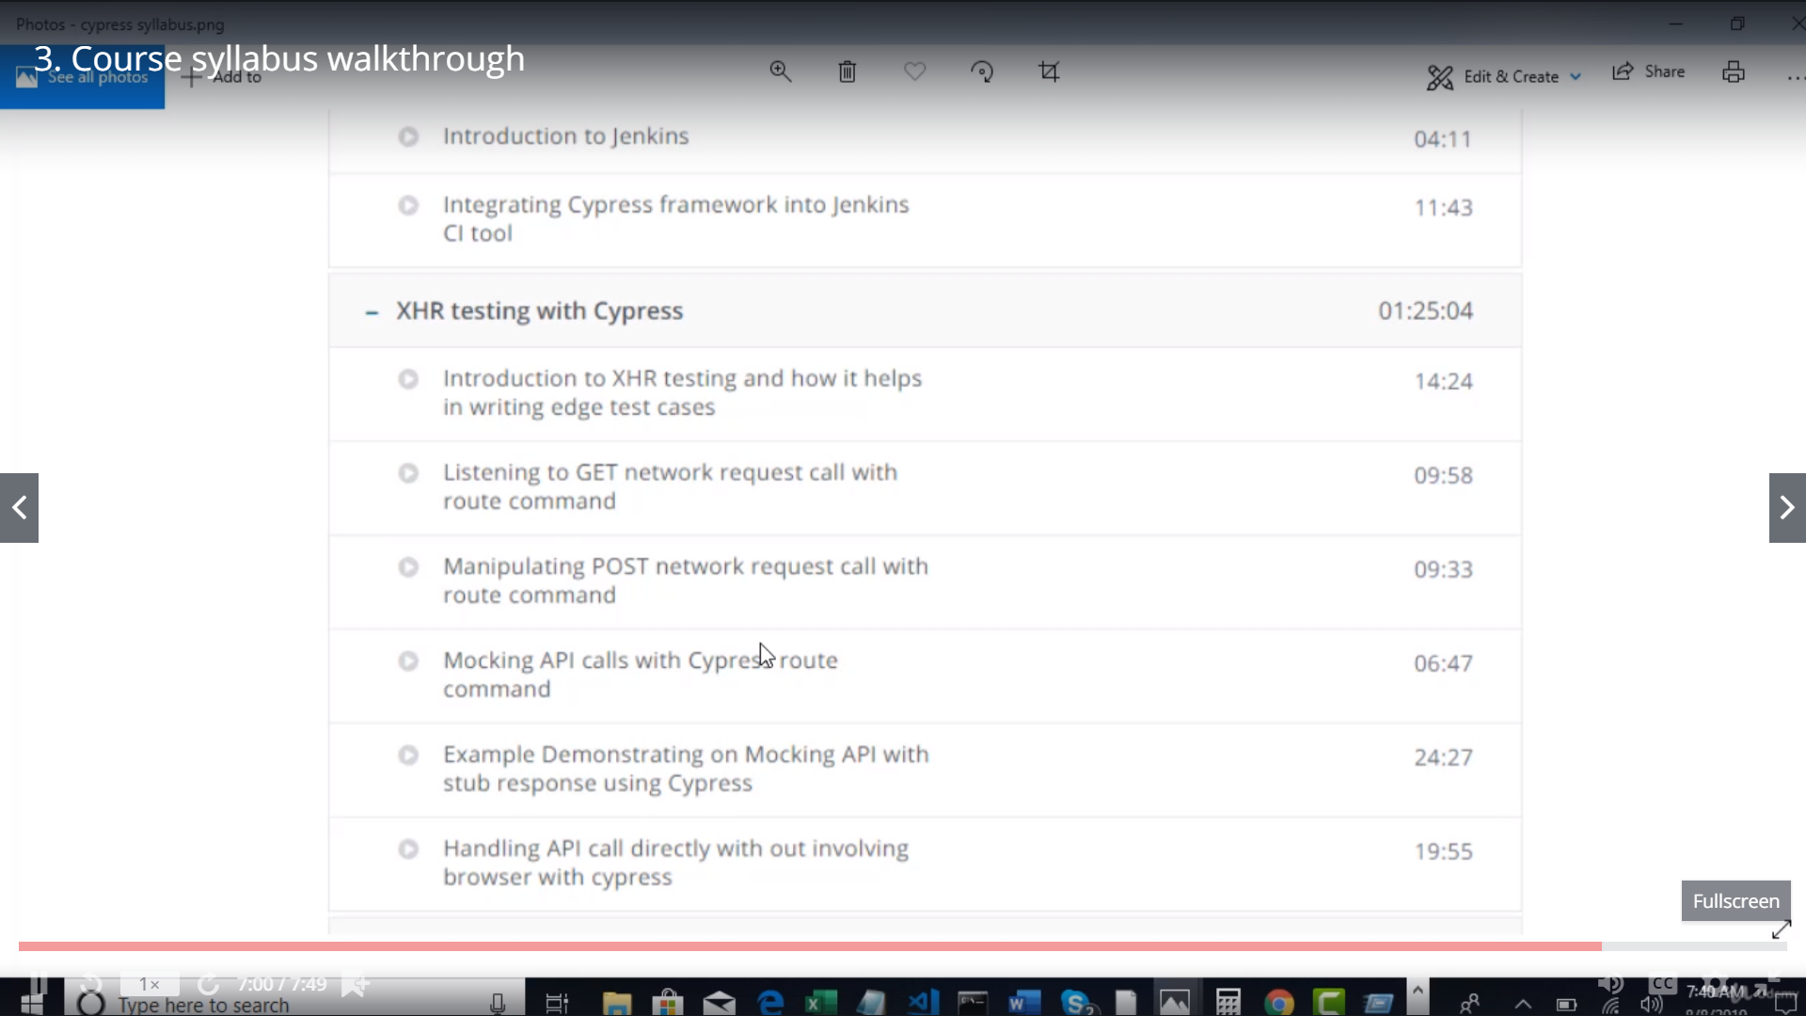

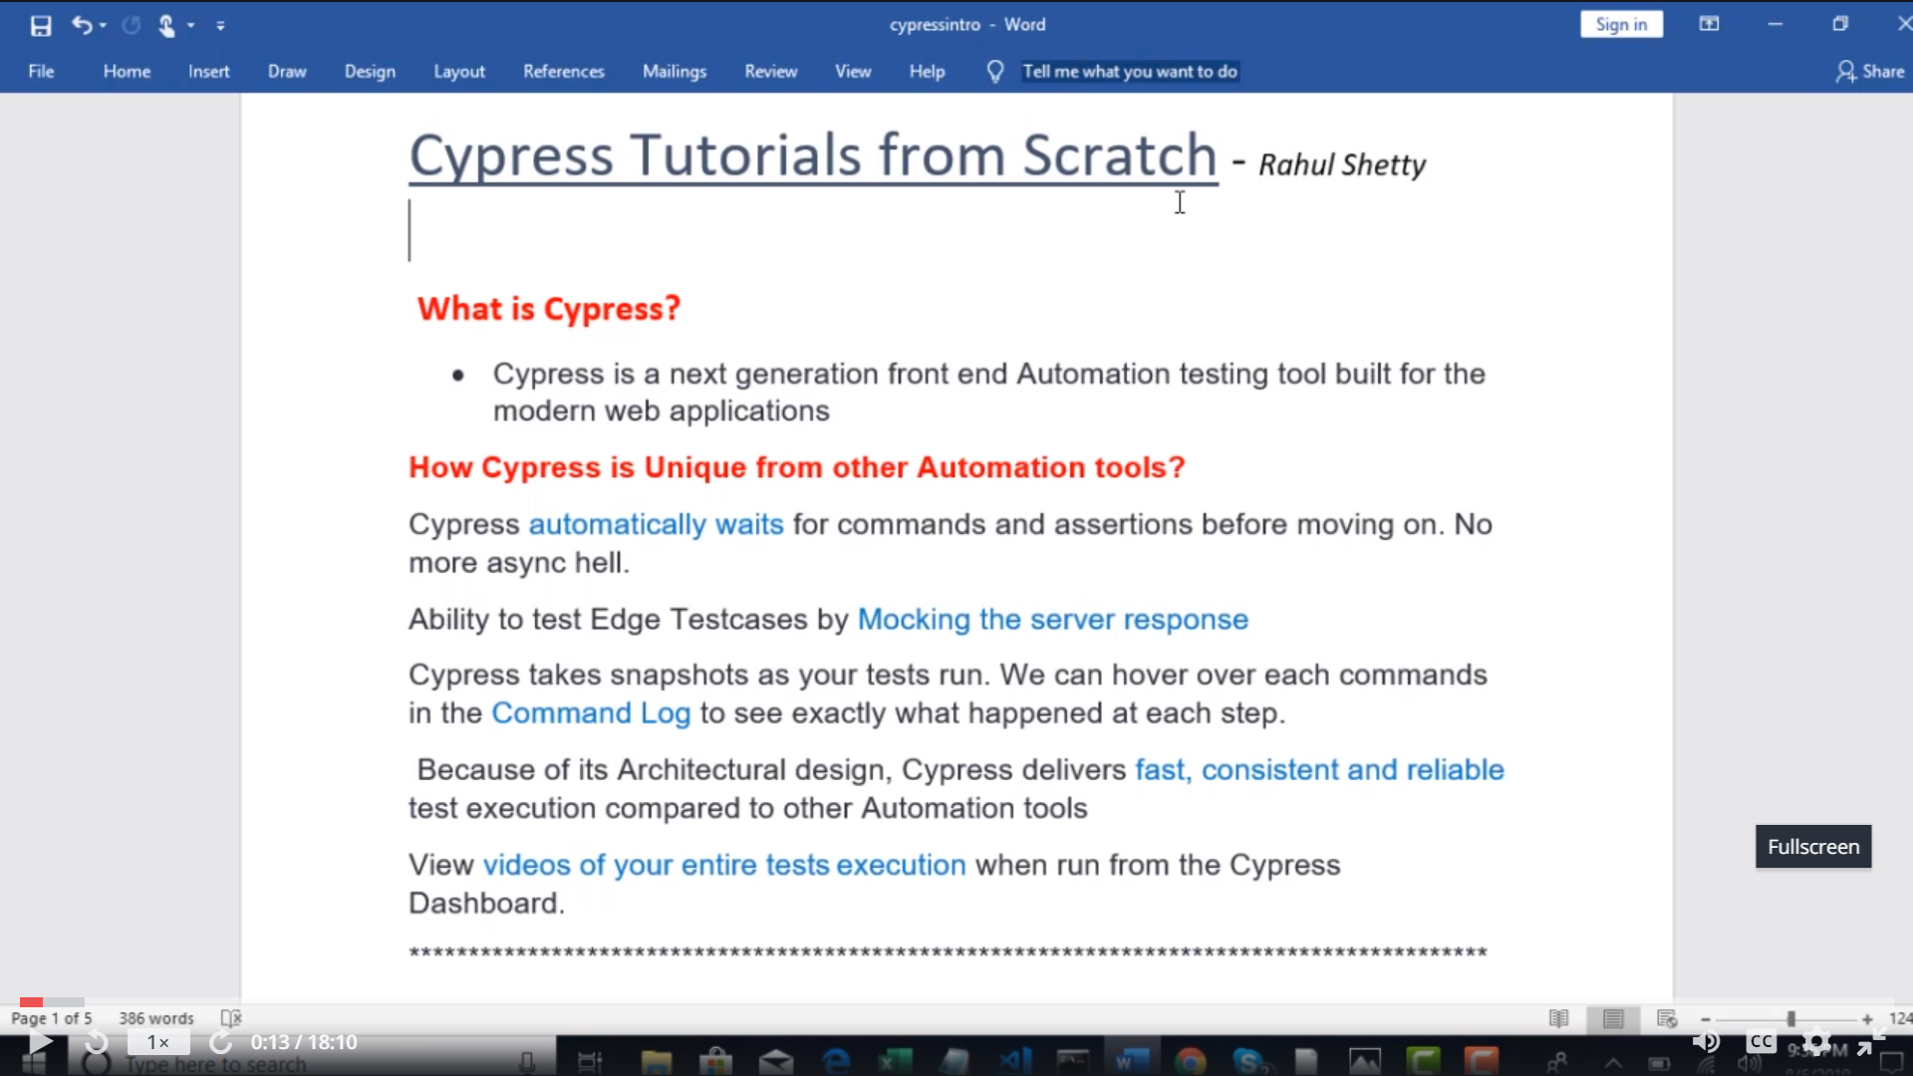

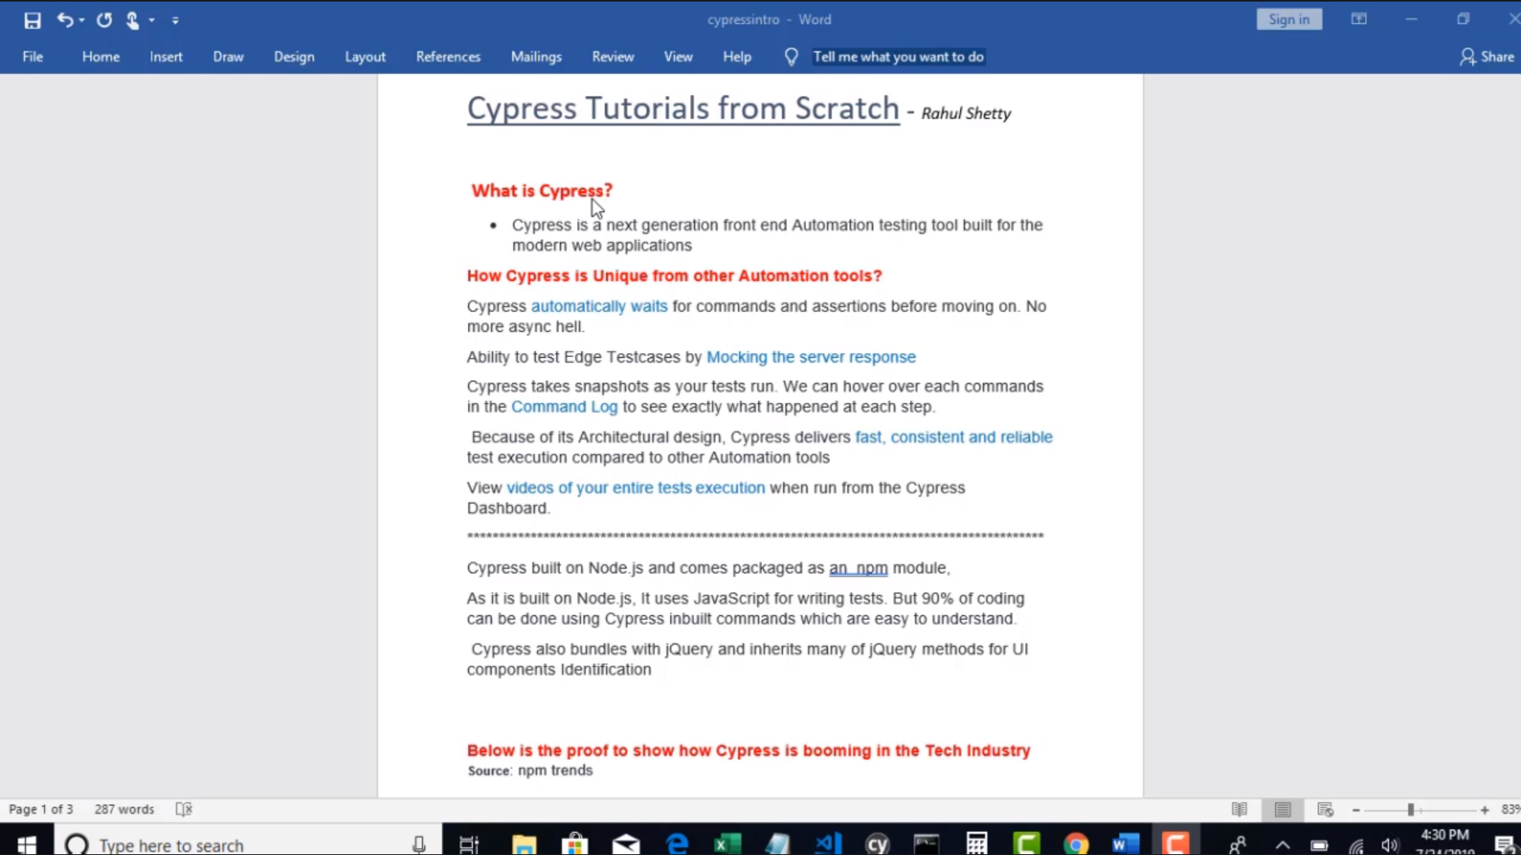

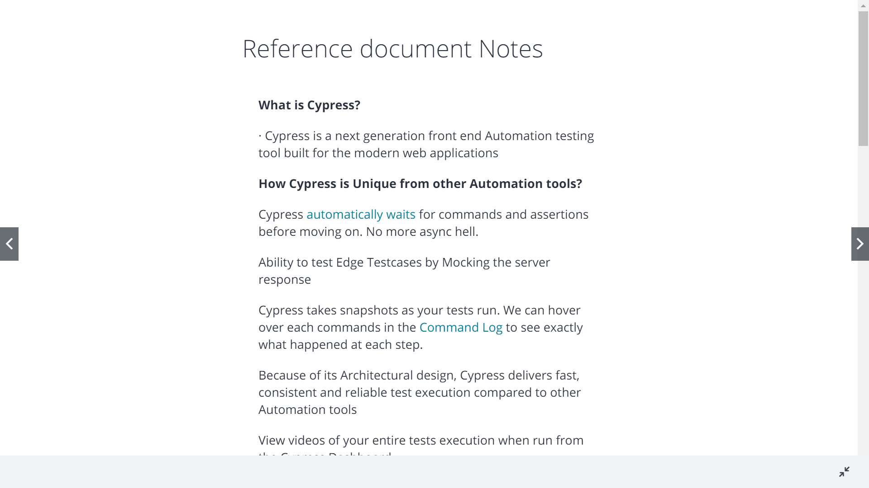

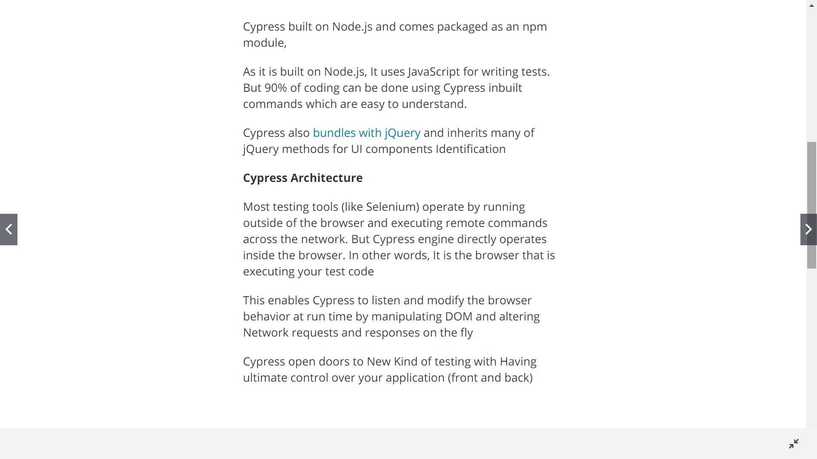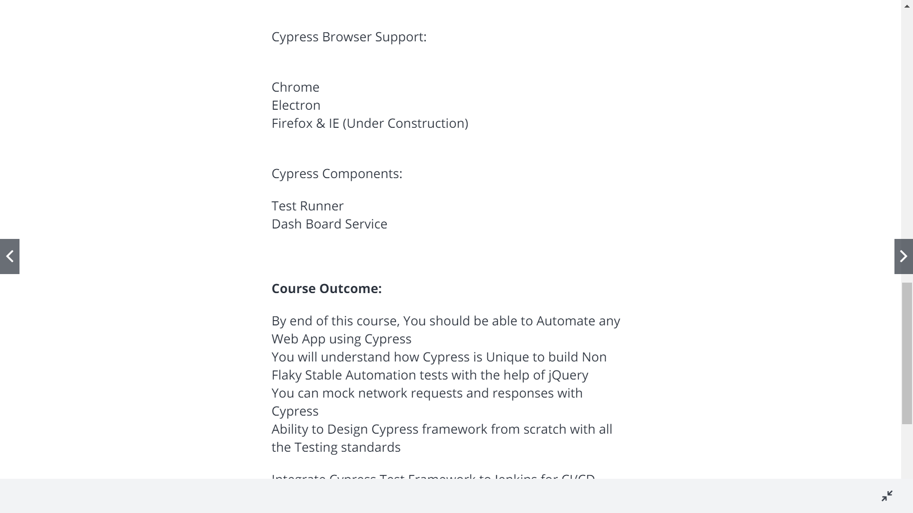

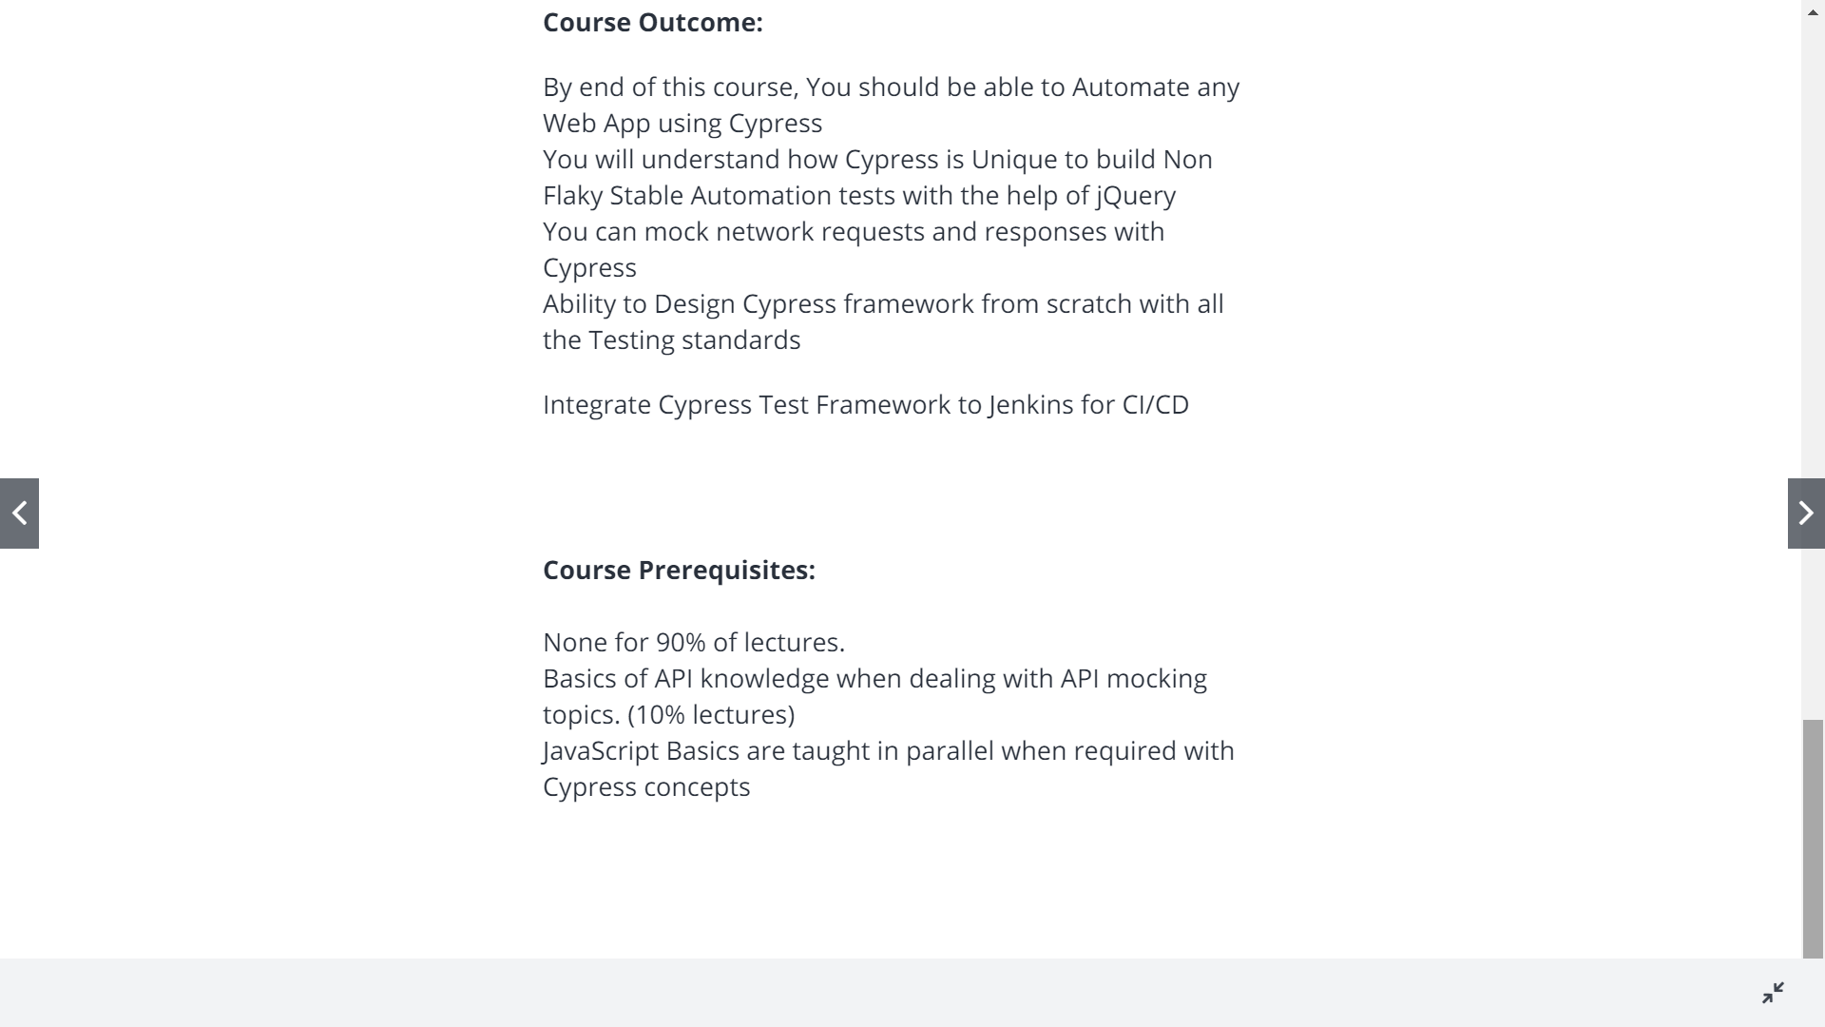

**Cypress Features**

Automatic waiting and asserting

Every page snapshot is taken

You could mock a server with fake data

Can view entire test exec as video

Cypress built on Node.js and comes packaged as an npm module

It uses jquery to identify objects

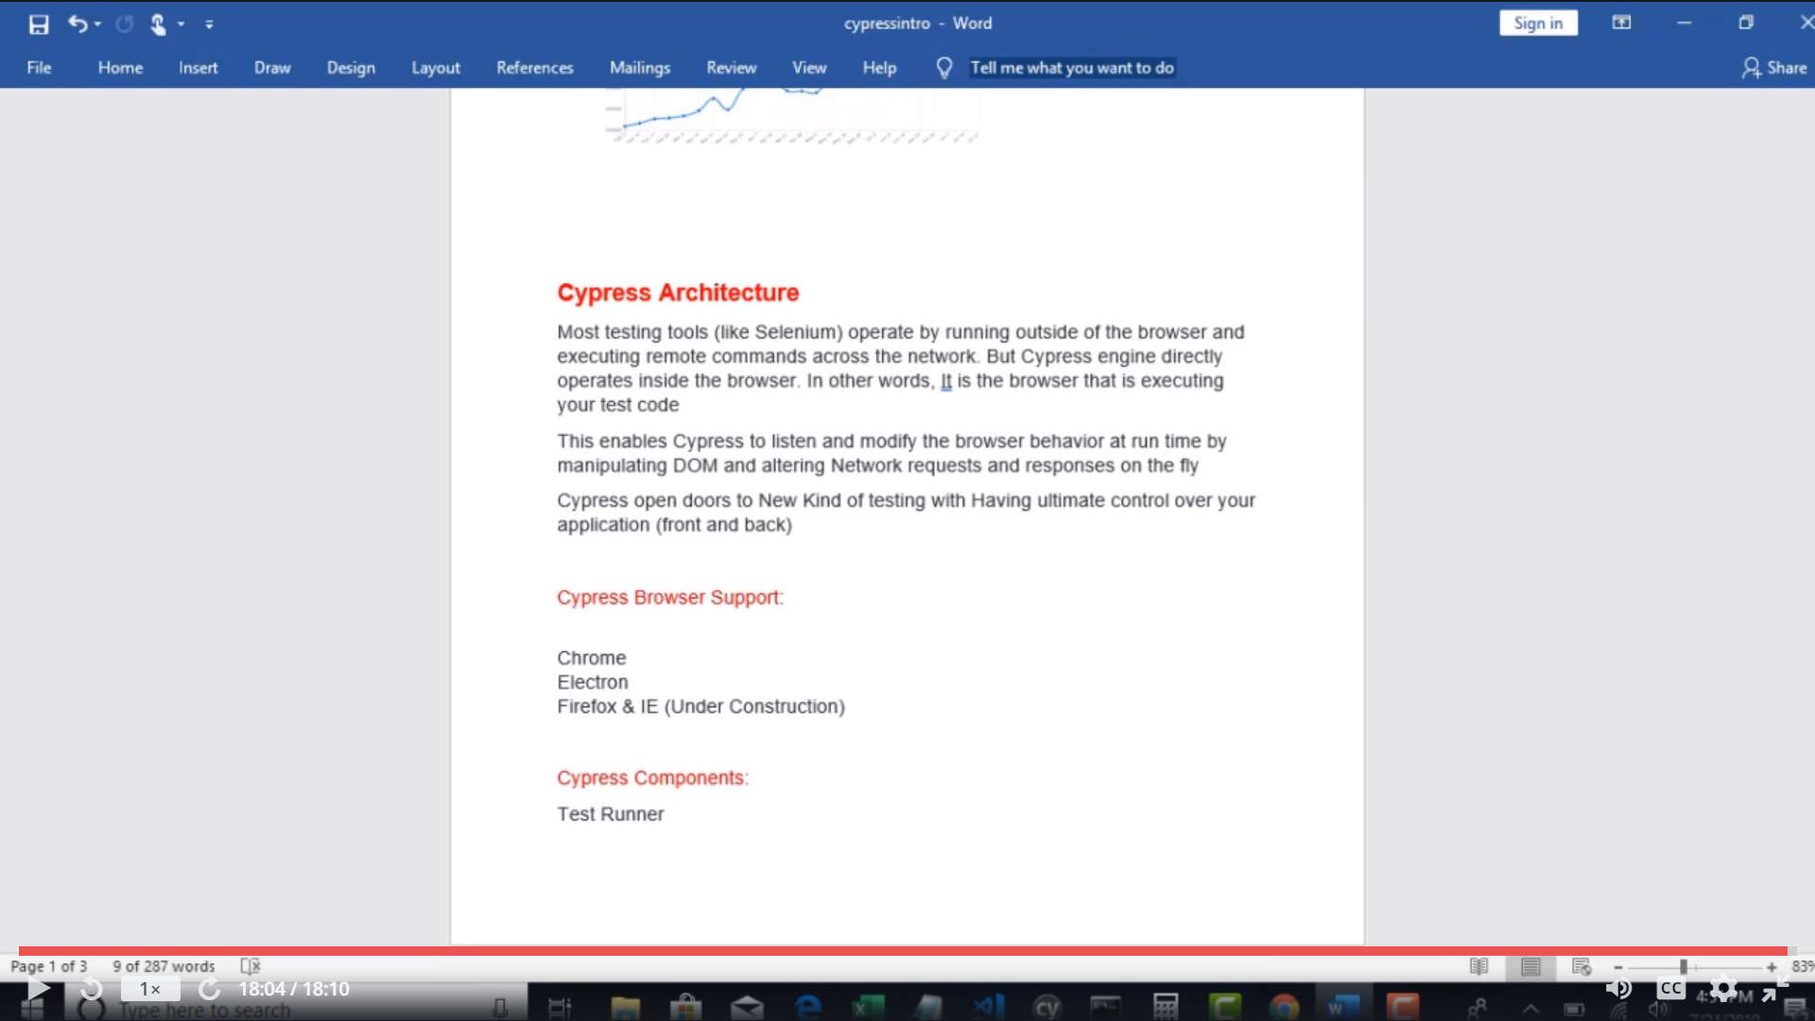

Selenium Arch

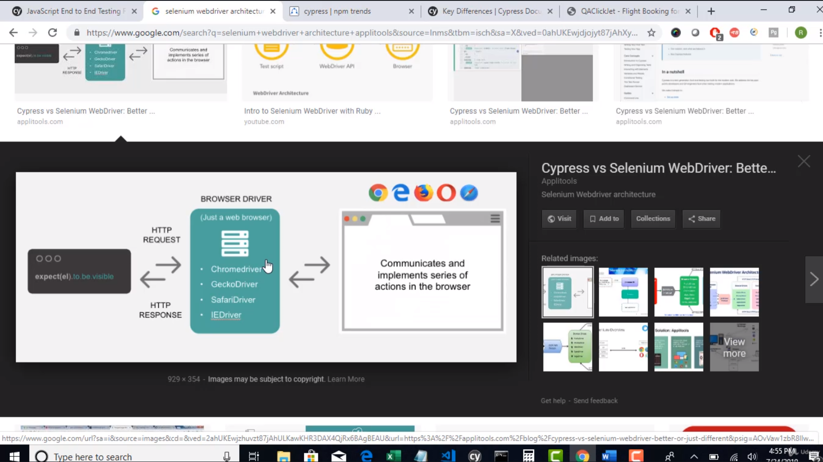

USing Cypress u can do unit,integr,e2e testing

Cypress with comes Electron which is lighter weight version of Chrome

Cypress componenets

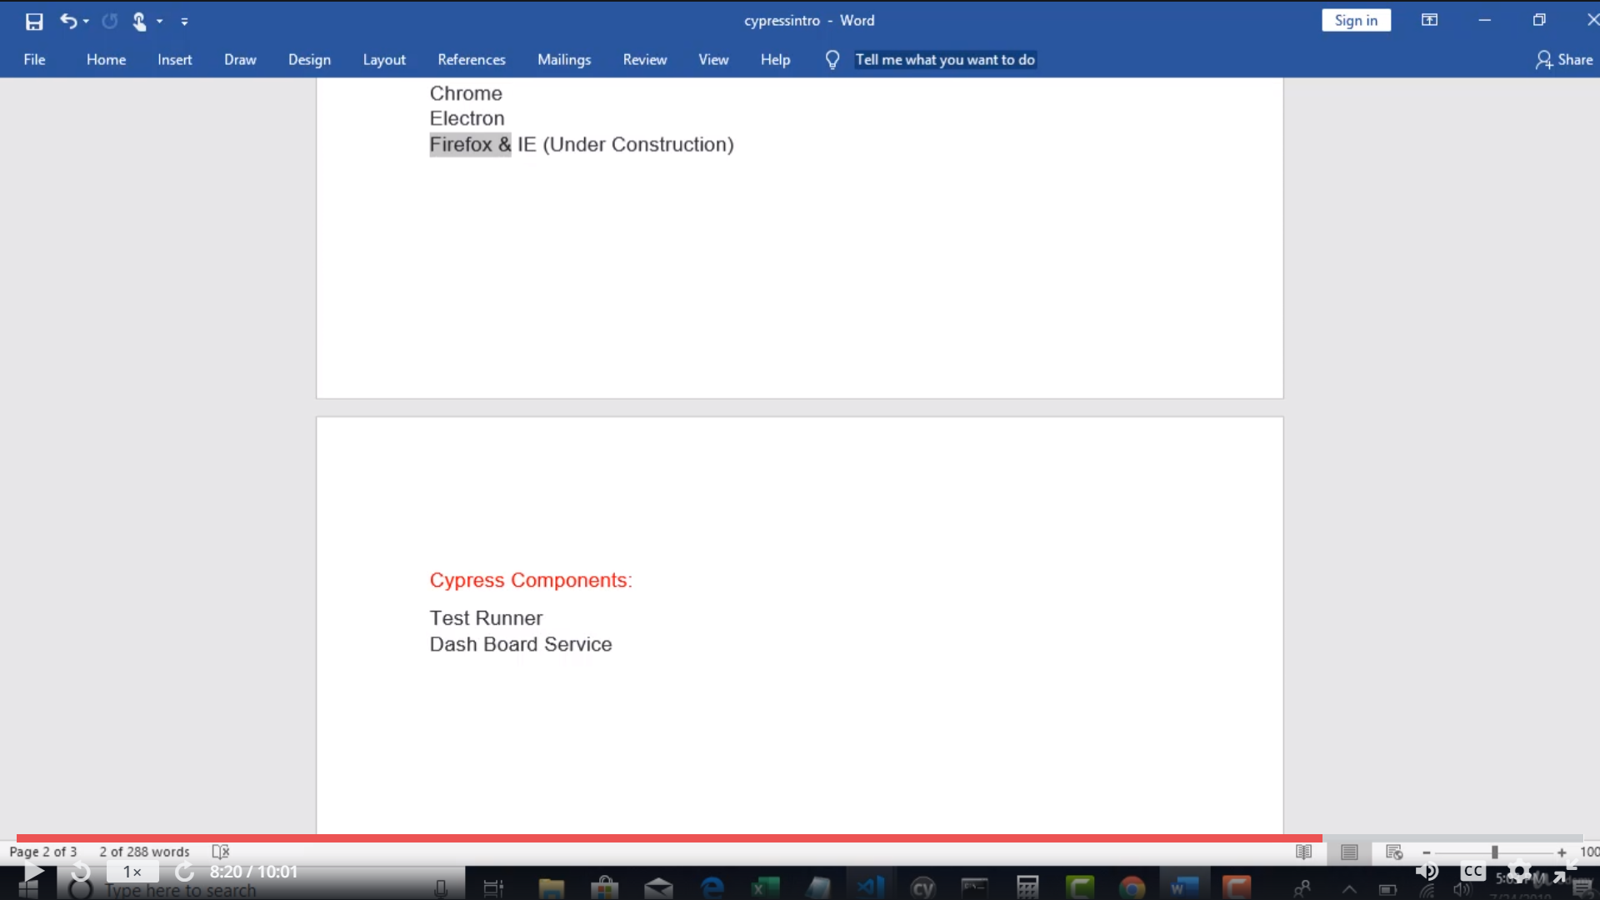

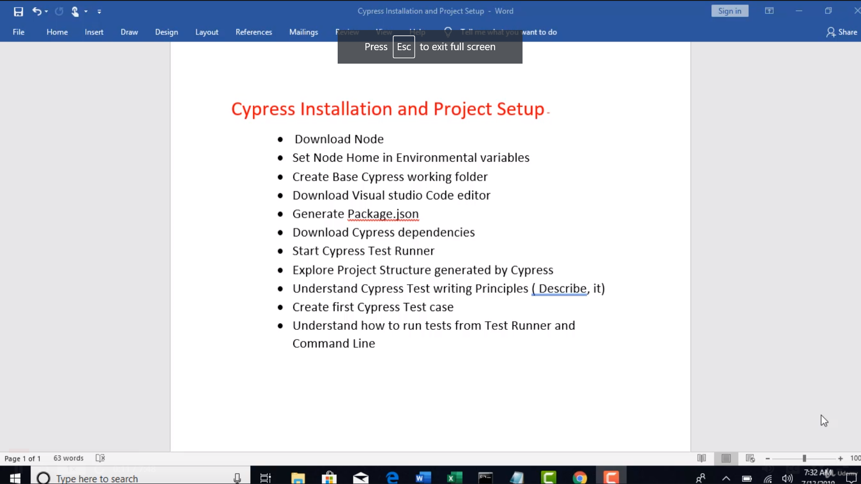

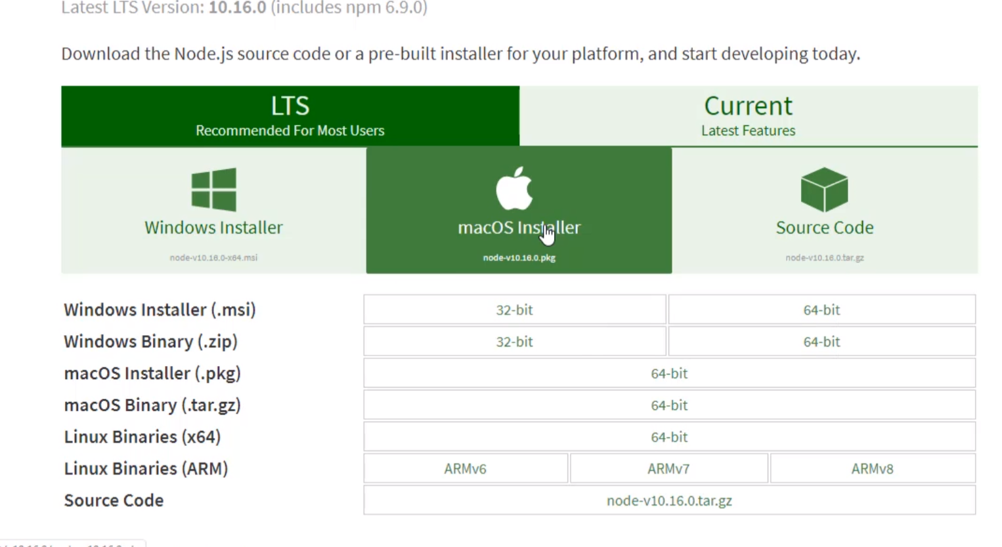

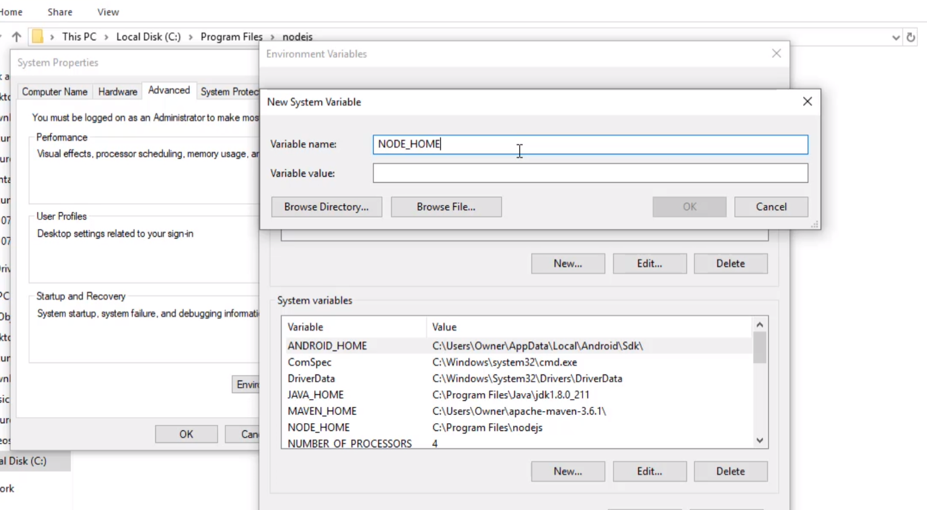

cReate base cypress working folder

: Place where all ur tests would be located

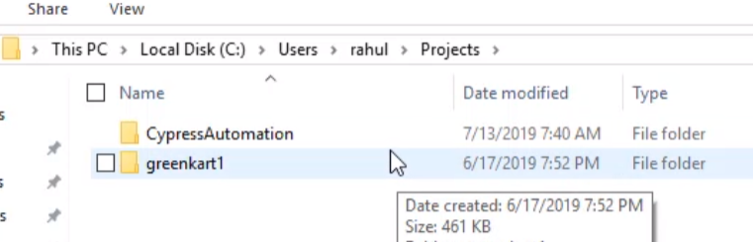

* To write our code we need one editor : Visual Studio Code

Download the VS Code

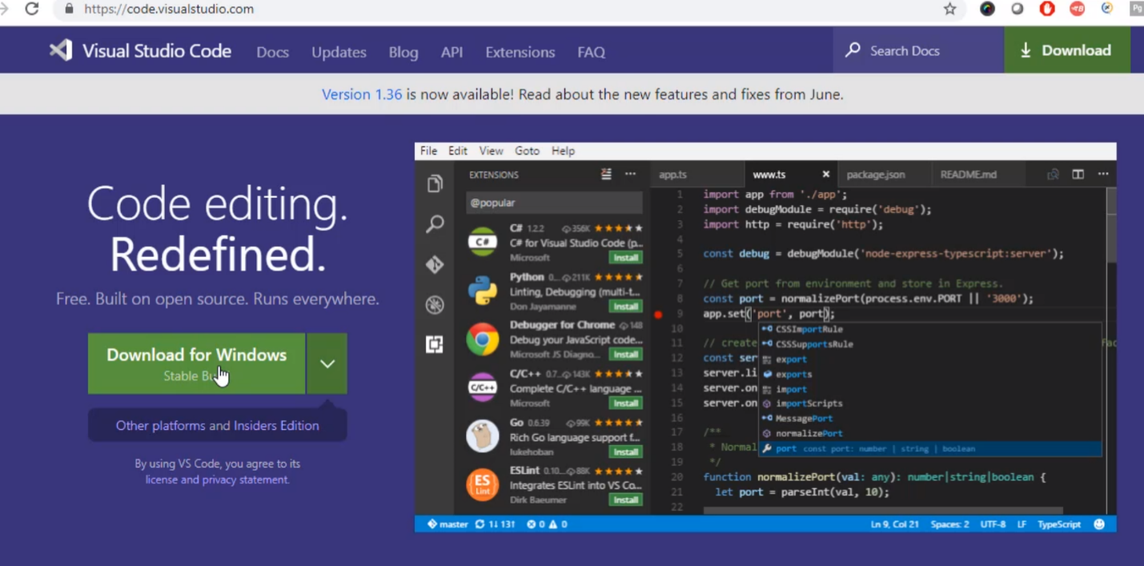

Create new project

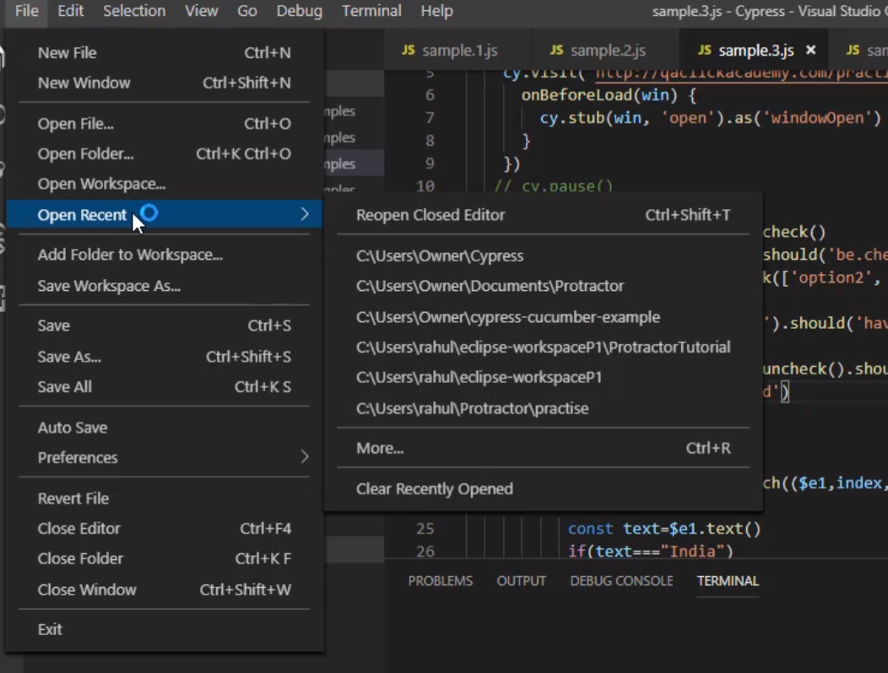

New Window

File >> open the folder >> select the folder u created

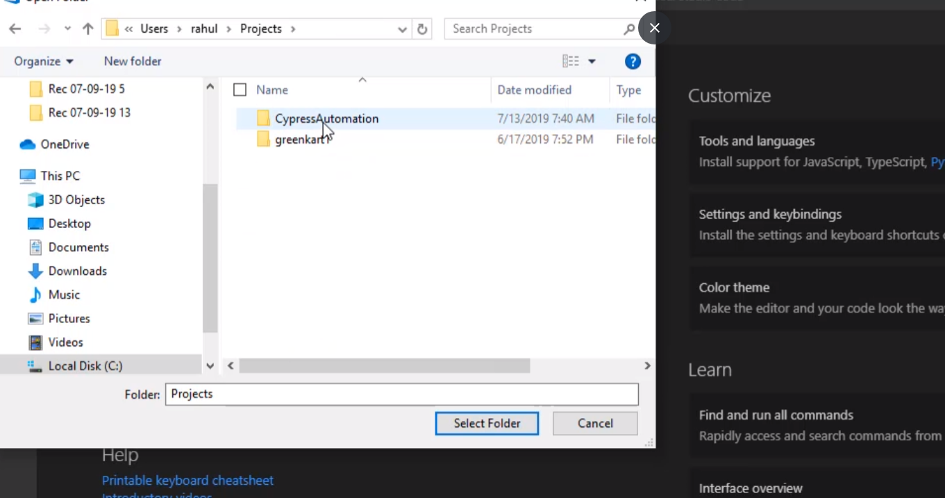

When we want to use typescript/ javascript in vscode we would normally give all the required packages in package.JSON

AND THEN RUN npm install which would get all the required dependencies mentioned in package.json

* Shortcut to open terminal in Vs Code: click on the left footer

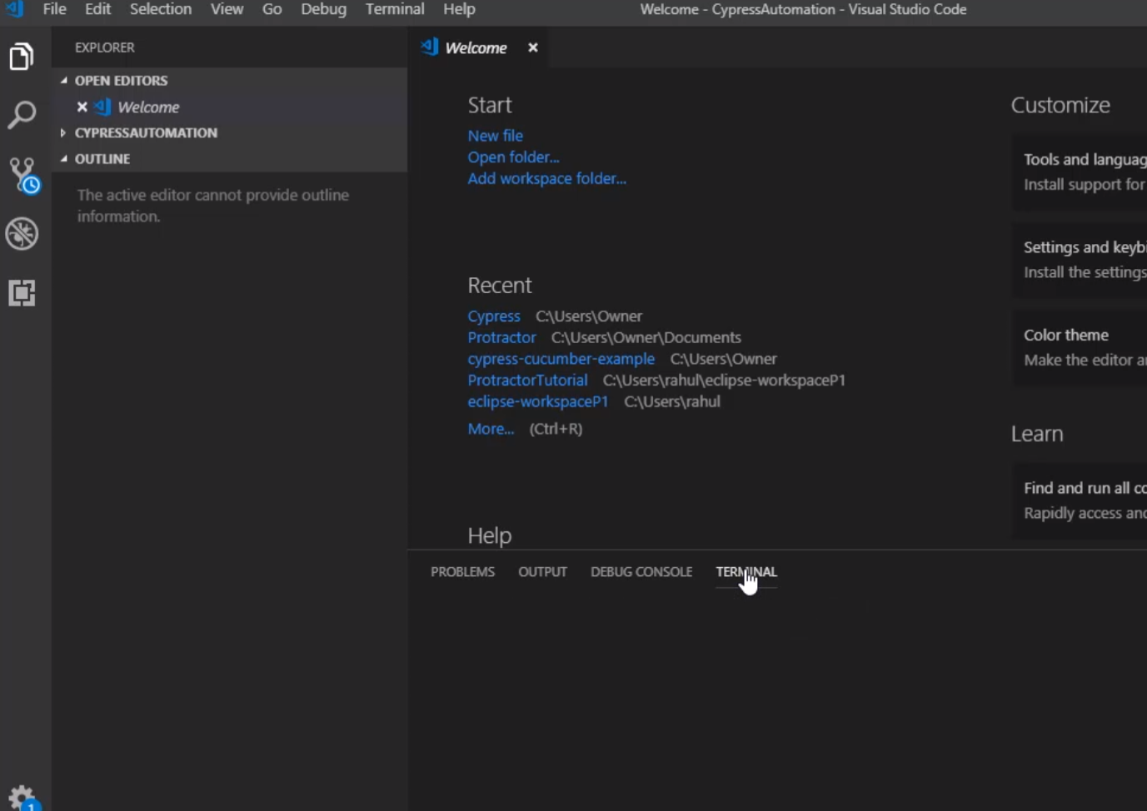

npm init

Will autogenerate package.json

It will ask packagename: automation

Version 1.0.0

Description:

License : “ISC”

Any thing

* Now package.json should be aavailable

Executing test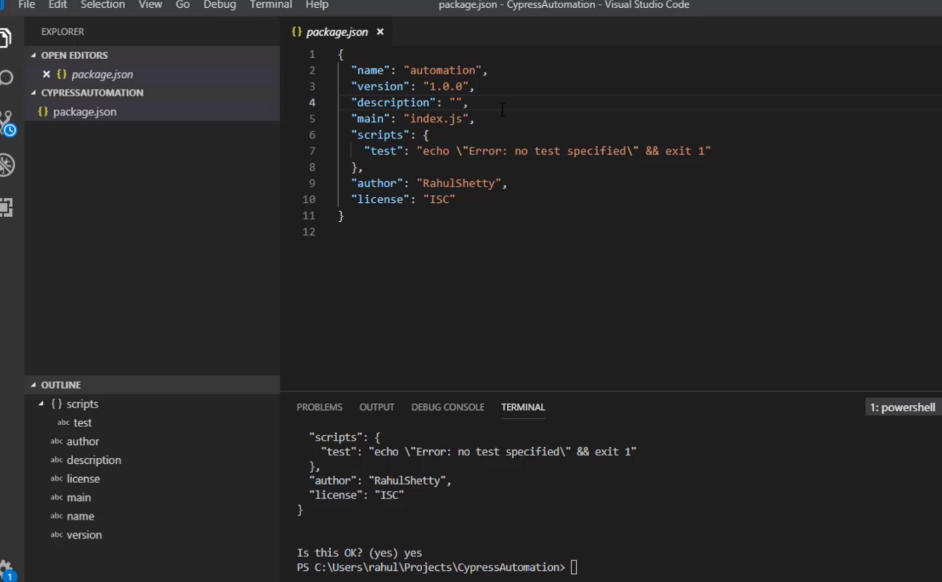

Now we need cypress

Cypress can be installed in two ways:

1. Declare cypress as a dependency in Package.json and run npm install
2. Else run npm install cypress –save-dev

Executing tests:

1. Running cypress by giving commands
2. Running via test runner

After installing cypress >> u would observe that node module folder is created for u…..

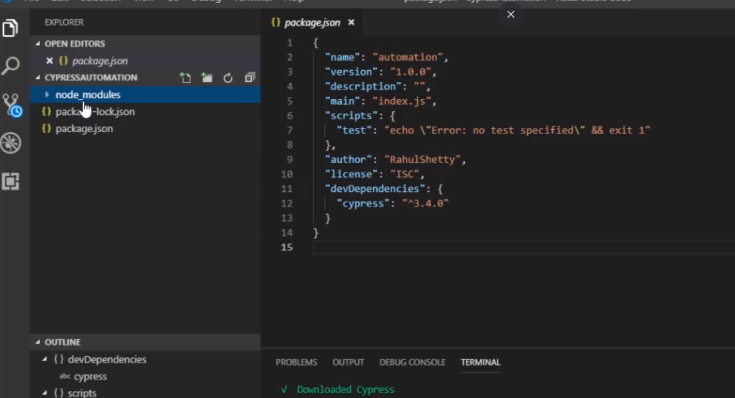

All cypress dependencies are stored under the node-modules dependency

If u watch the console carefully >> console says u can open the test runner via the command

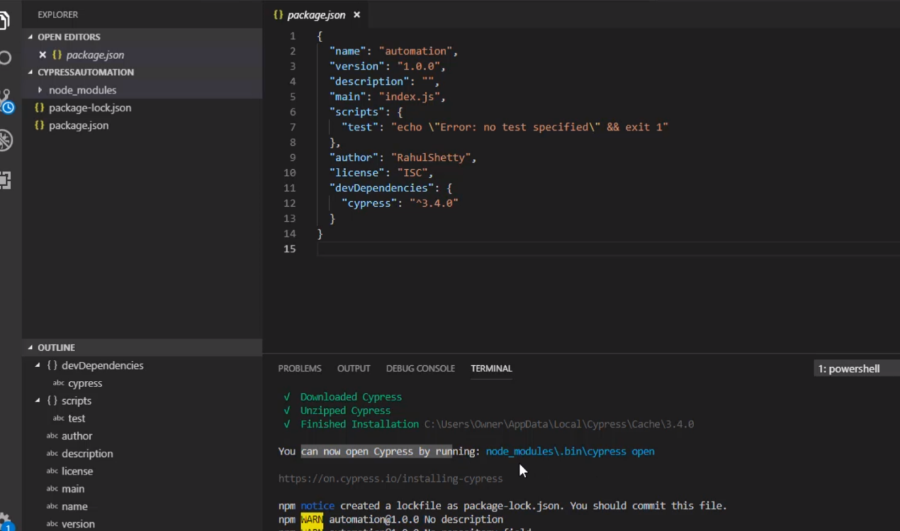

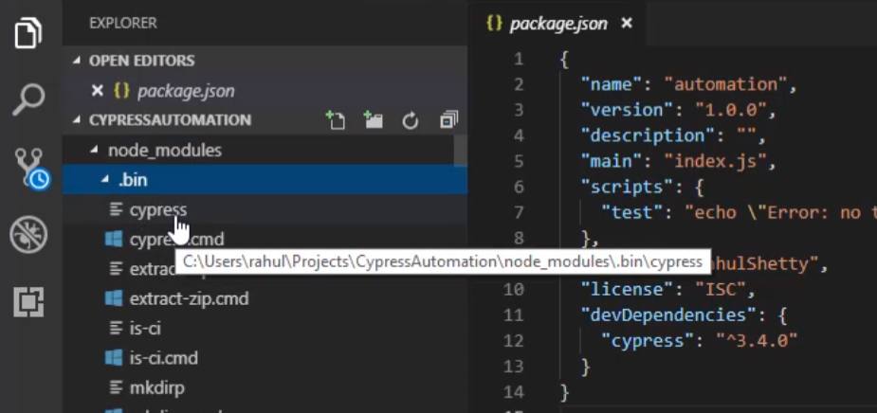

So if u want run the command u need to run it from node_modukes >> .bin >> cypress

If u run from any other path it would say cypress was not an internal/external command

How to Run??

Copy the path and place it and hit enter

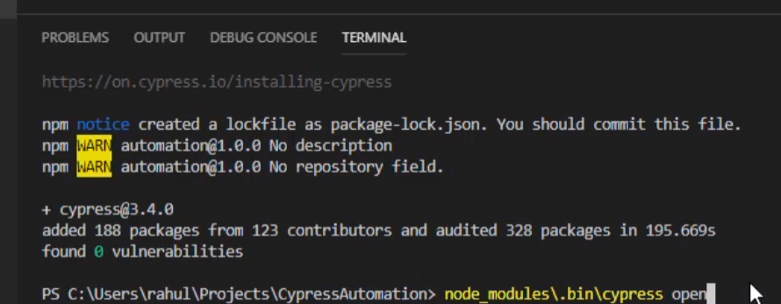

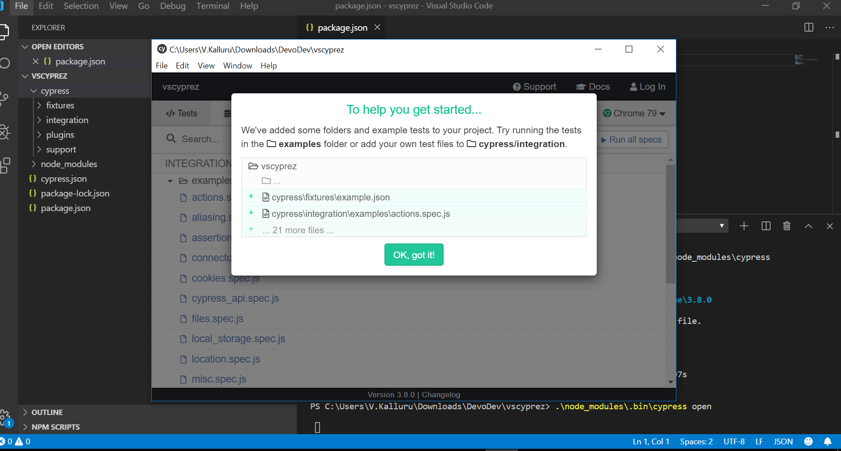

If u observe there s a cypress node created above the node_modules

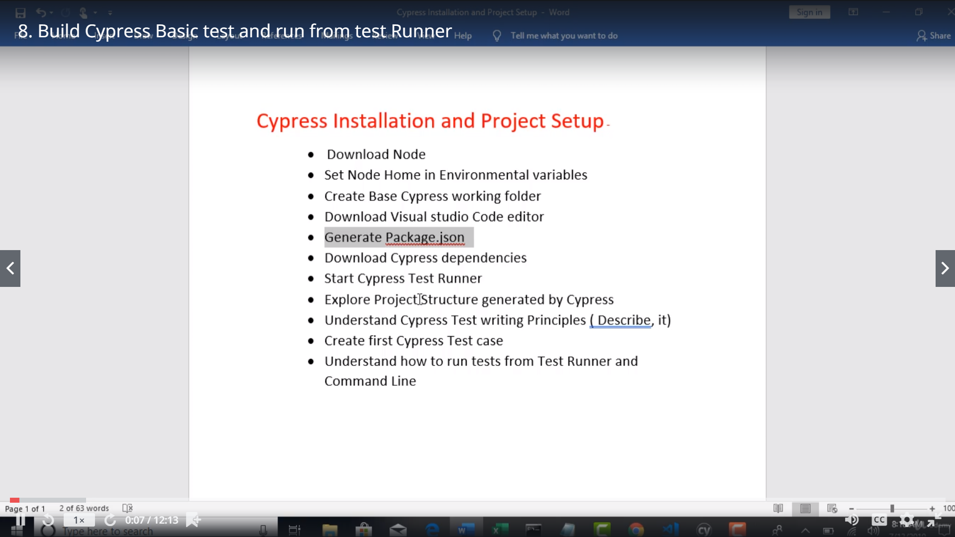

Deleting the example tests – so they don’t confuse us

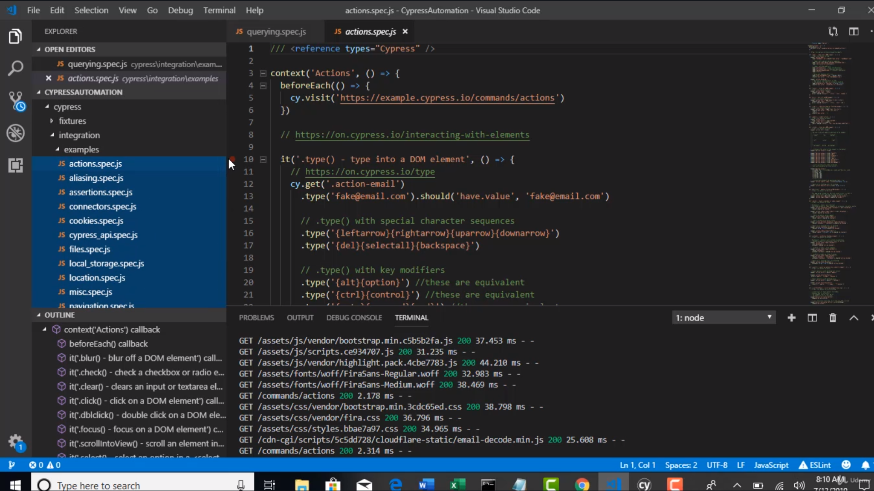

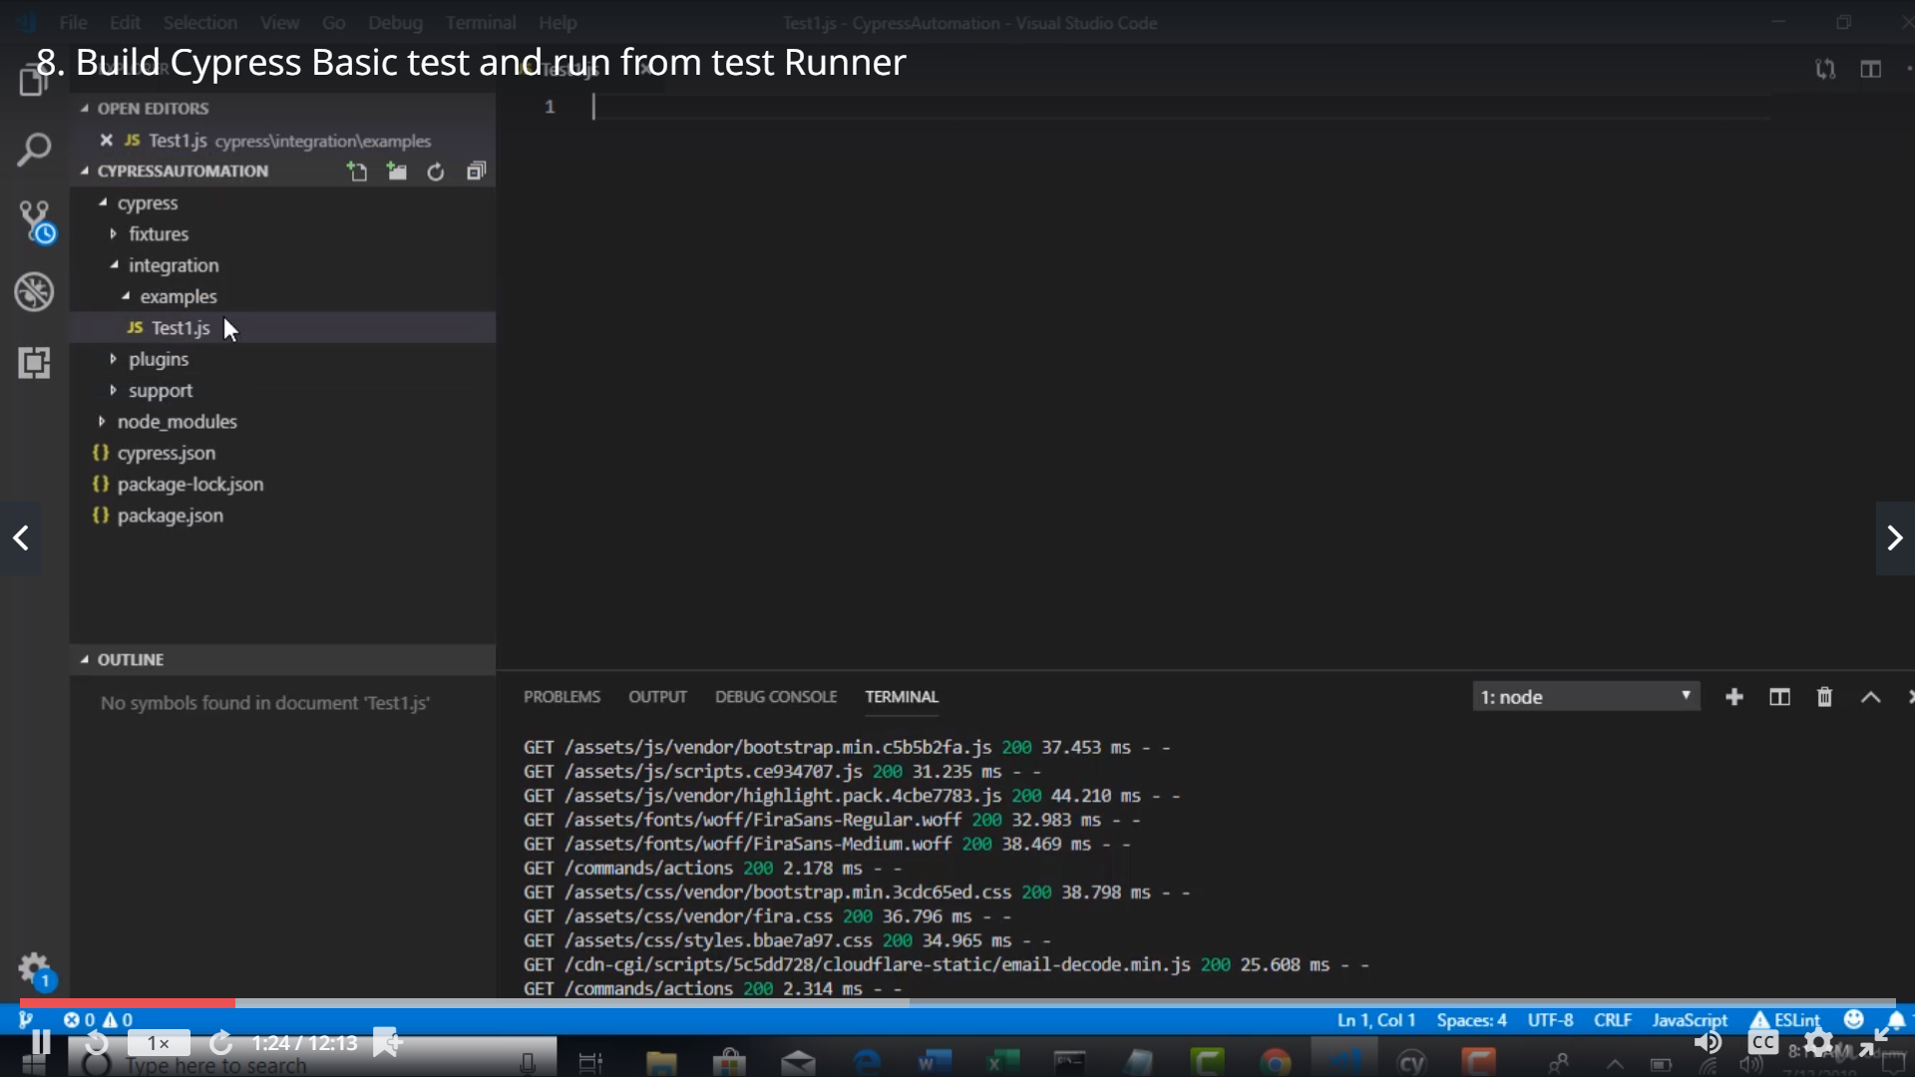

Test1.js

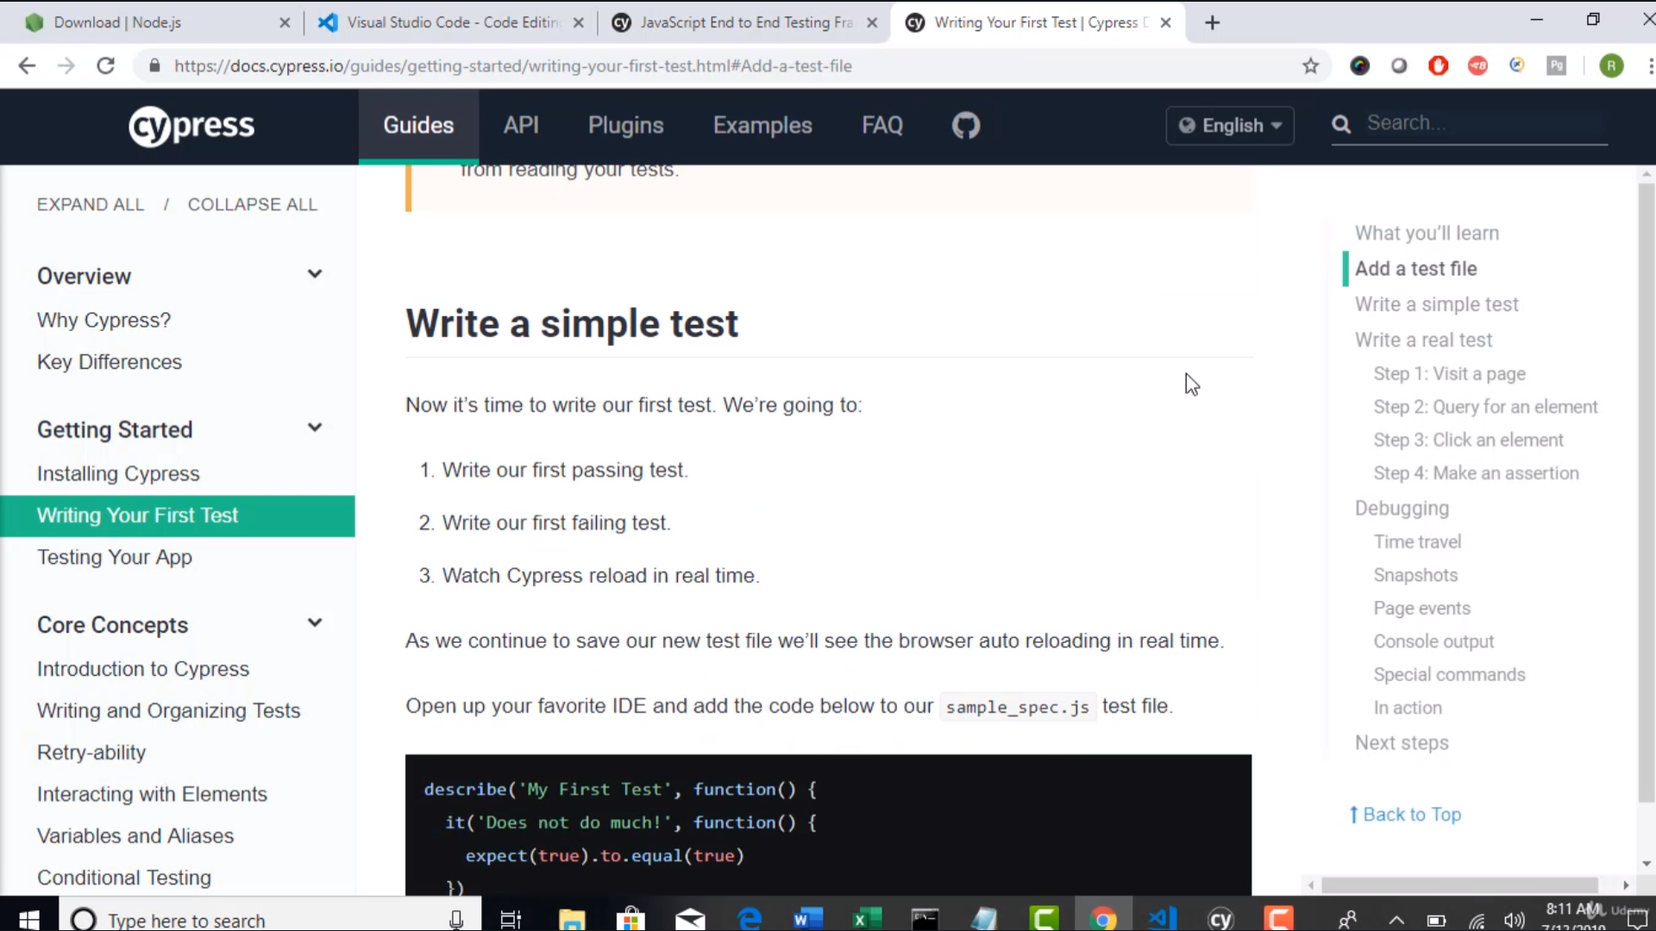

As we are writing the test in javascript >> we need to follow one of the javascript test frameworks like jasmine , mocha

U HAVE to inject u r cypress test in to one of the js test frameworks

* Cypress recommends to use Mocha
* Describe and it come from Mocha
* Expect comes fram chai
* It – block is treated as test case
* Describe – is test suite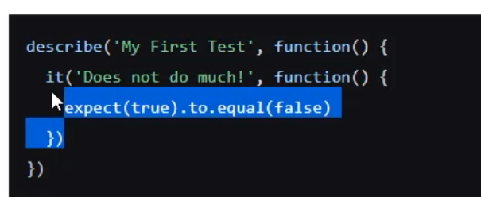
* Note: jssmine also has same syntax [describe and it]
* Describe will take 2 arguments -- 1st arg is describtion, 2nd arg is function with empty parenthesis which has all the test cases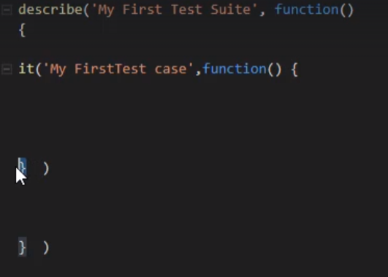
* All the test steps to be inside it – block
* 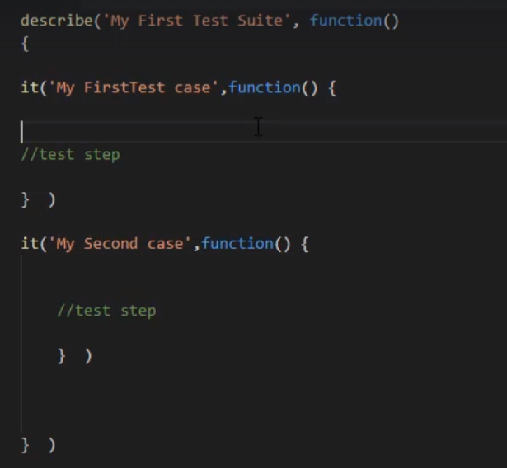

Cypress equvalent of Selenium driver is ‘cy’

Currently on installation we will not get the intellisense ofr auto filling

So when u type cy. --- no methods willll auto populate

Cy.visit() – to invoke browser

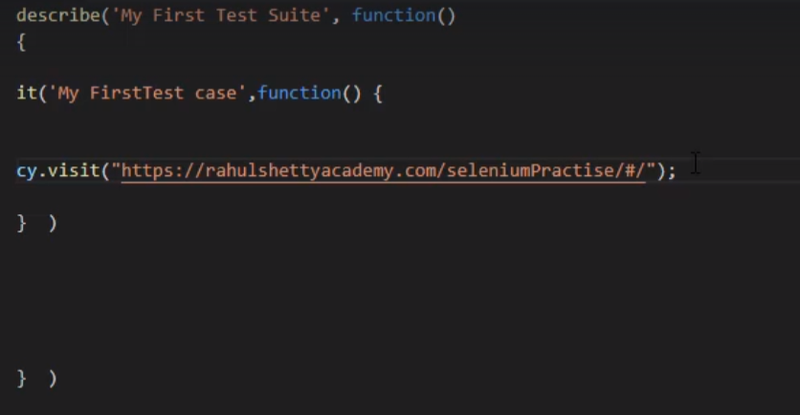

Save the test in vs code. And if u go to Testrunner u will find the test there…

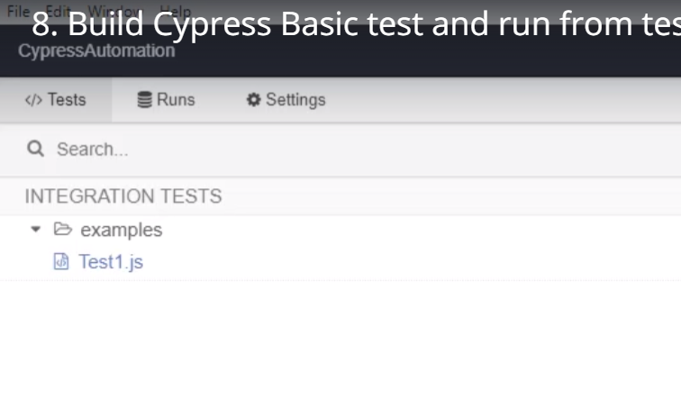

Just select the test … automatically it will run

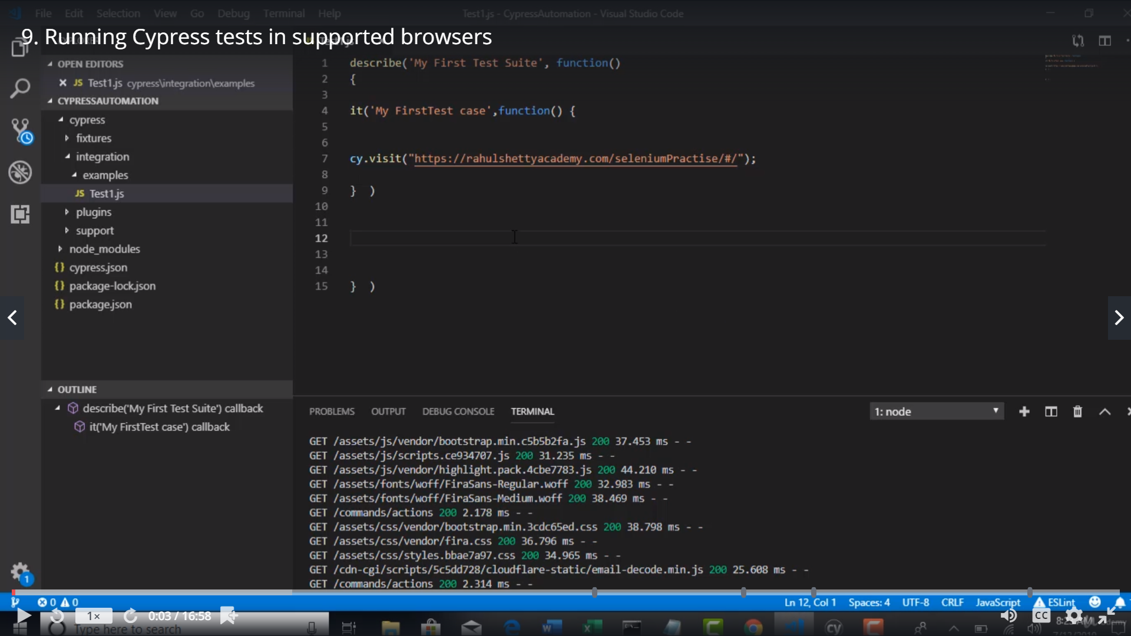

If u want run in chrome/electron select the browser in the right side top corner

And select the test to run

If u want to run from the terminal … open in a new terminal in vs code and 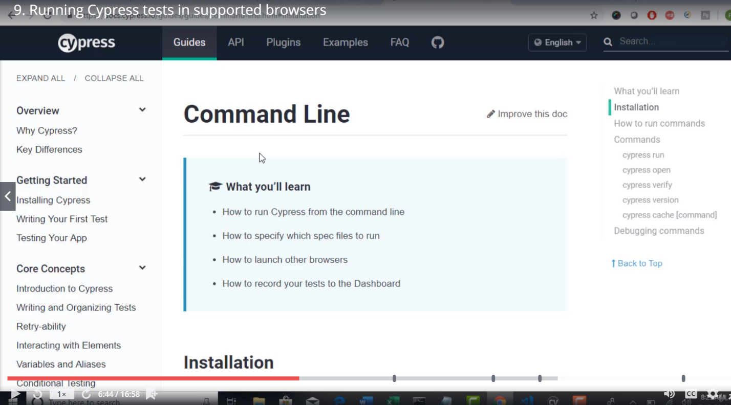

If u want to open test runner >>

./node_modules/.bin/cypress open

If u want to run cypress in the terminal

./node_modules/.bin/cypress run

Note: Above command wil trigger all the testcases under the examples flder

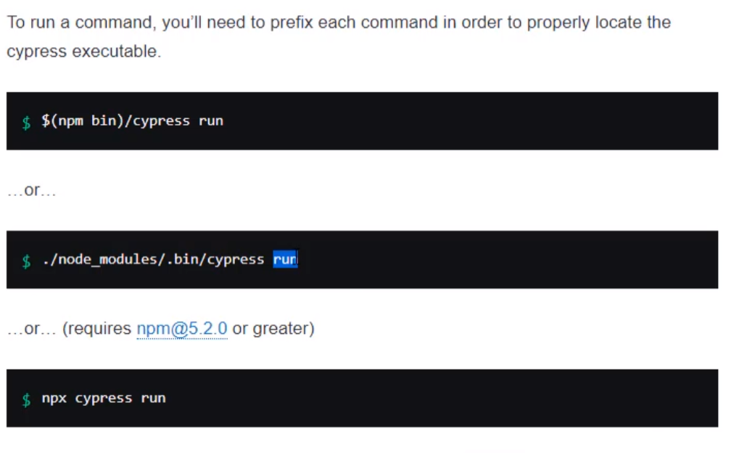

If u want to run specific spec file/test

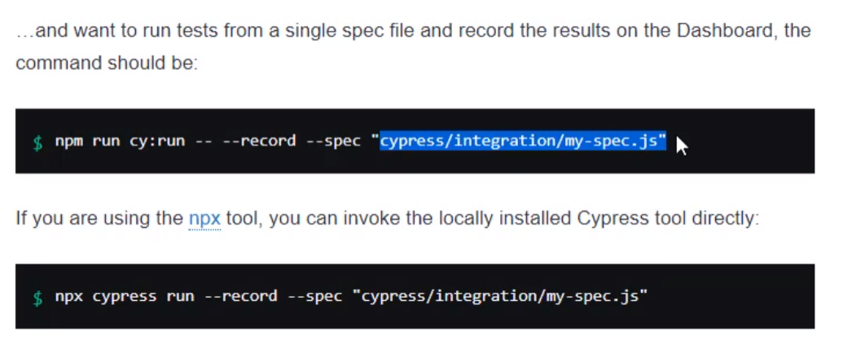

Note:

1. Via testrunner >> execution is always headless
2. Via command line >> execution is by default via Electron browser and headless

.\node_modules\.bin\cypress run

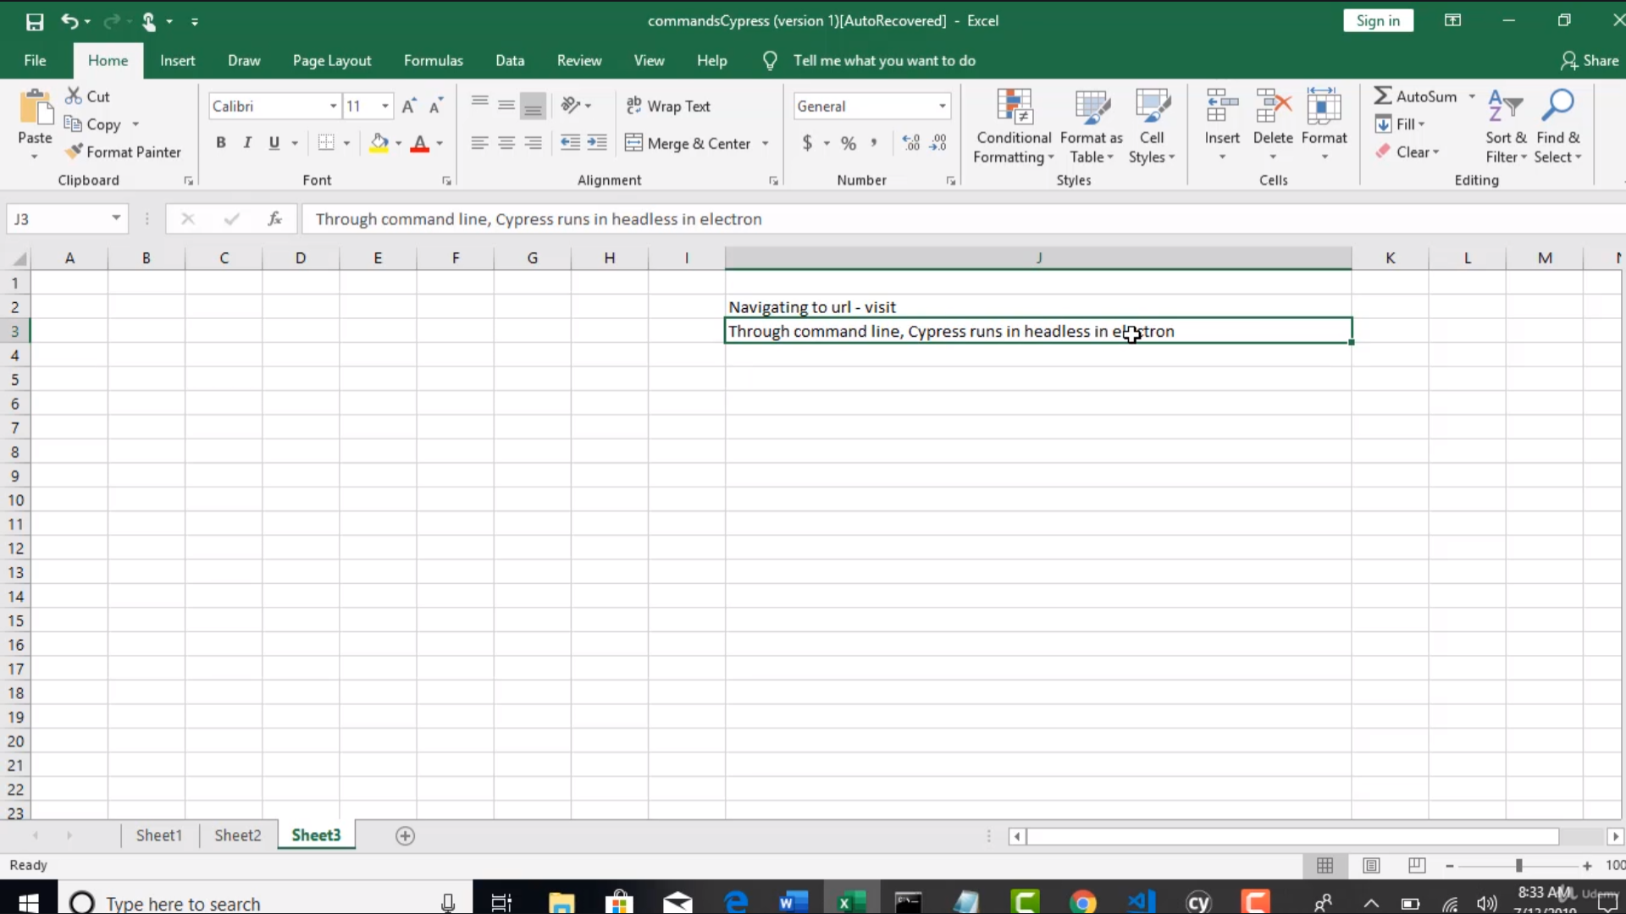

1. If u want head execution via command line >> then u need to specify specifications

.\node_modules\.bin\cypress run –headed

Above works for electron

If want to run on chrome

.\node_modules\.bin\cypress run –browser chrome

The 2nd /3rd option can be used via Jenkins CI

**Browser Info:**

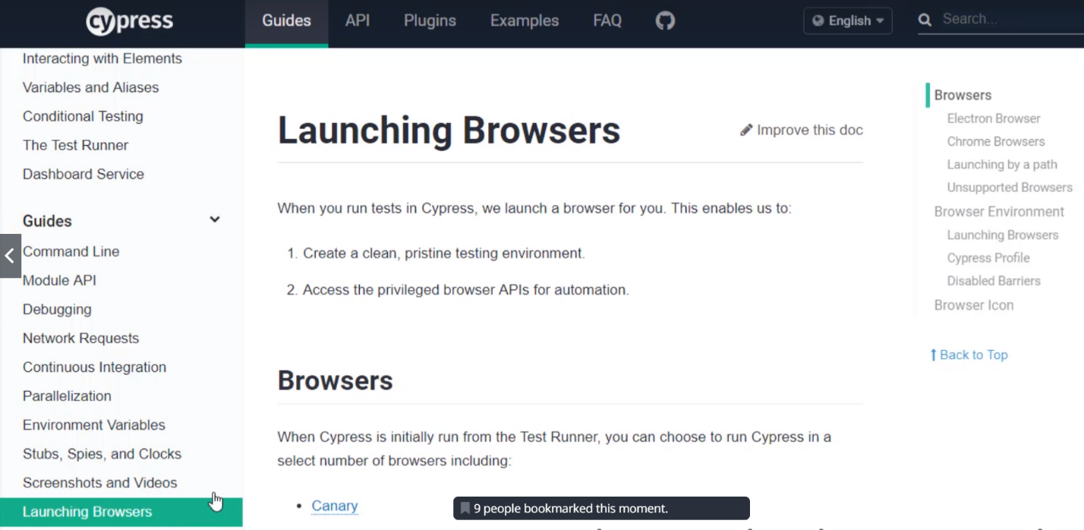

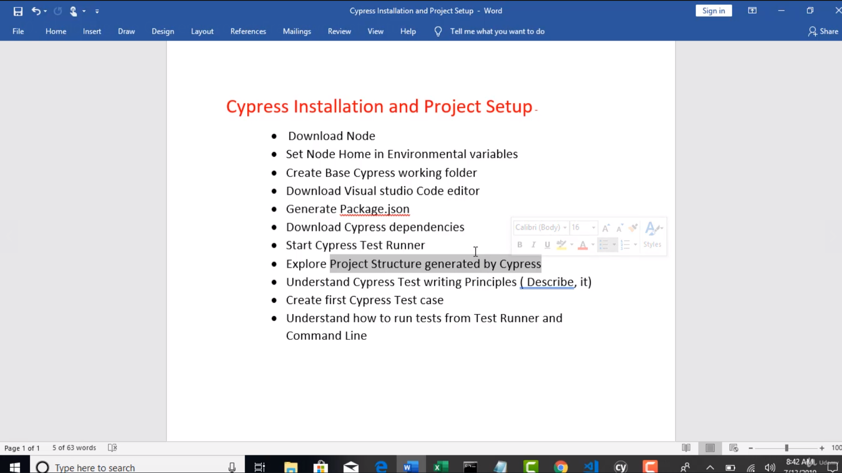

By default when u click cypress open command >> the folder structure is created

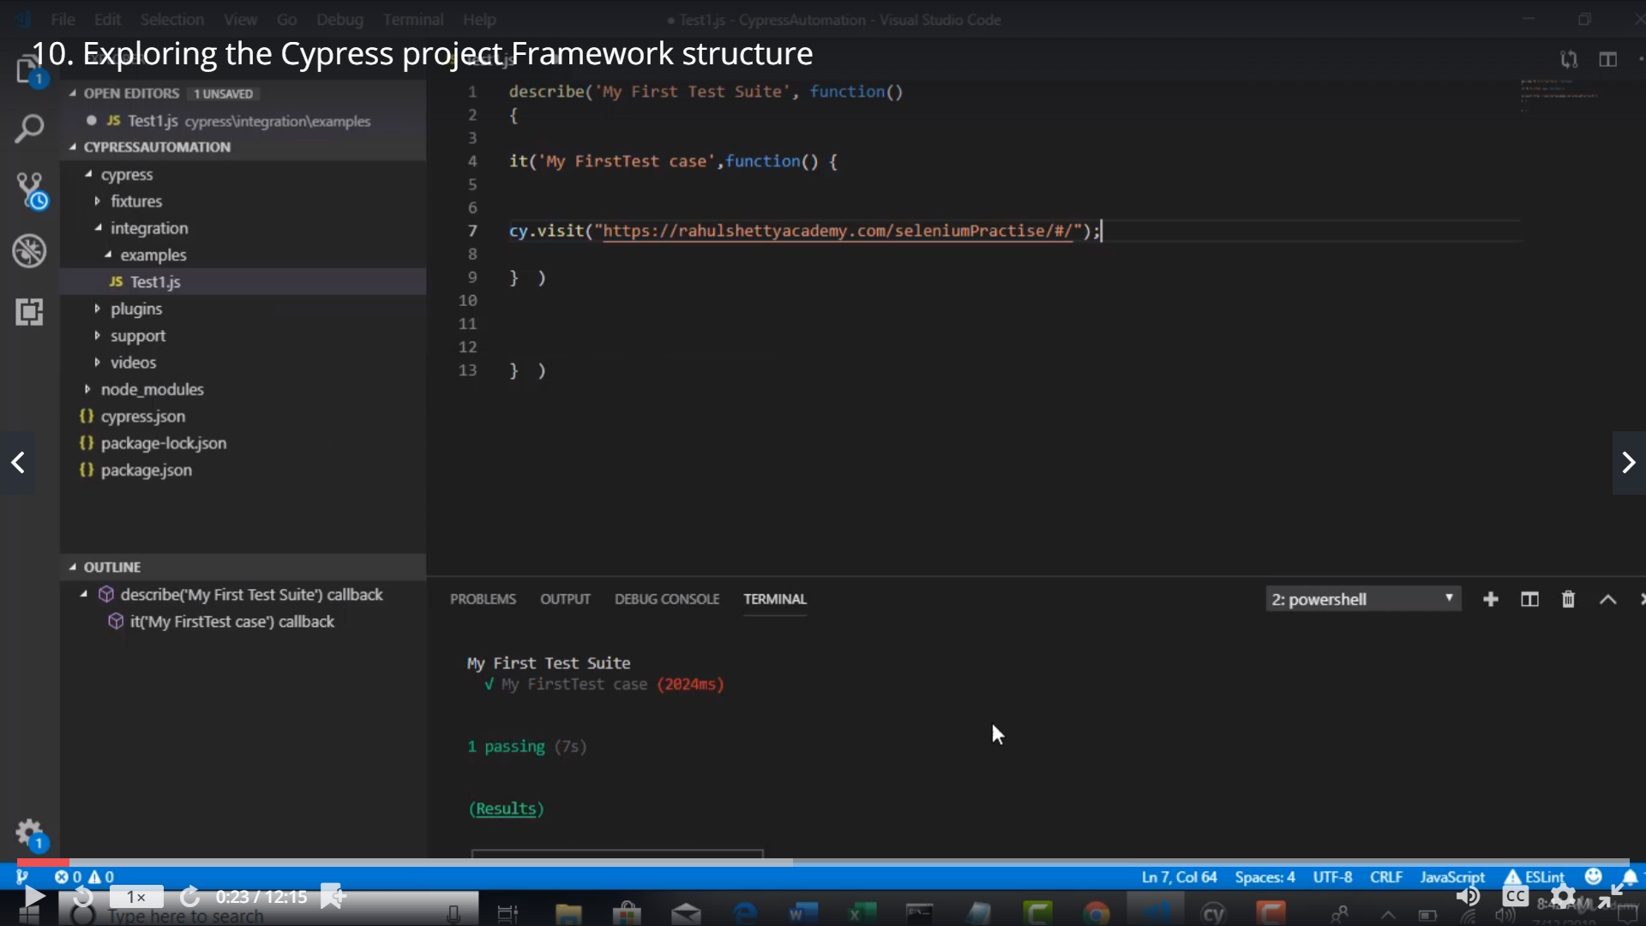

Fixtures: Folder responsible to hold the test data excel , xml, json

With a singe step u can access the test data

Integration : Folder all test to be placed under this folder..

Plugins: foder >> kind of listeners

Example: u want to switch to browser full screen mode

To inject customized options to browser to accept certificates

We will give that info in index.js

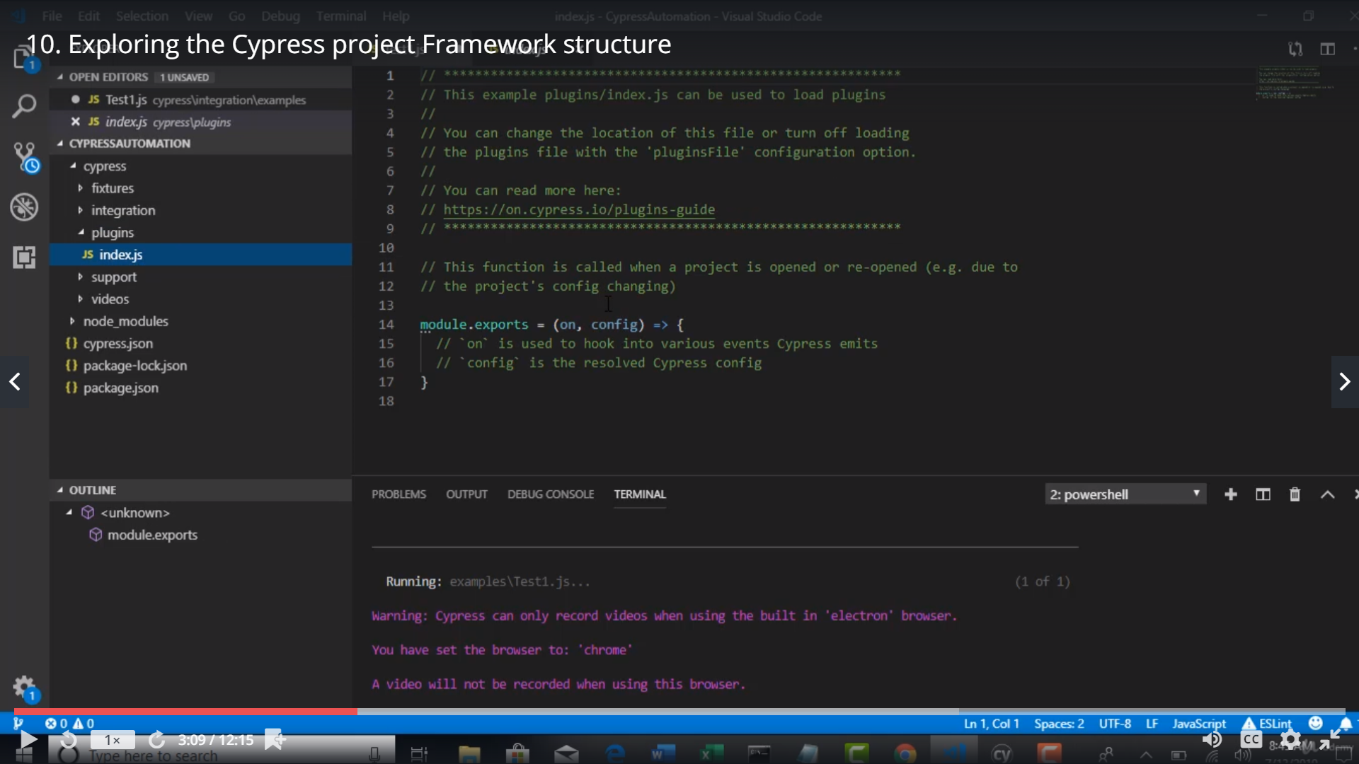

Support – Folder : reusable function we place here so they are automatically available in the tests

Video – folder :: for every test run video is captured

Node_modules – folder this will be created when u do npm install

Cypress.json

In testrunner > u can find the configuration

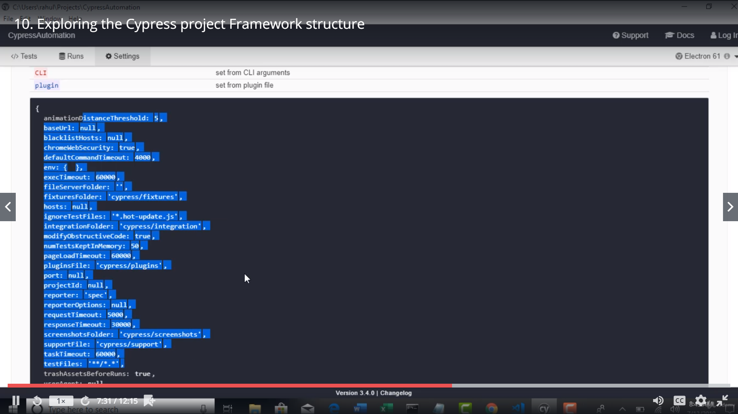

If u want to override the default configuration.. u can update in cypress.json

It will automatically update the default config in Testrunner

Package.json: only for the first time u will run npm install cypress –save-dev

Once u do tht command it will automatically update the dependencies in package.json.

And when u give the whole package to some one they need to just do npm install

Since all the dependencies are marked in package.json

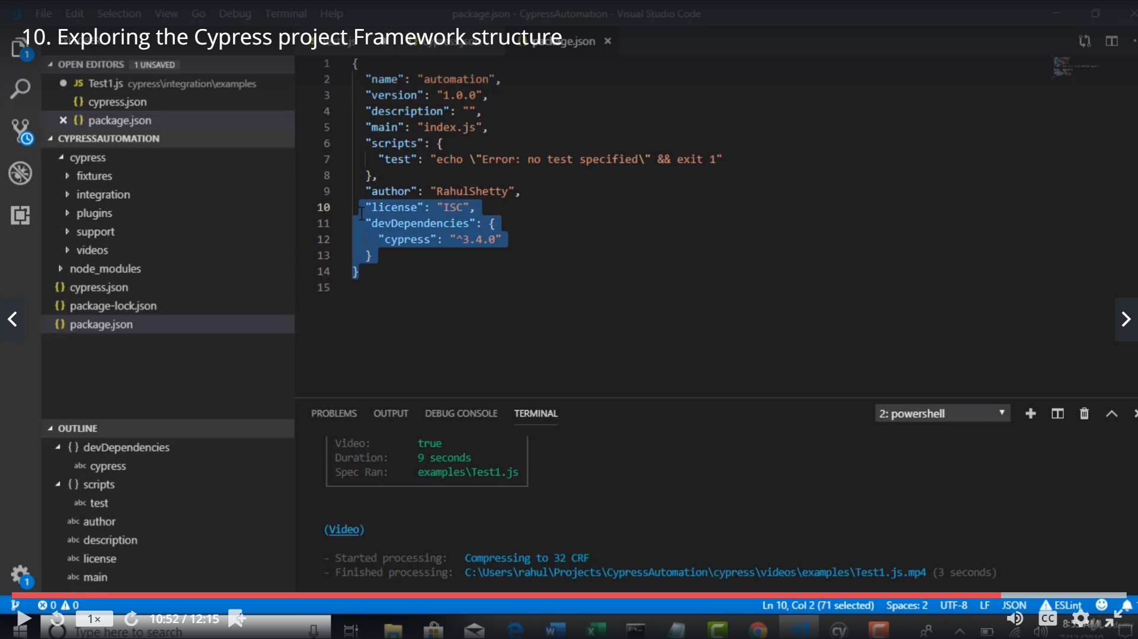

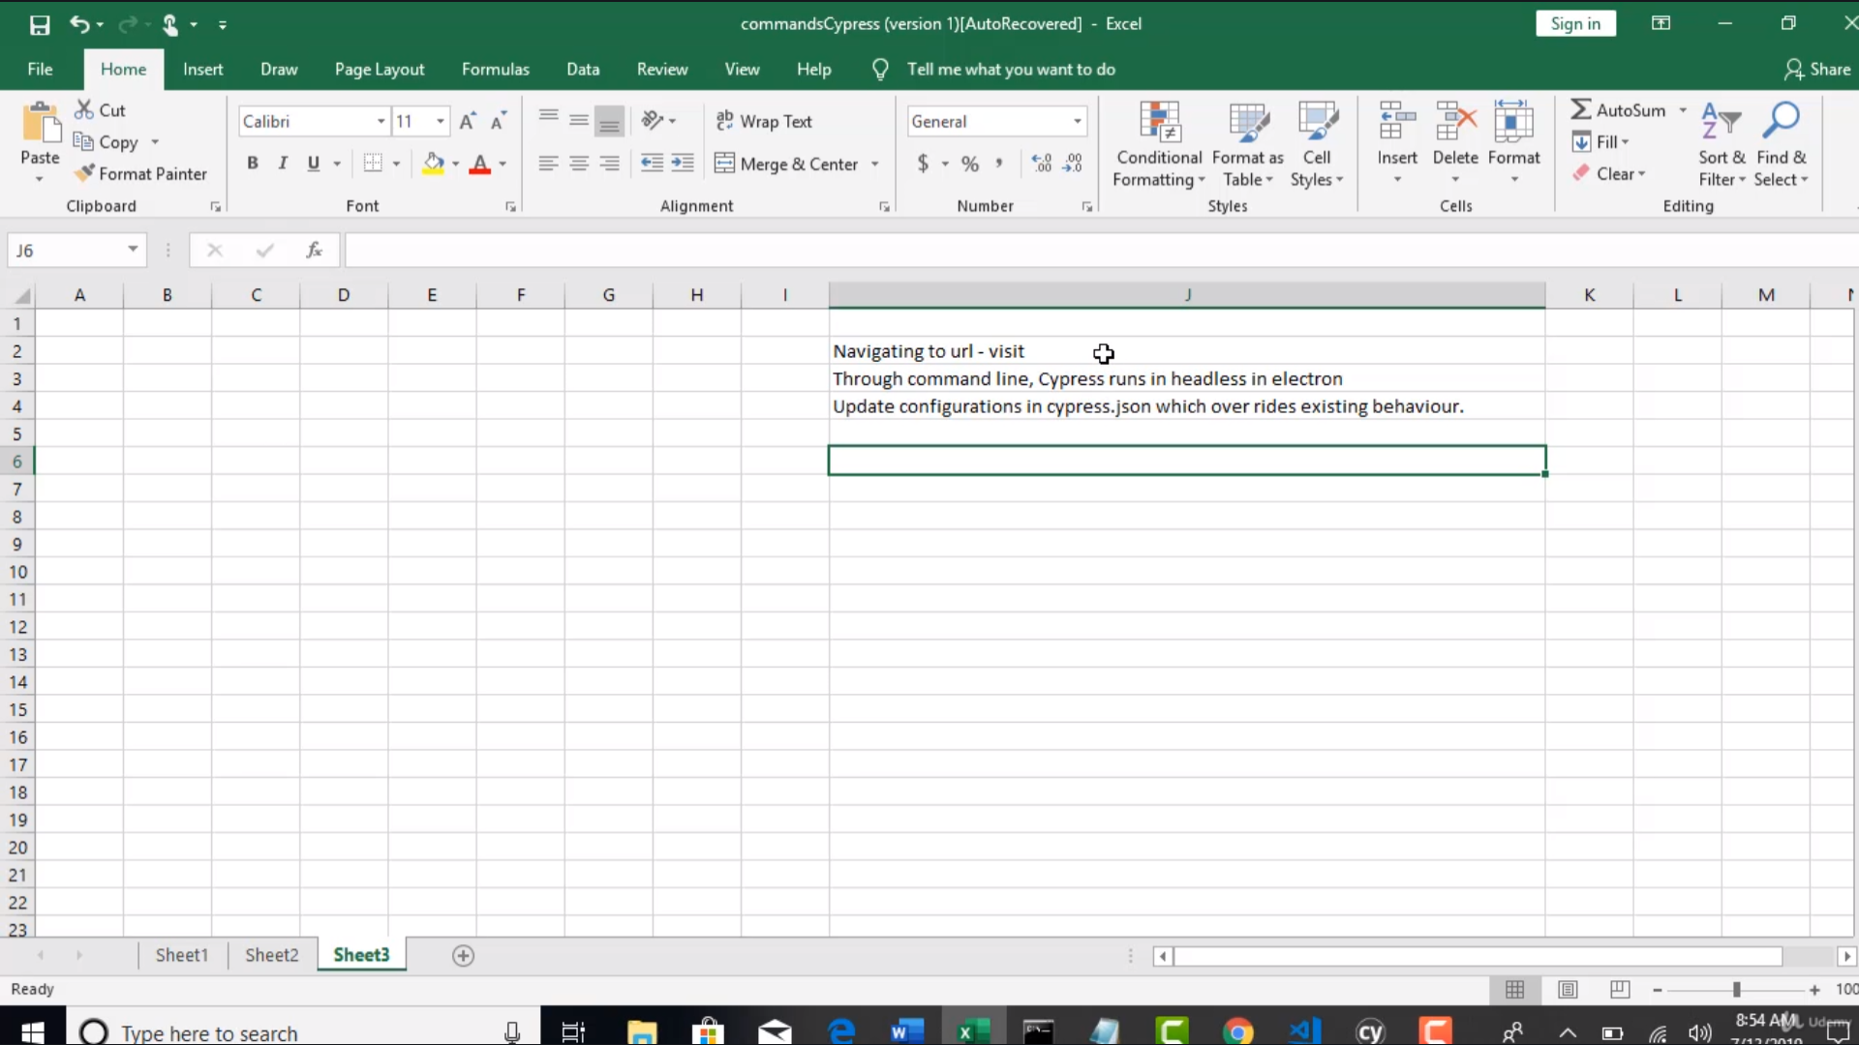

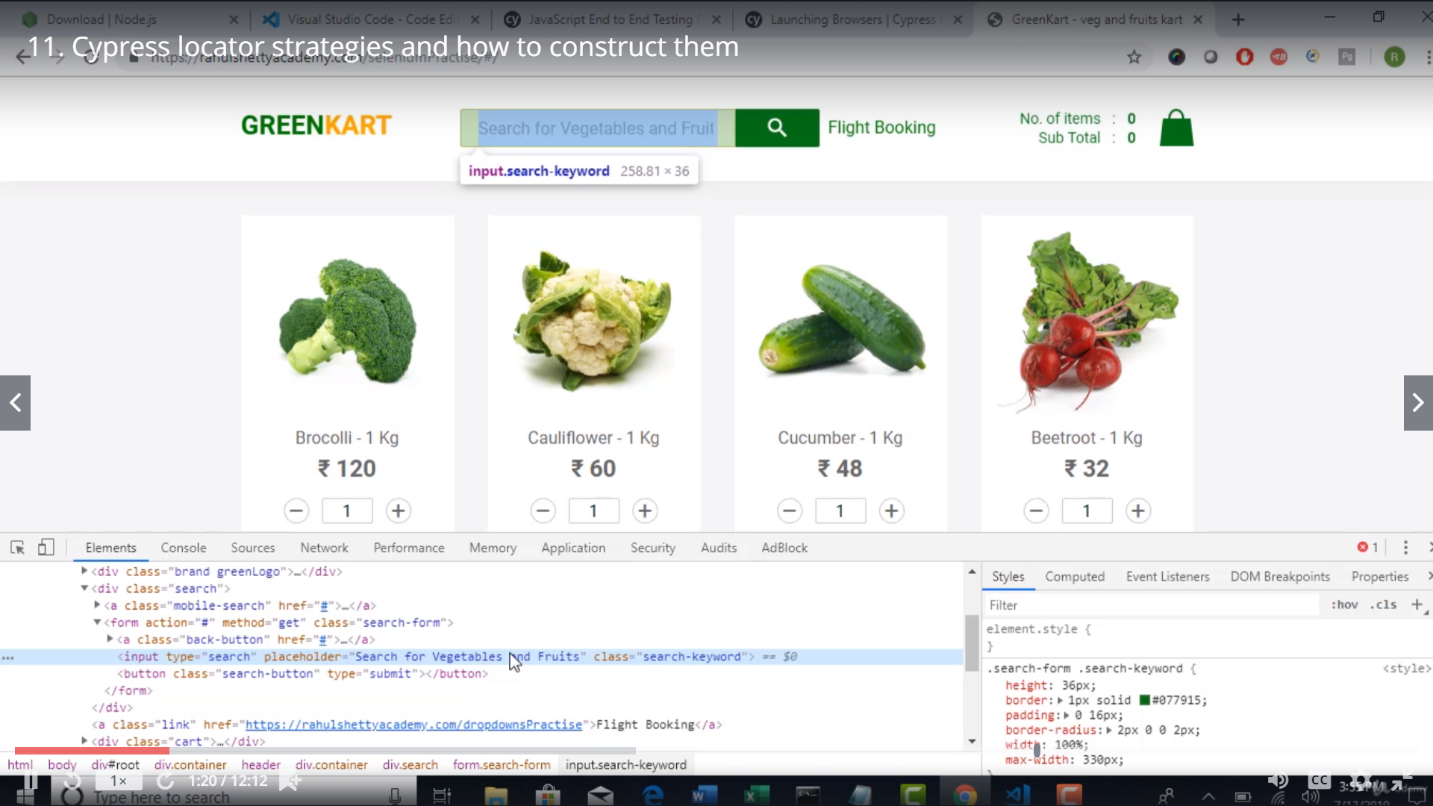

Cypress supports only Cssselectors [jquery is based on css selector]

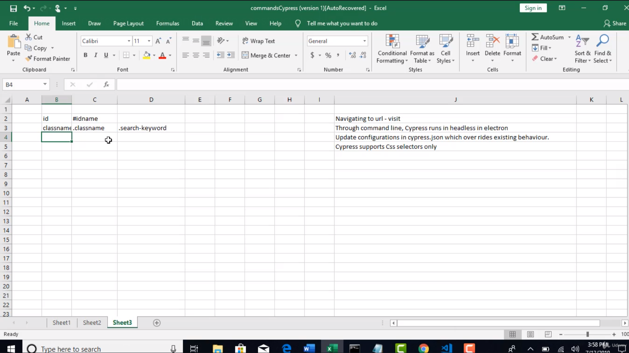

In css if there is a space between words u have to replace the space with a .

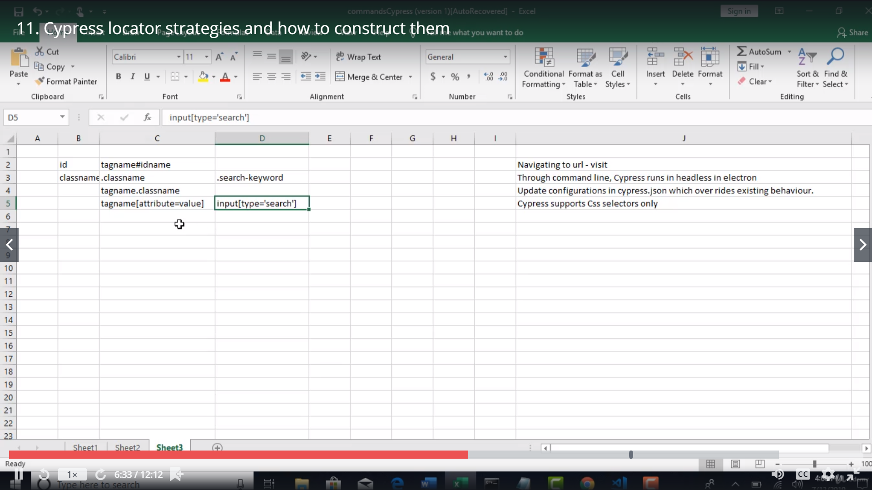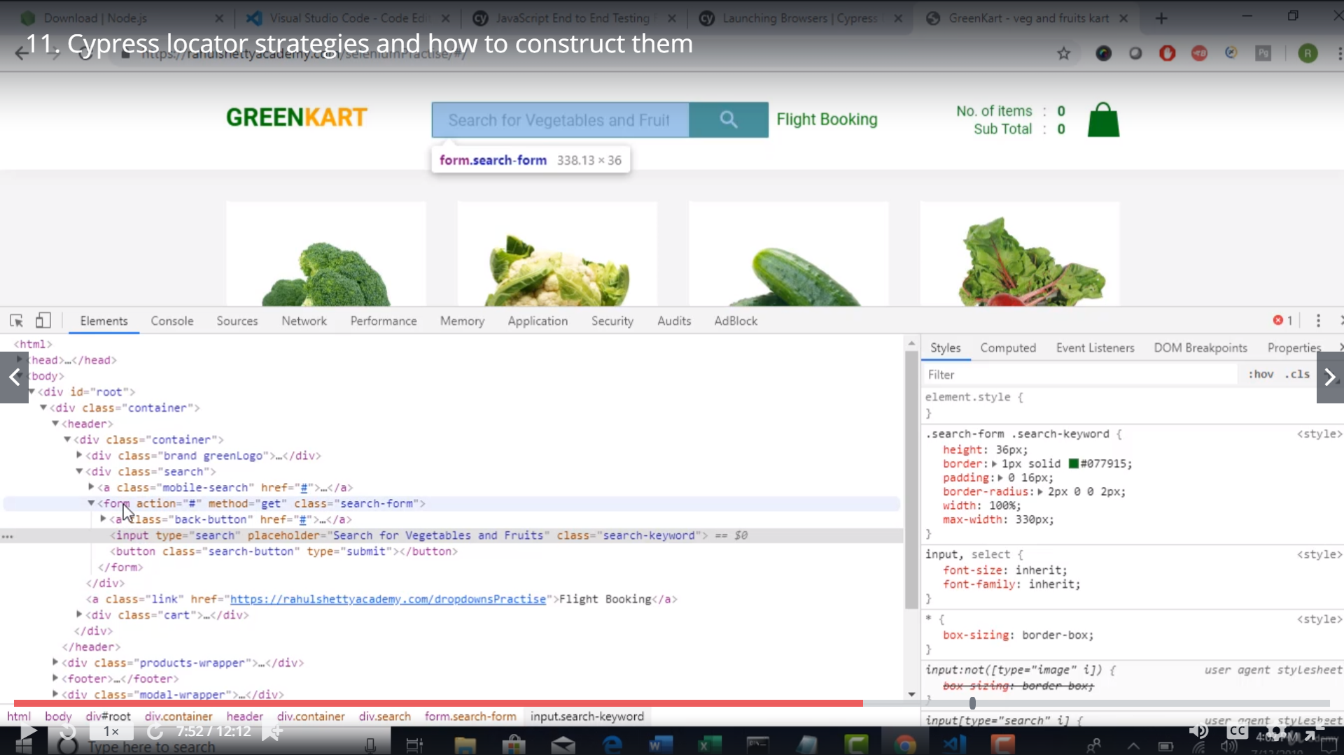

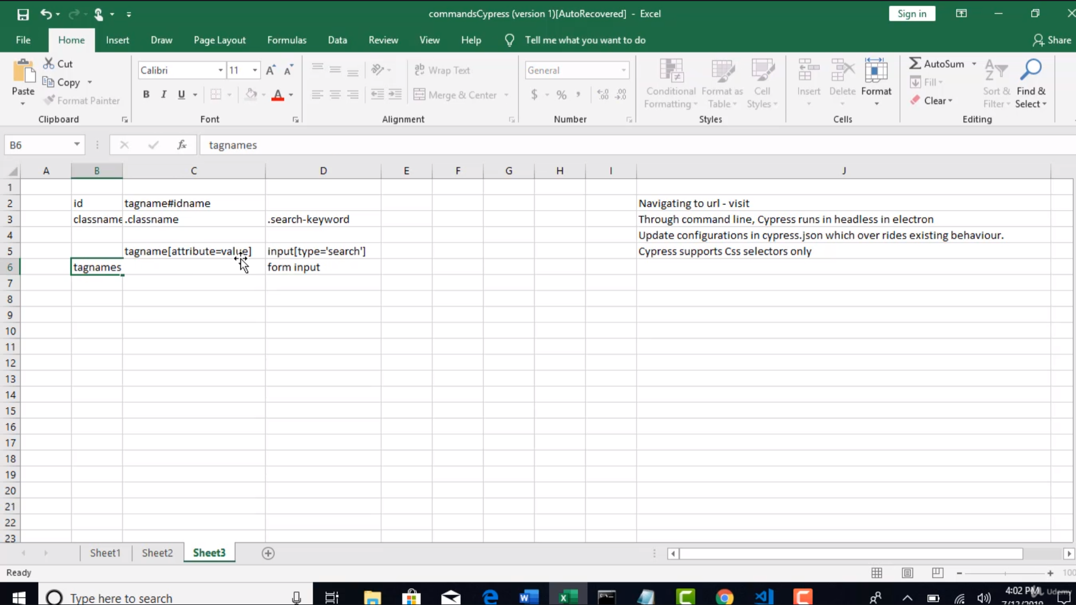

To traverse the dom u need to give a space eg: form input

The equvalent of xpath form/input

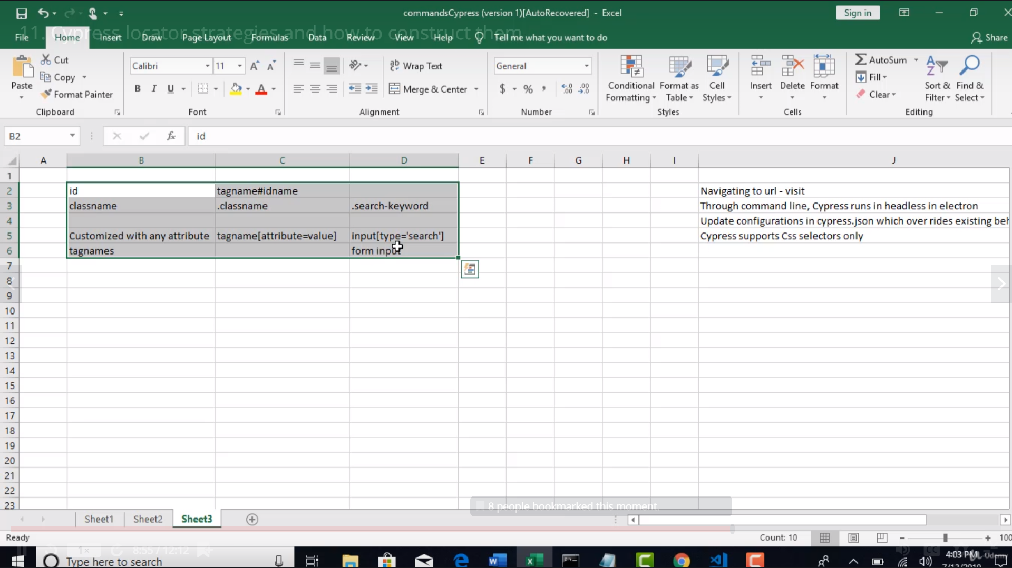

Download chropath plugin

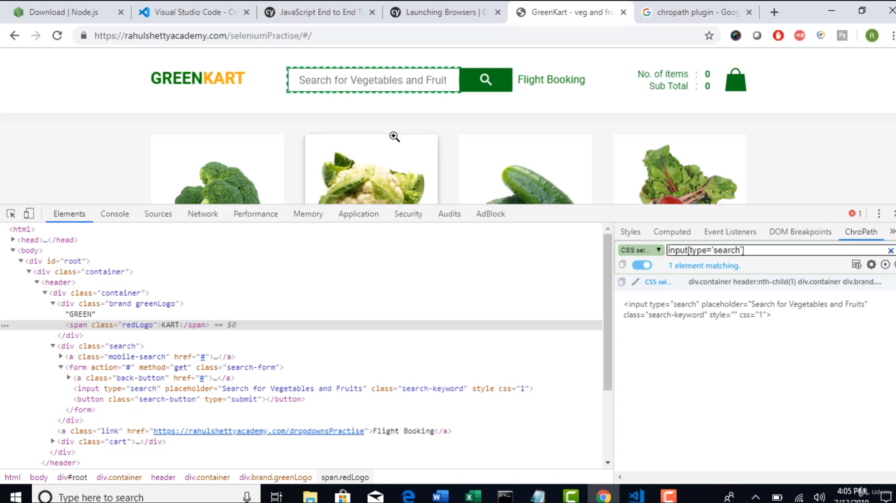

With cypress u have an additional way to identify elements

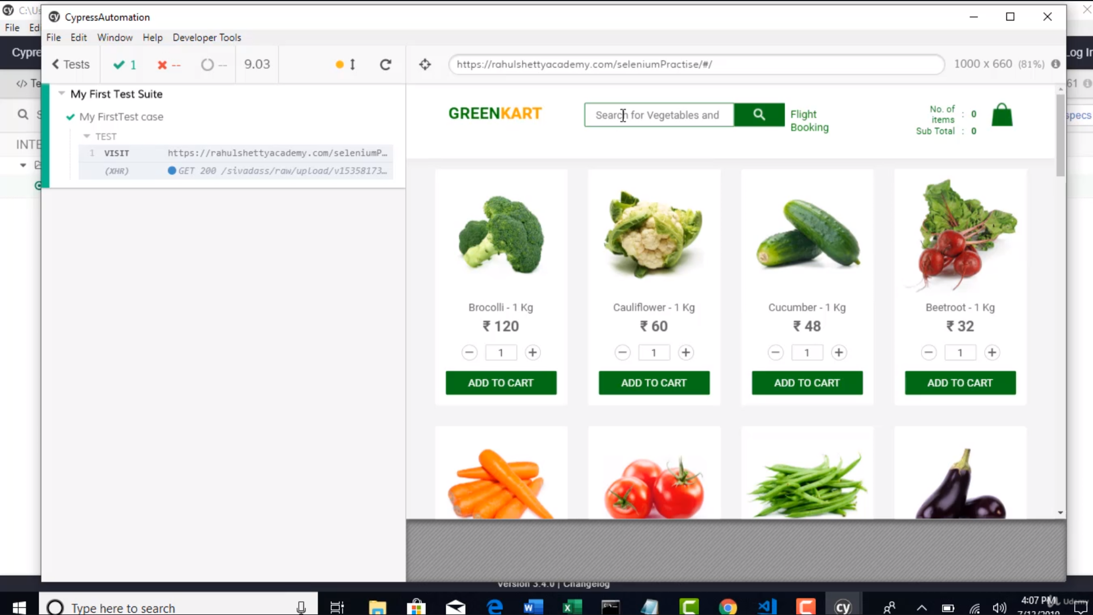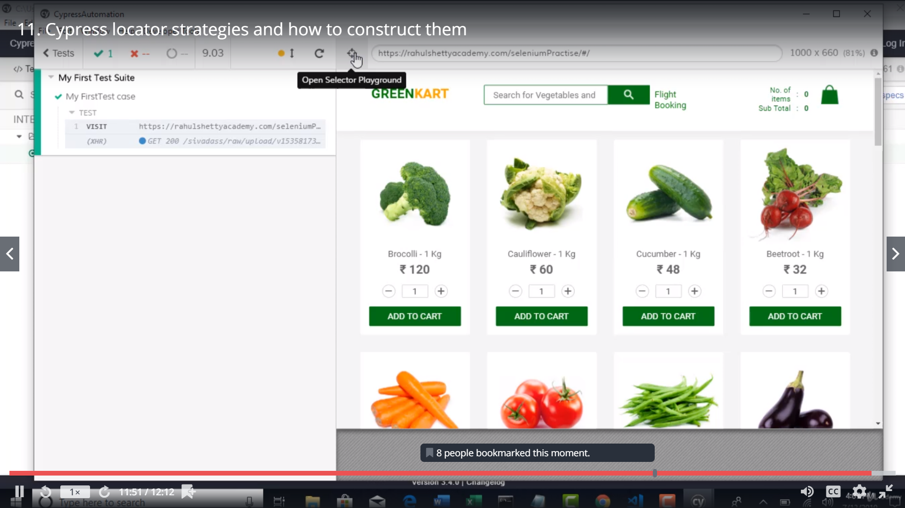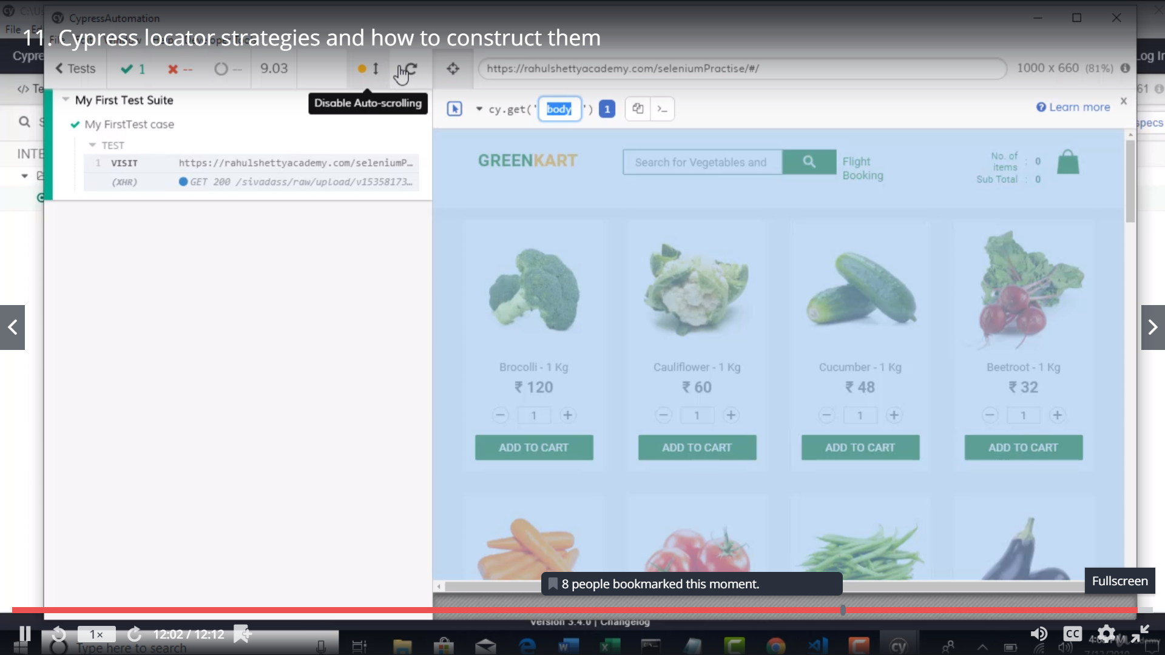

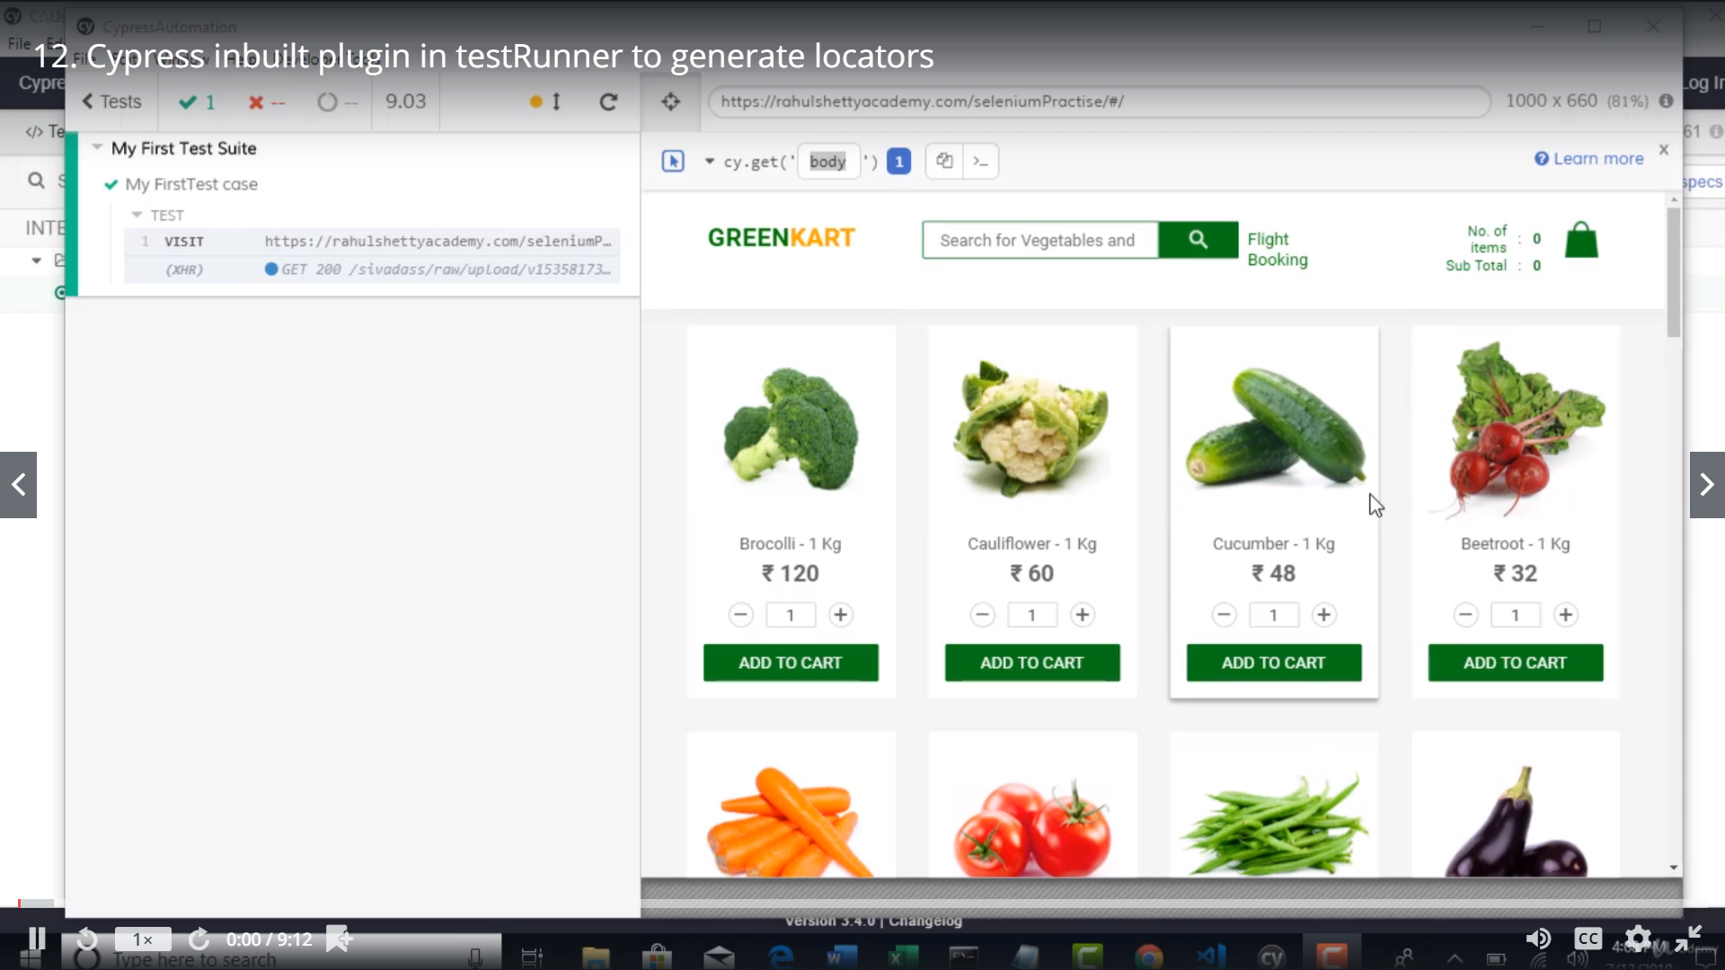

Automatically the css is given in open strategy locator when u mouse over an element

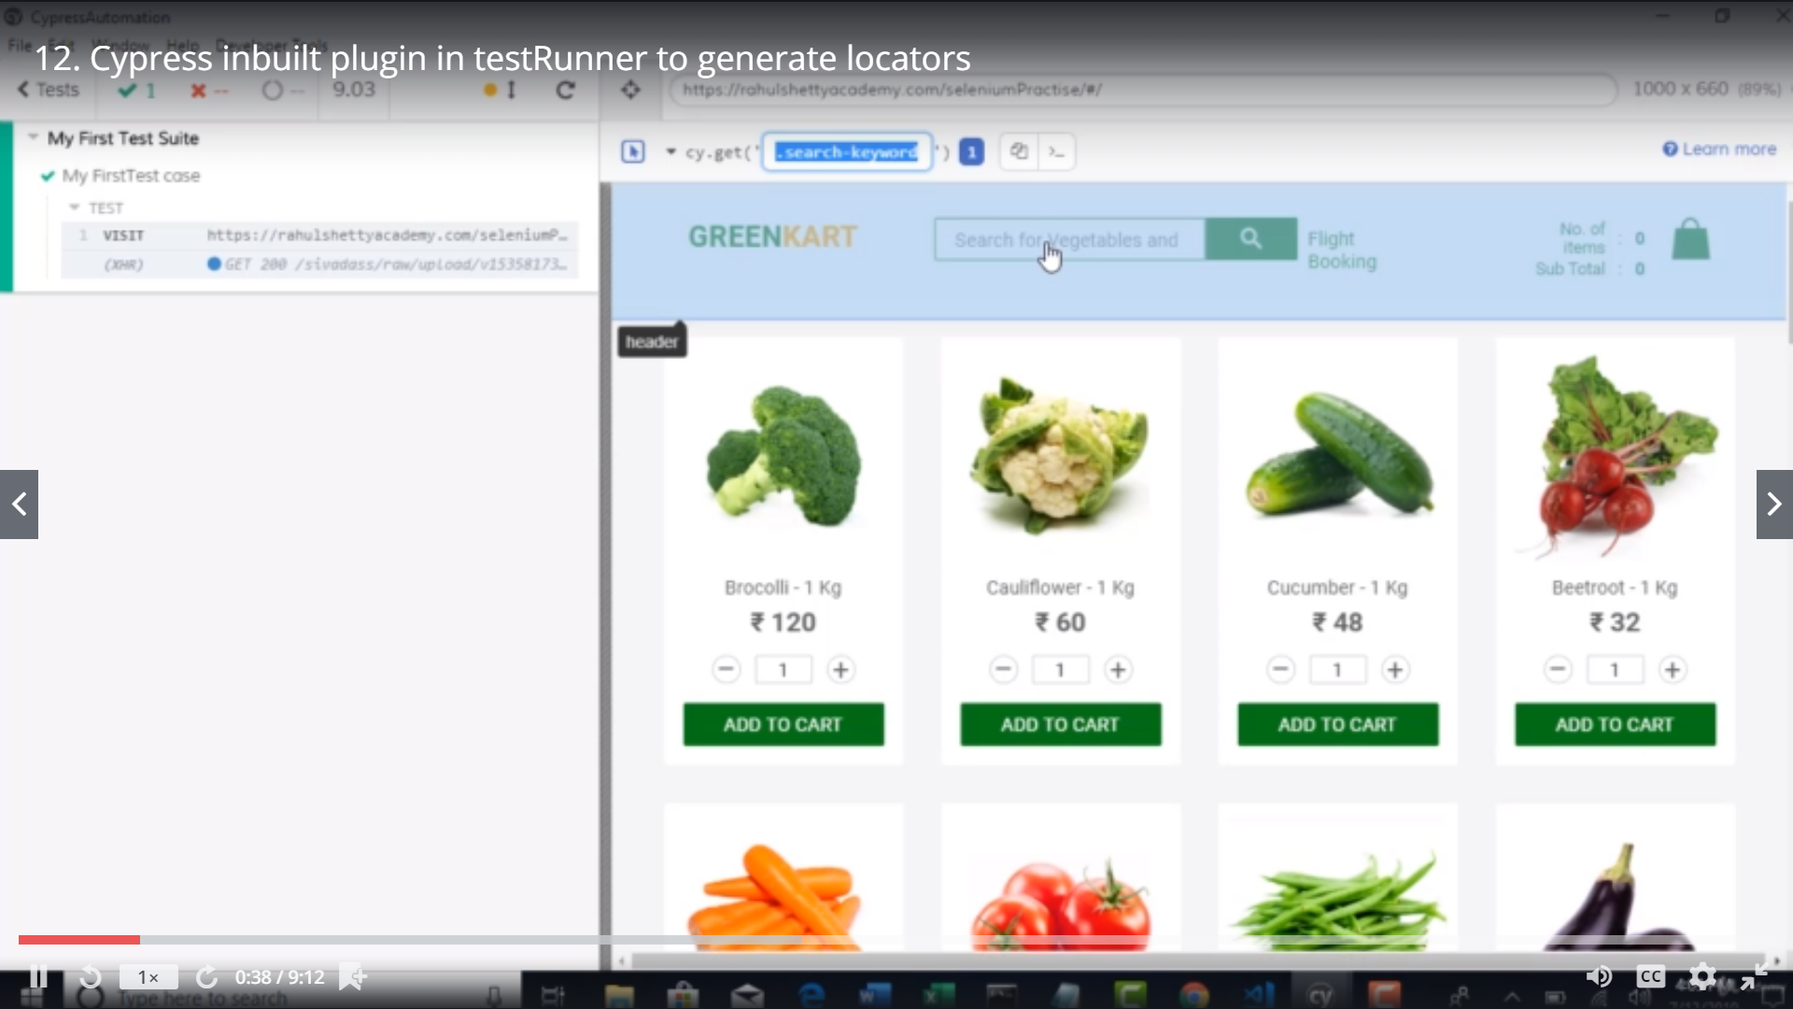

Lets start writing tests

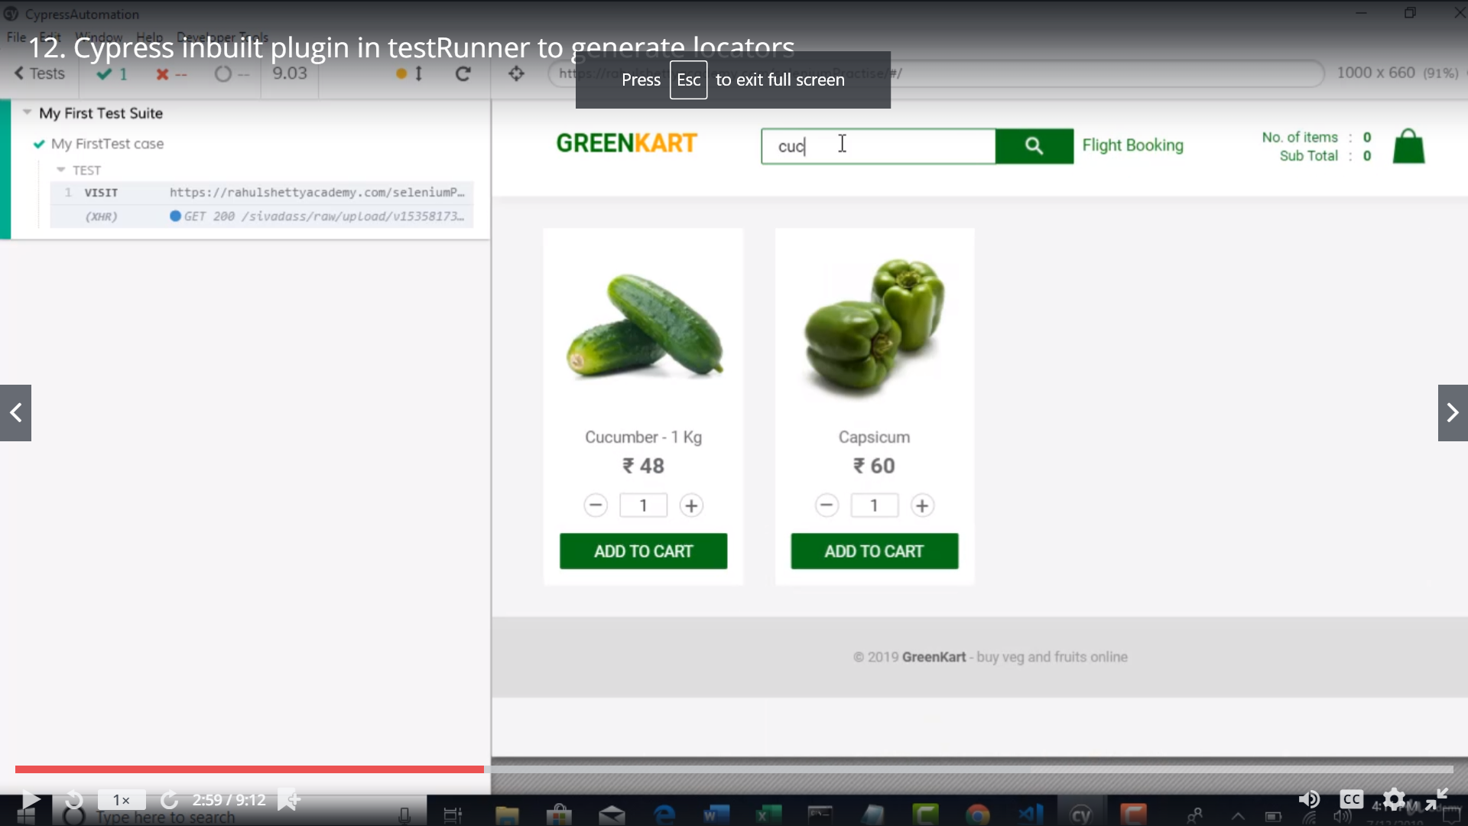

In Testrunner itself u can use the application lke how u use it in a browser

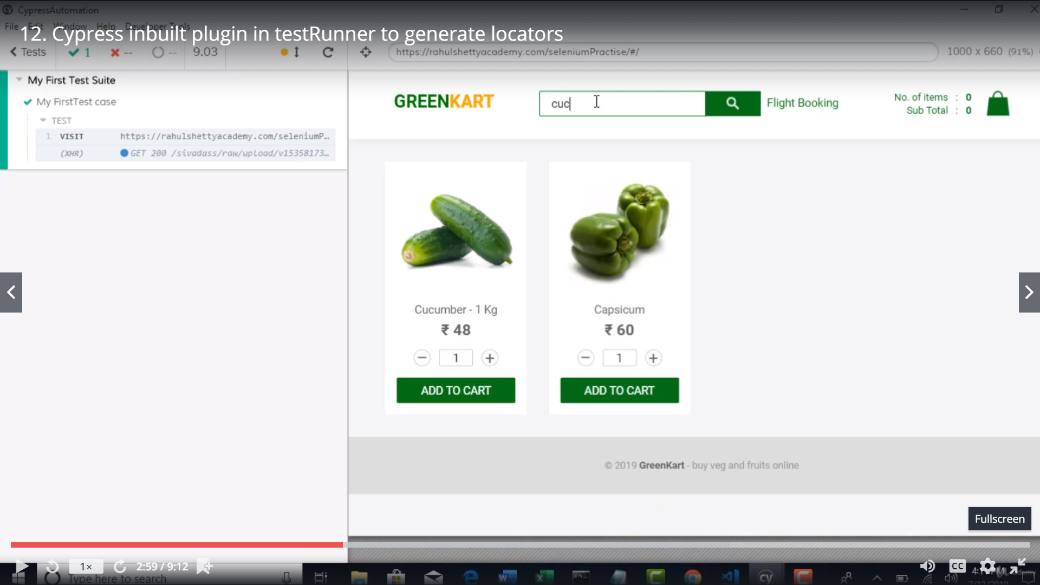

How to get autosuggestions in vs code for cypress

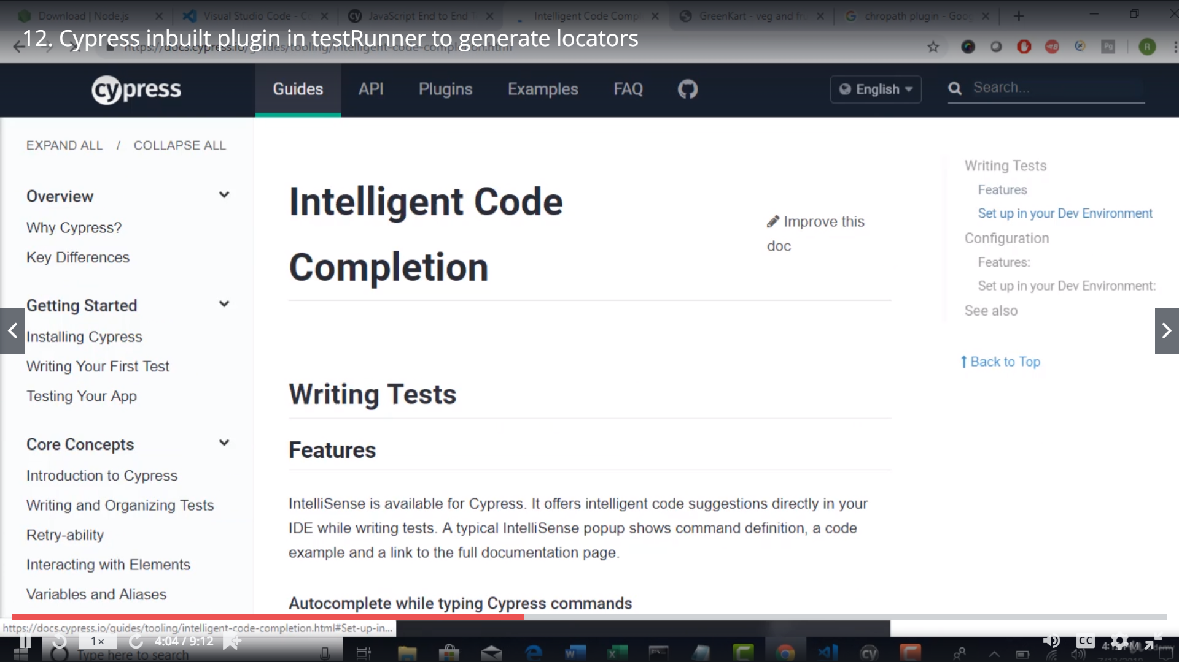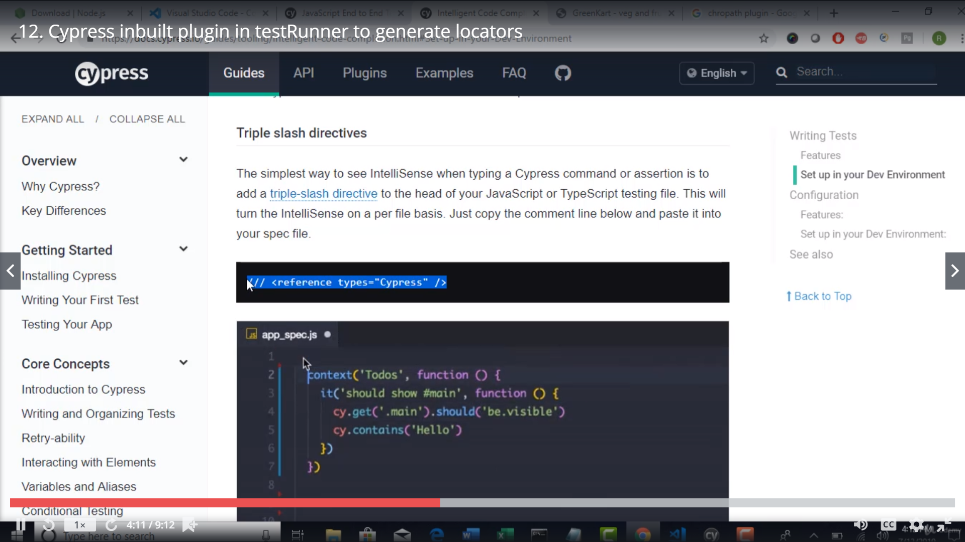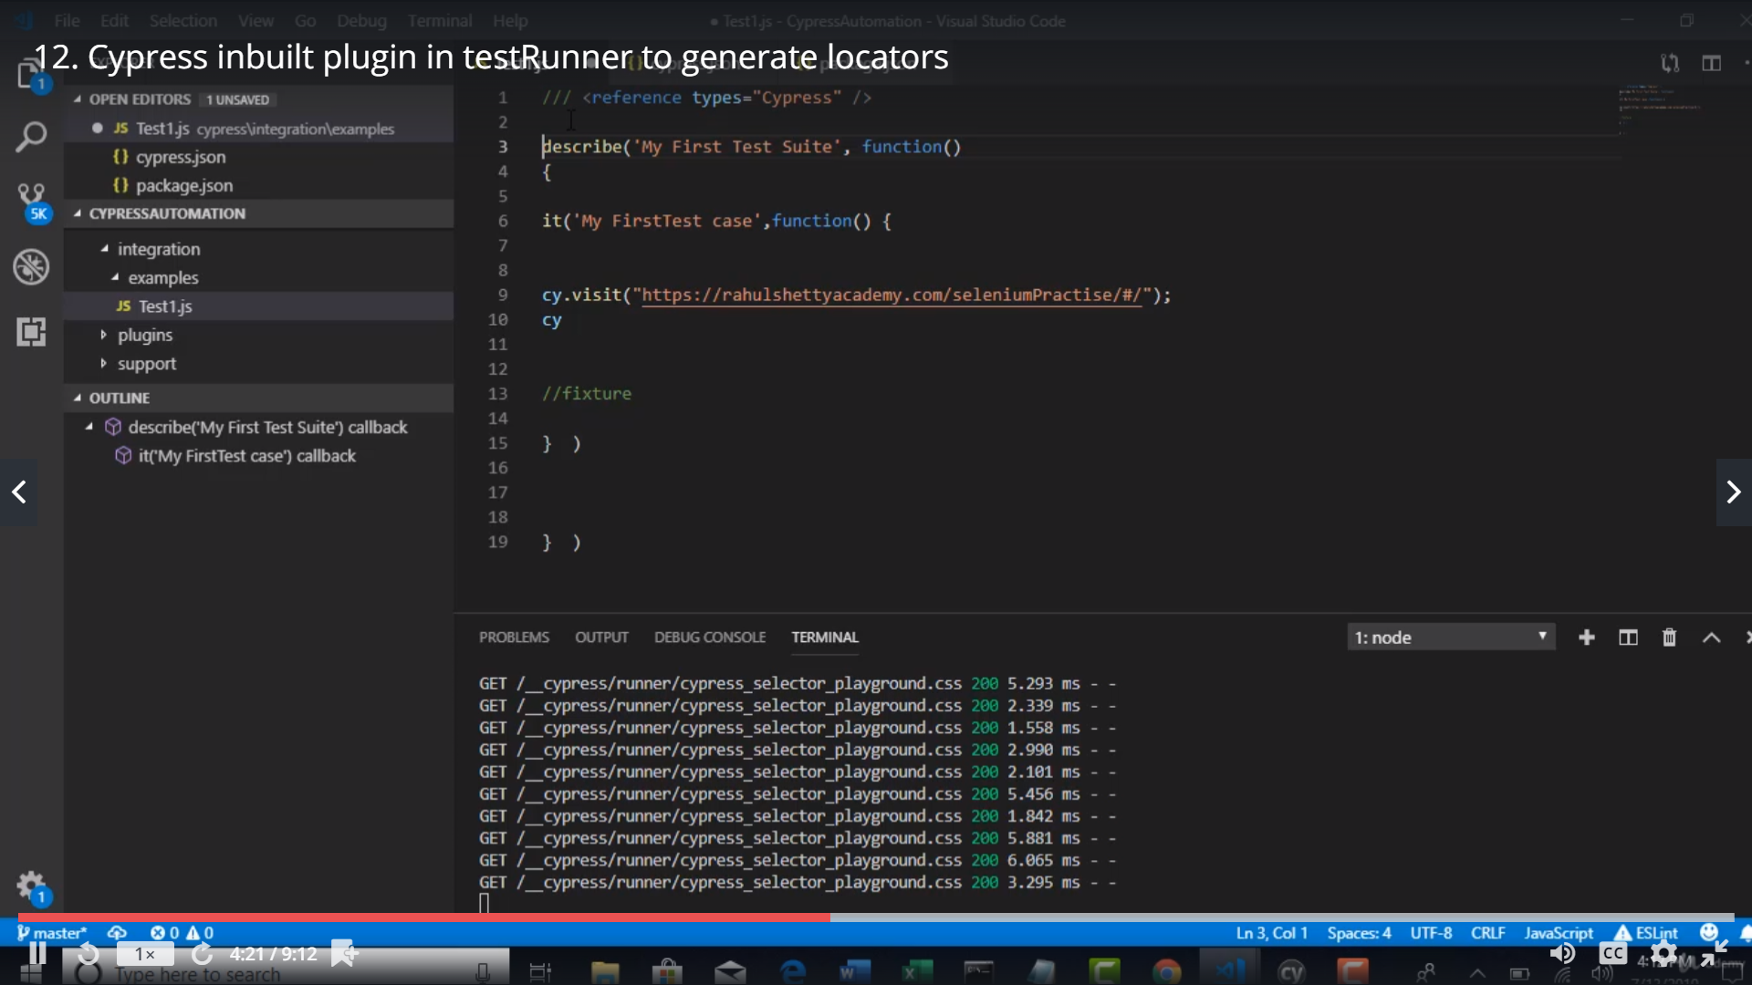

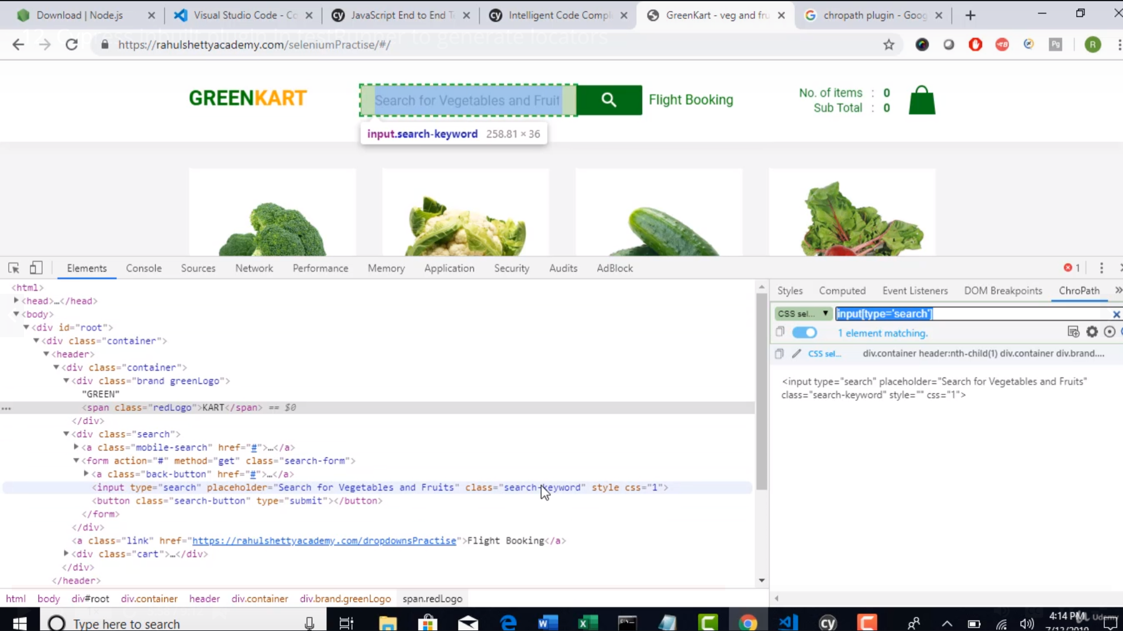

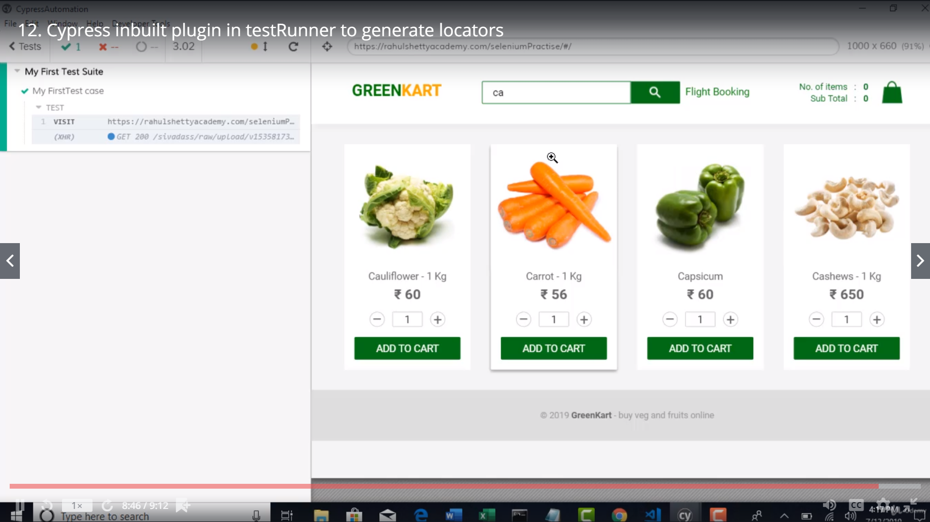

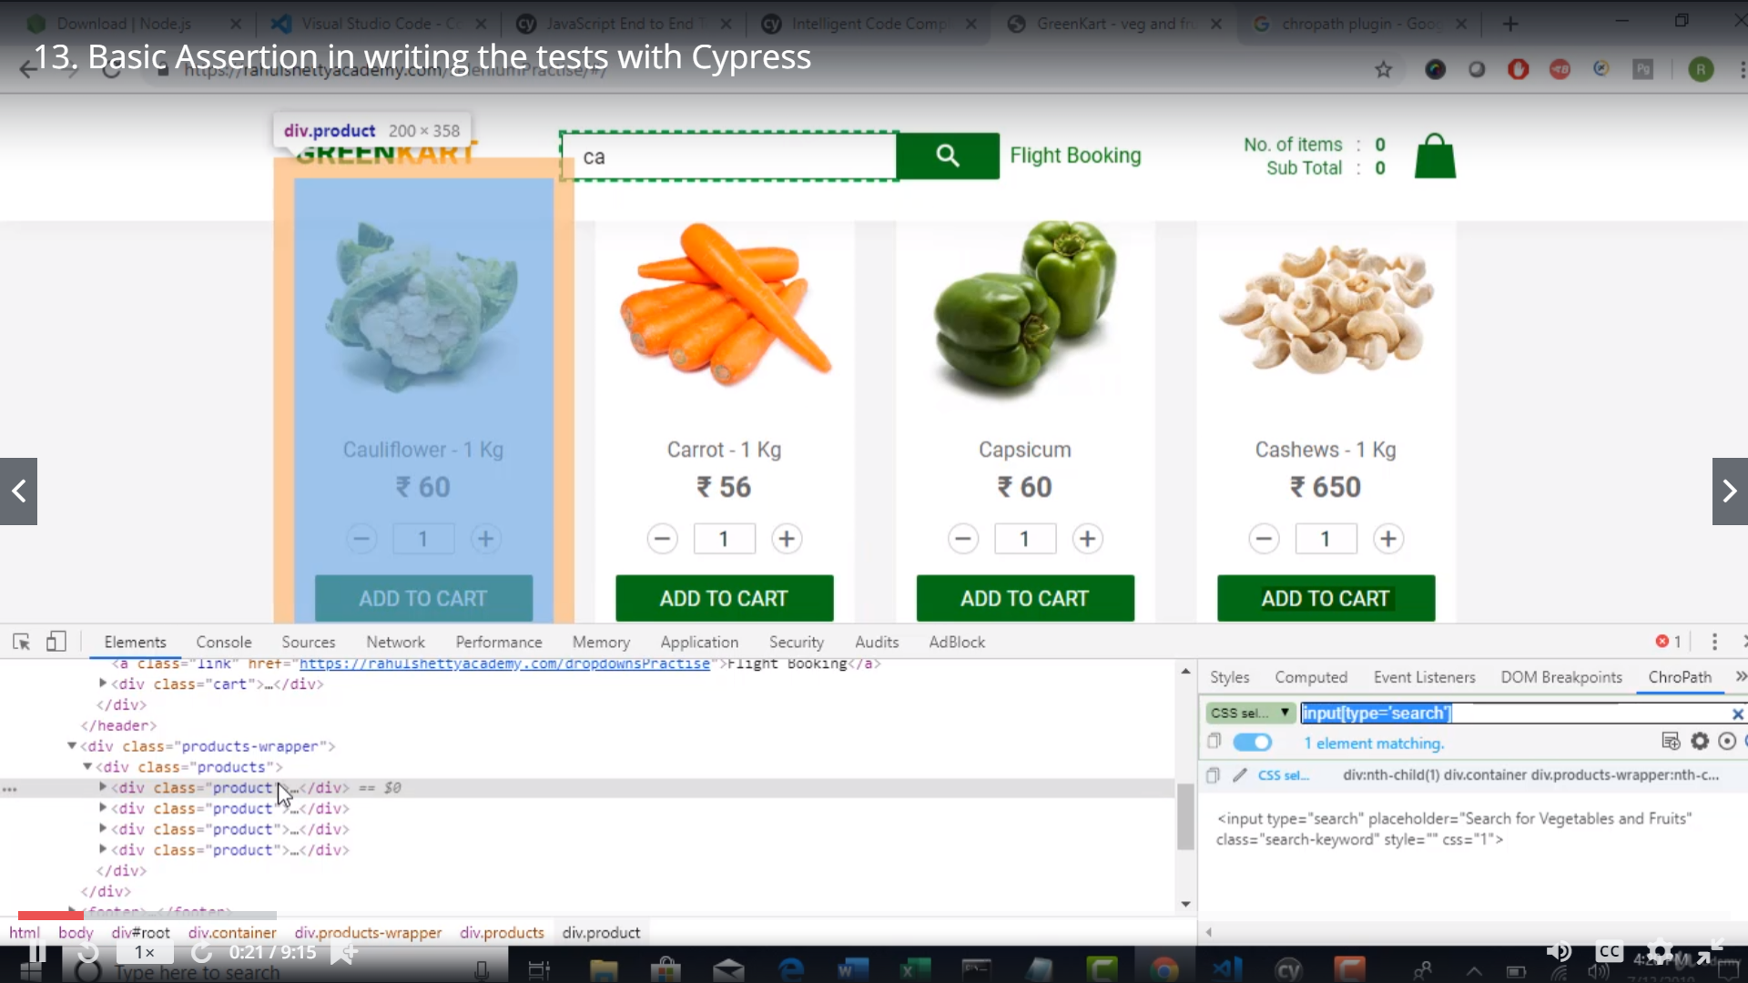

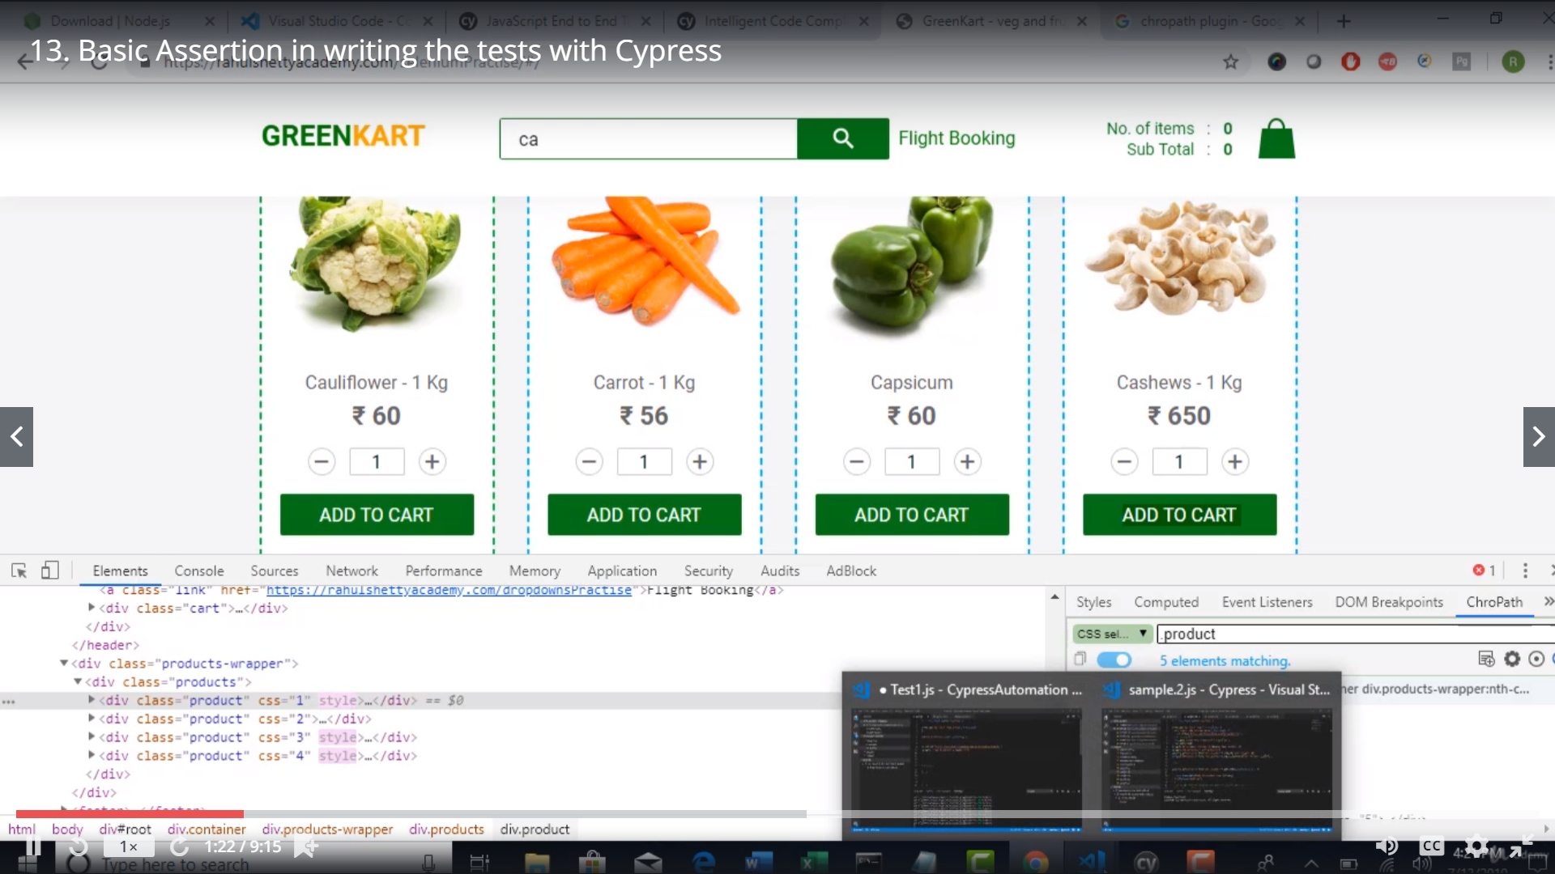

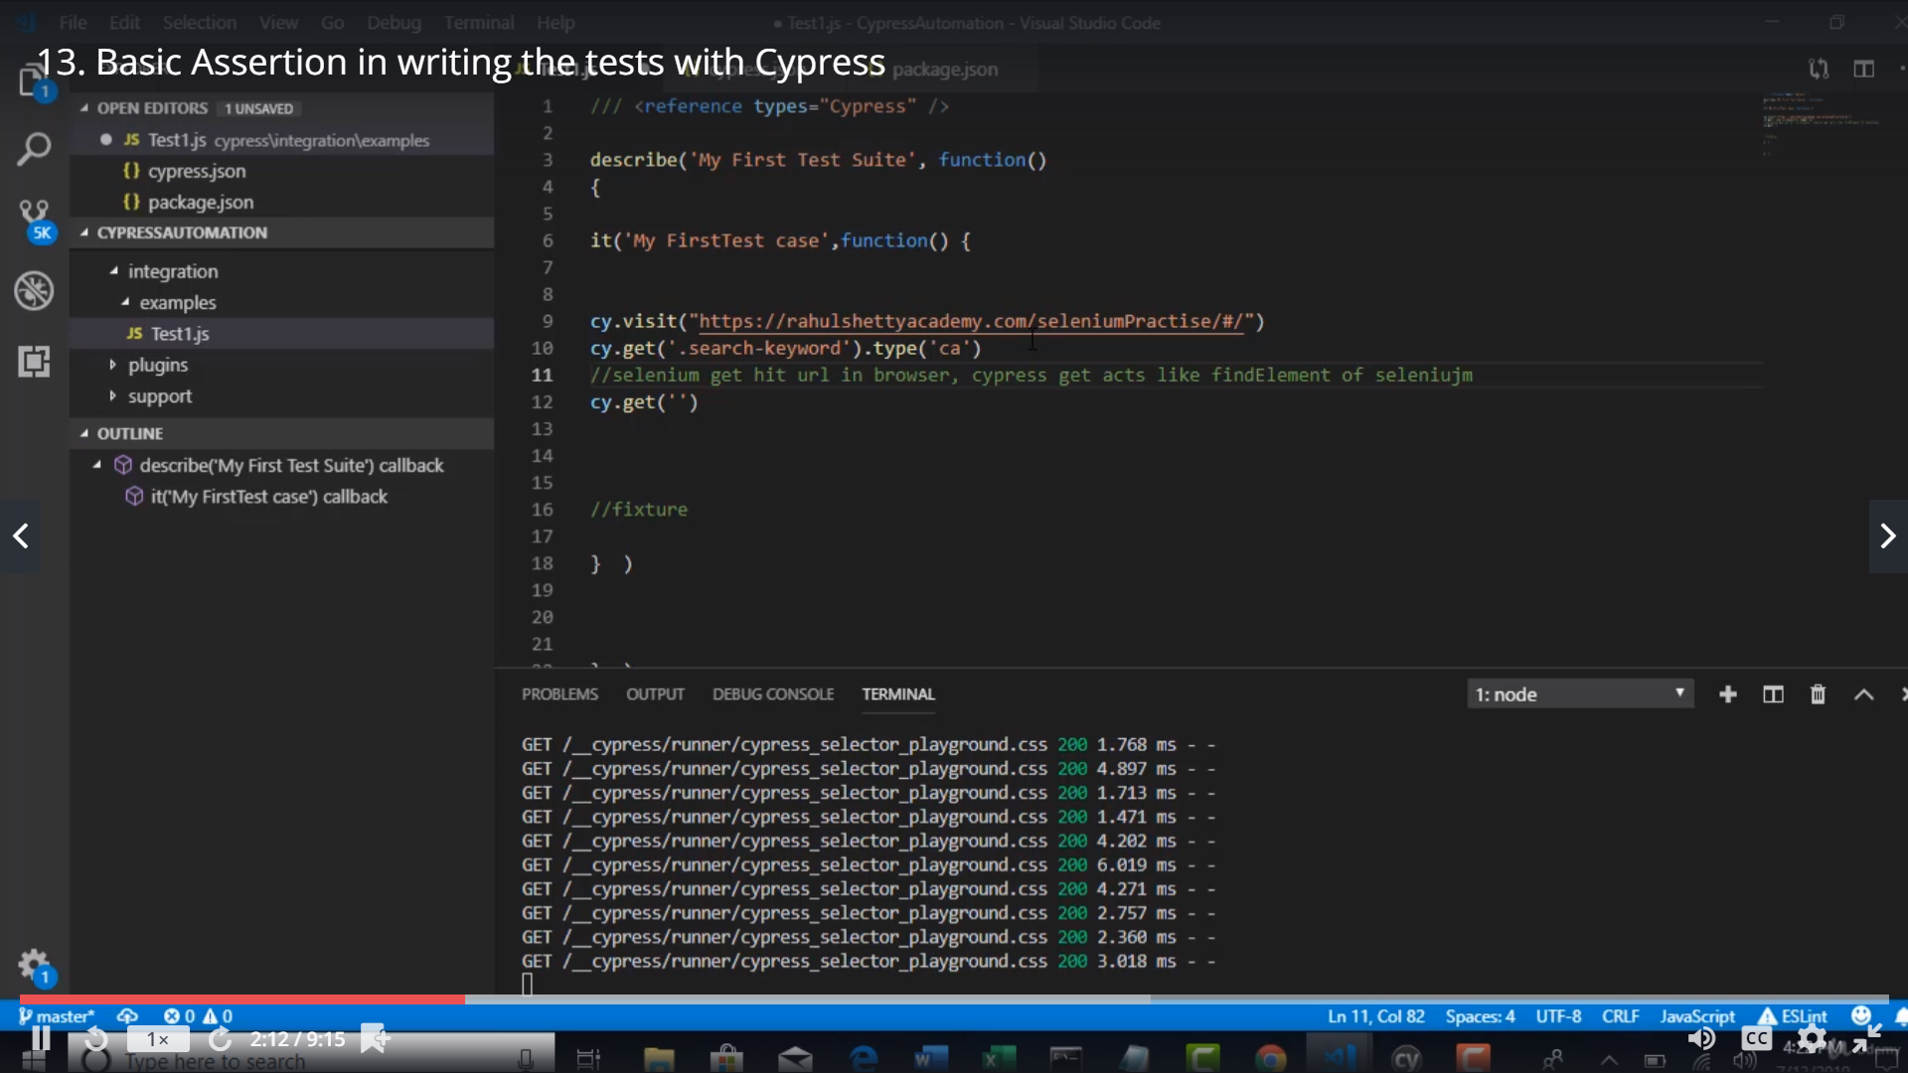

Assert with chai that there are 4 products for the given step

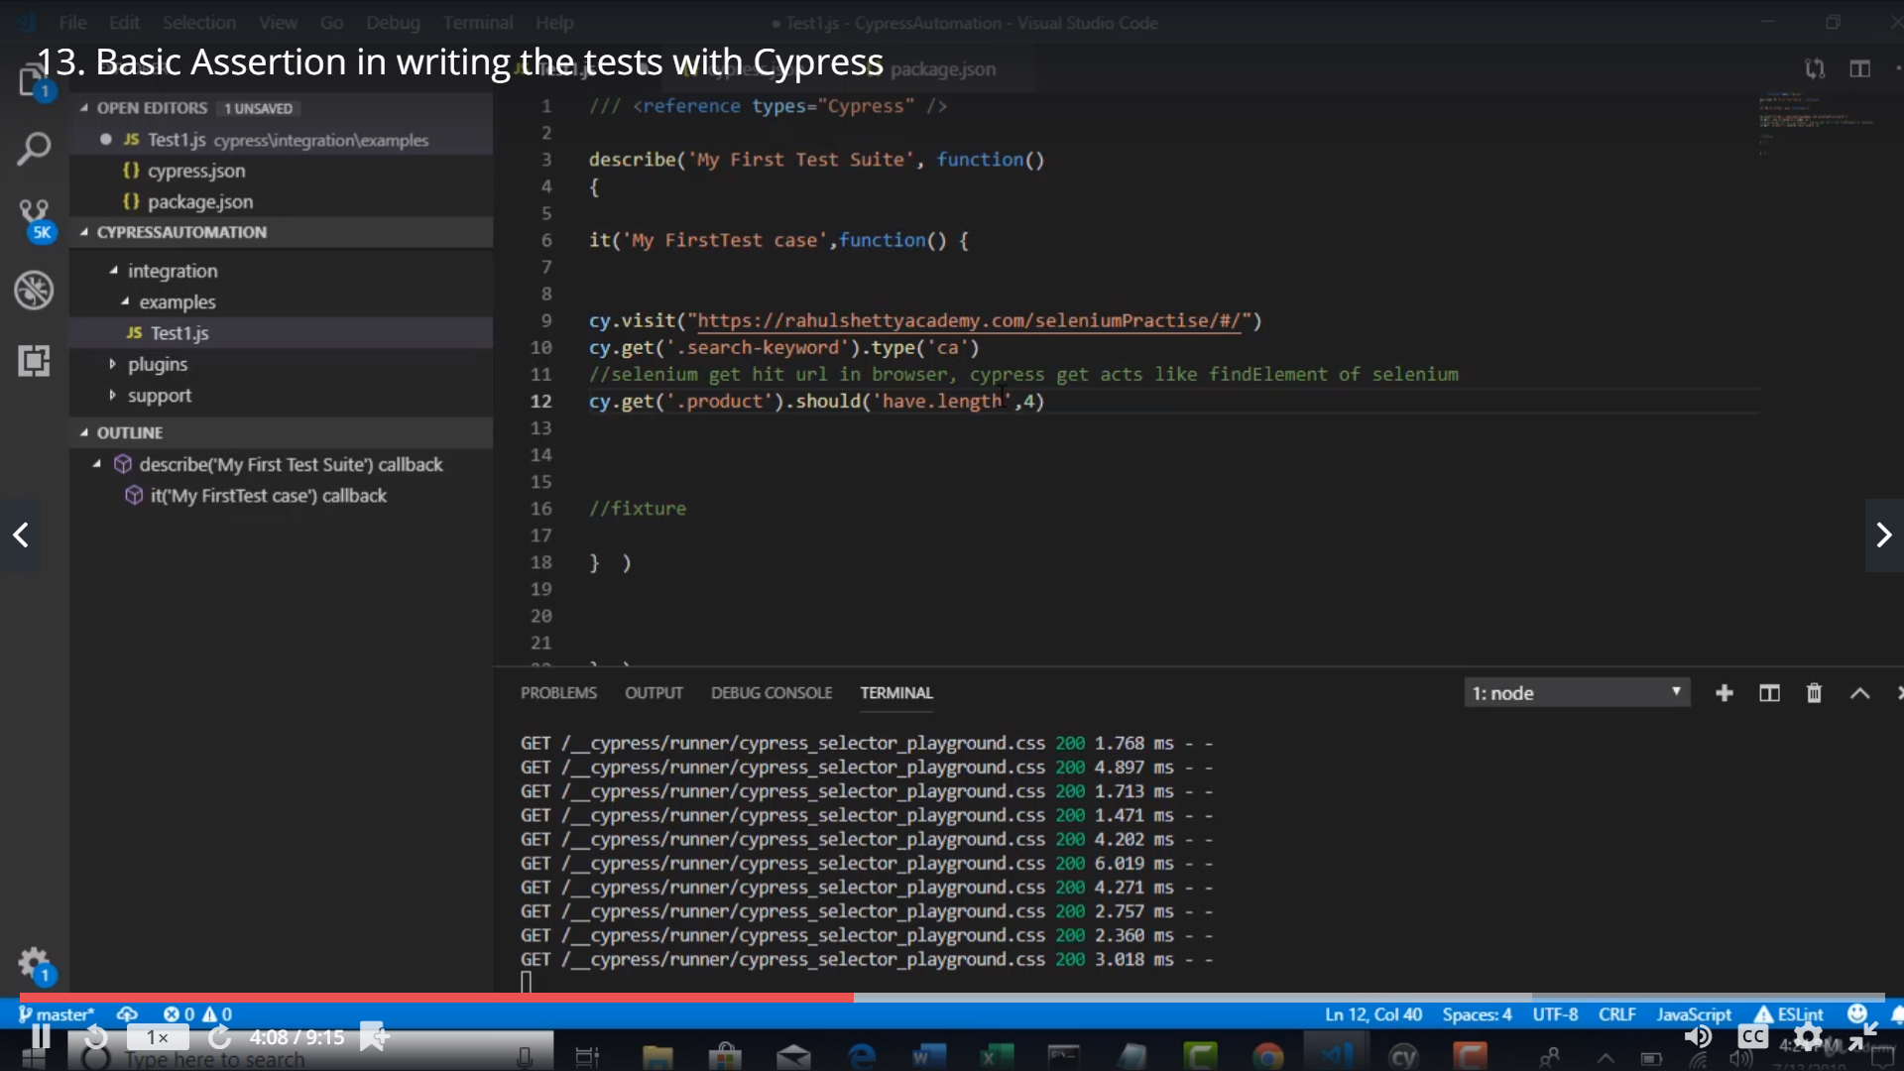

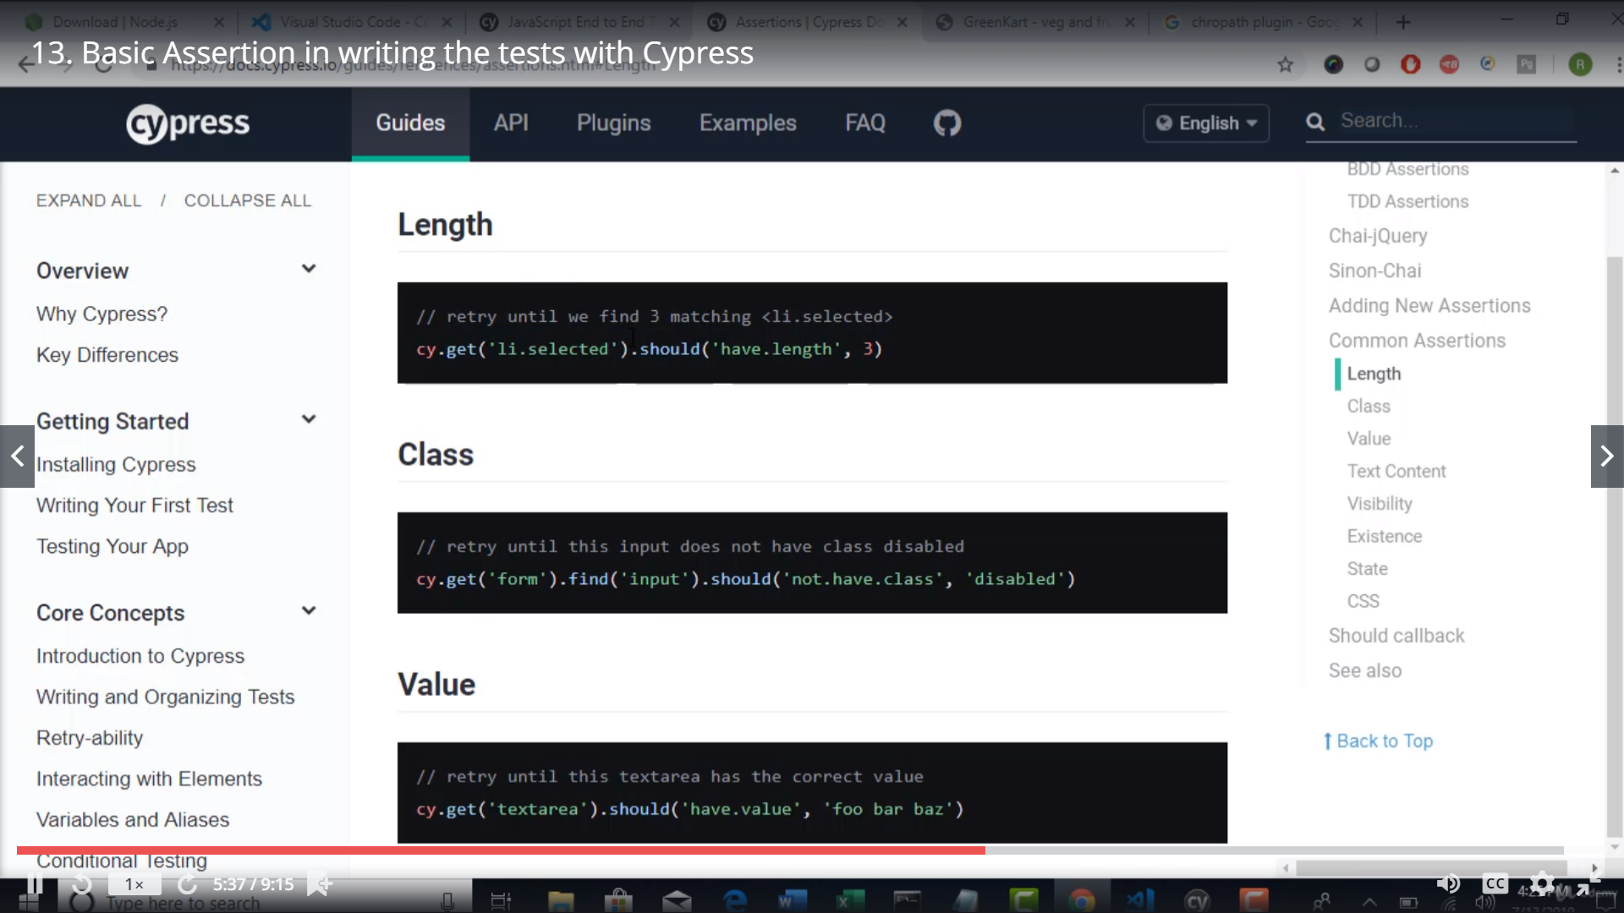

How to use wait

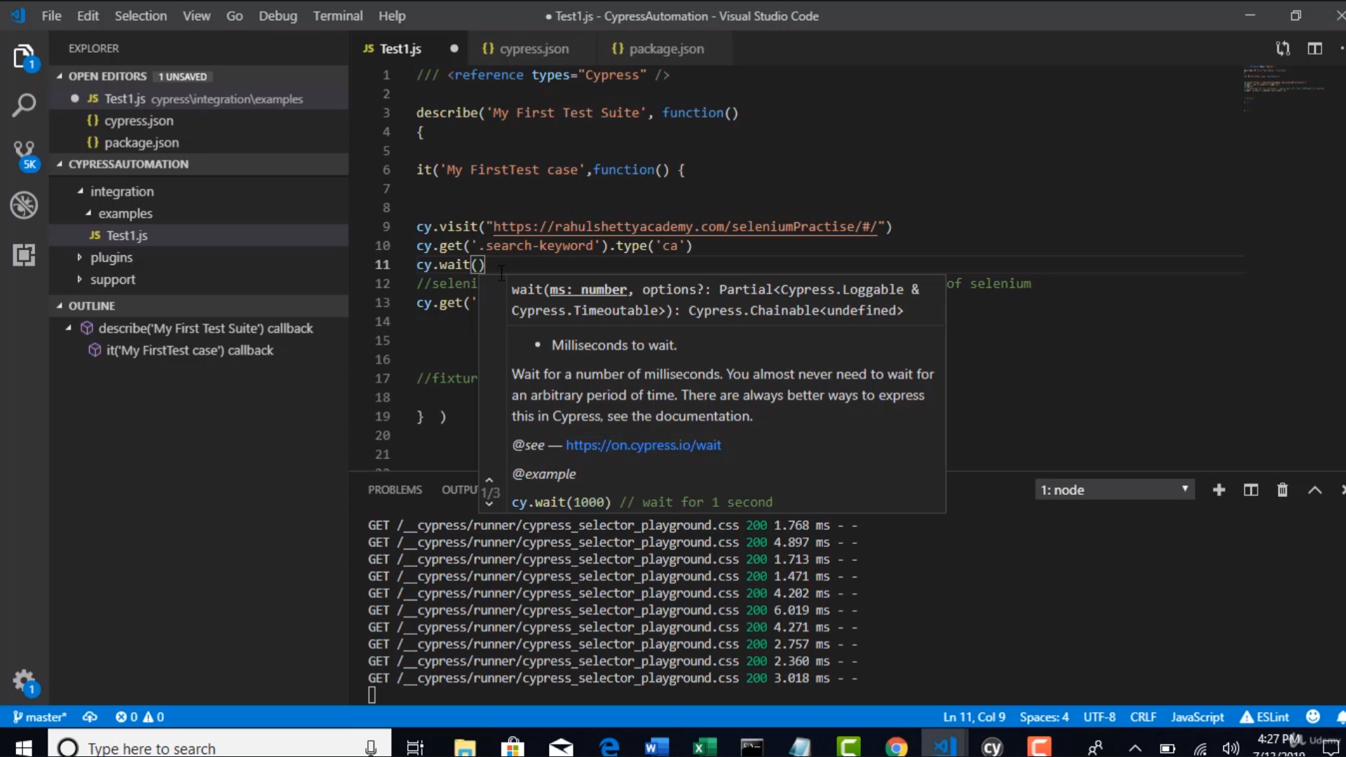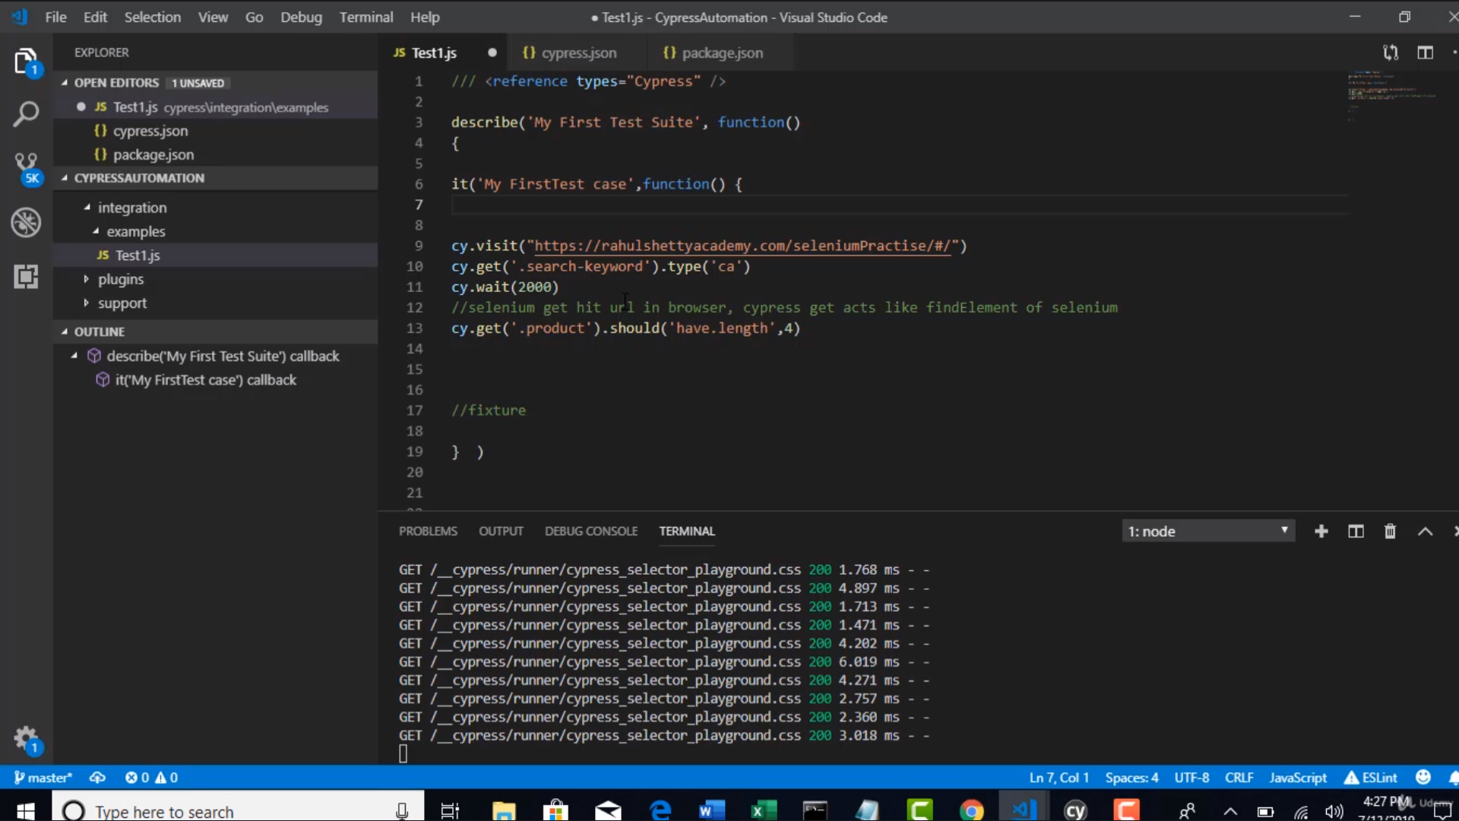

Wait is ||| to thread.sleep

If you have the test open in test runner and then in Vs Code if u r saving ur changes… the test will automatically run for u..

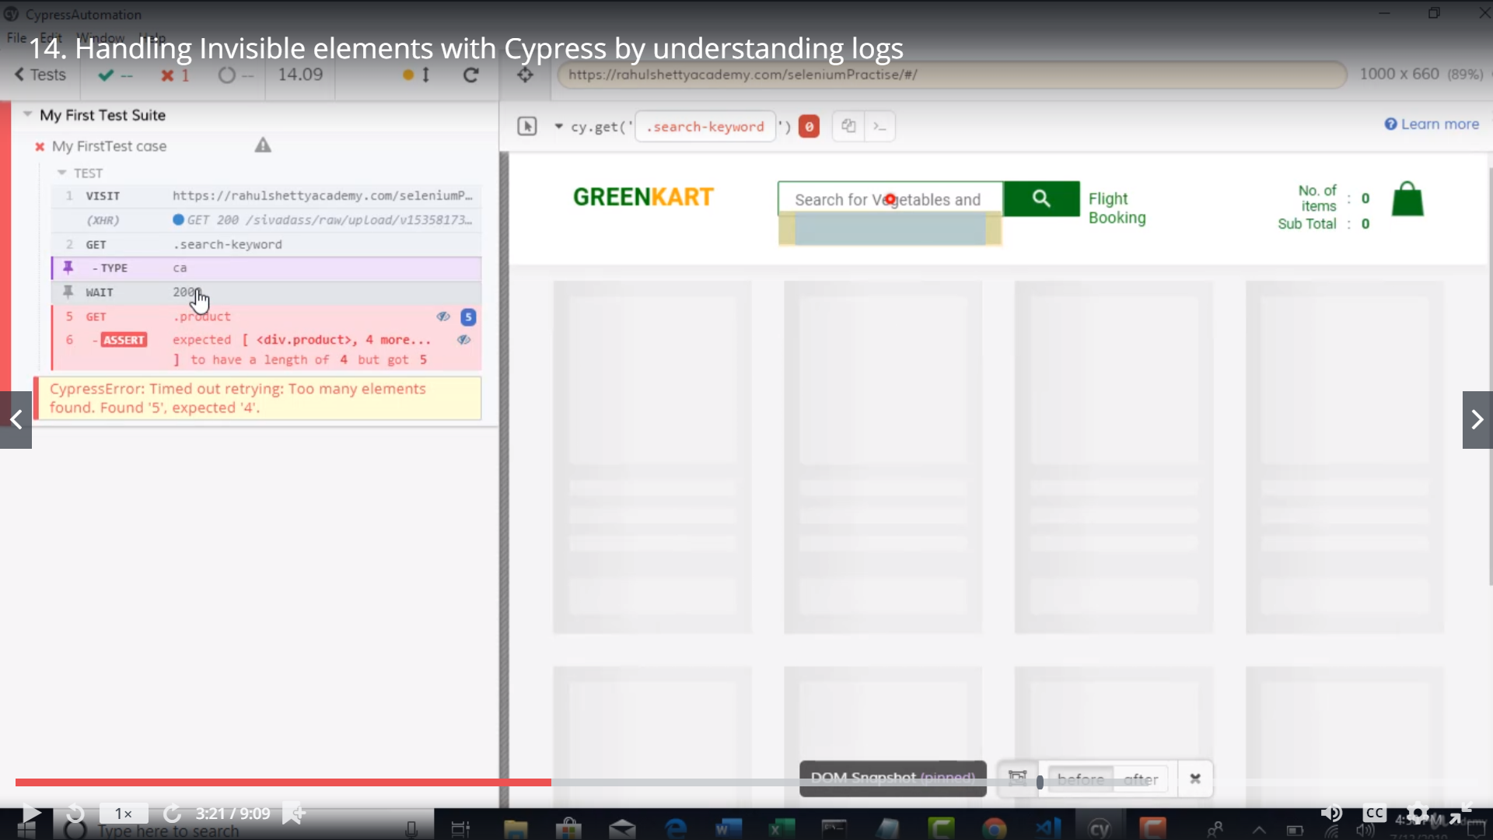

U need to click on the left log and click each comment so u can see what happened at each step

Also at each step u can see before/after – where u can see what happened b4 and After the step executed

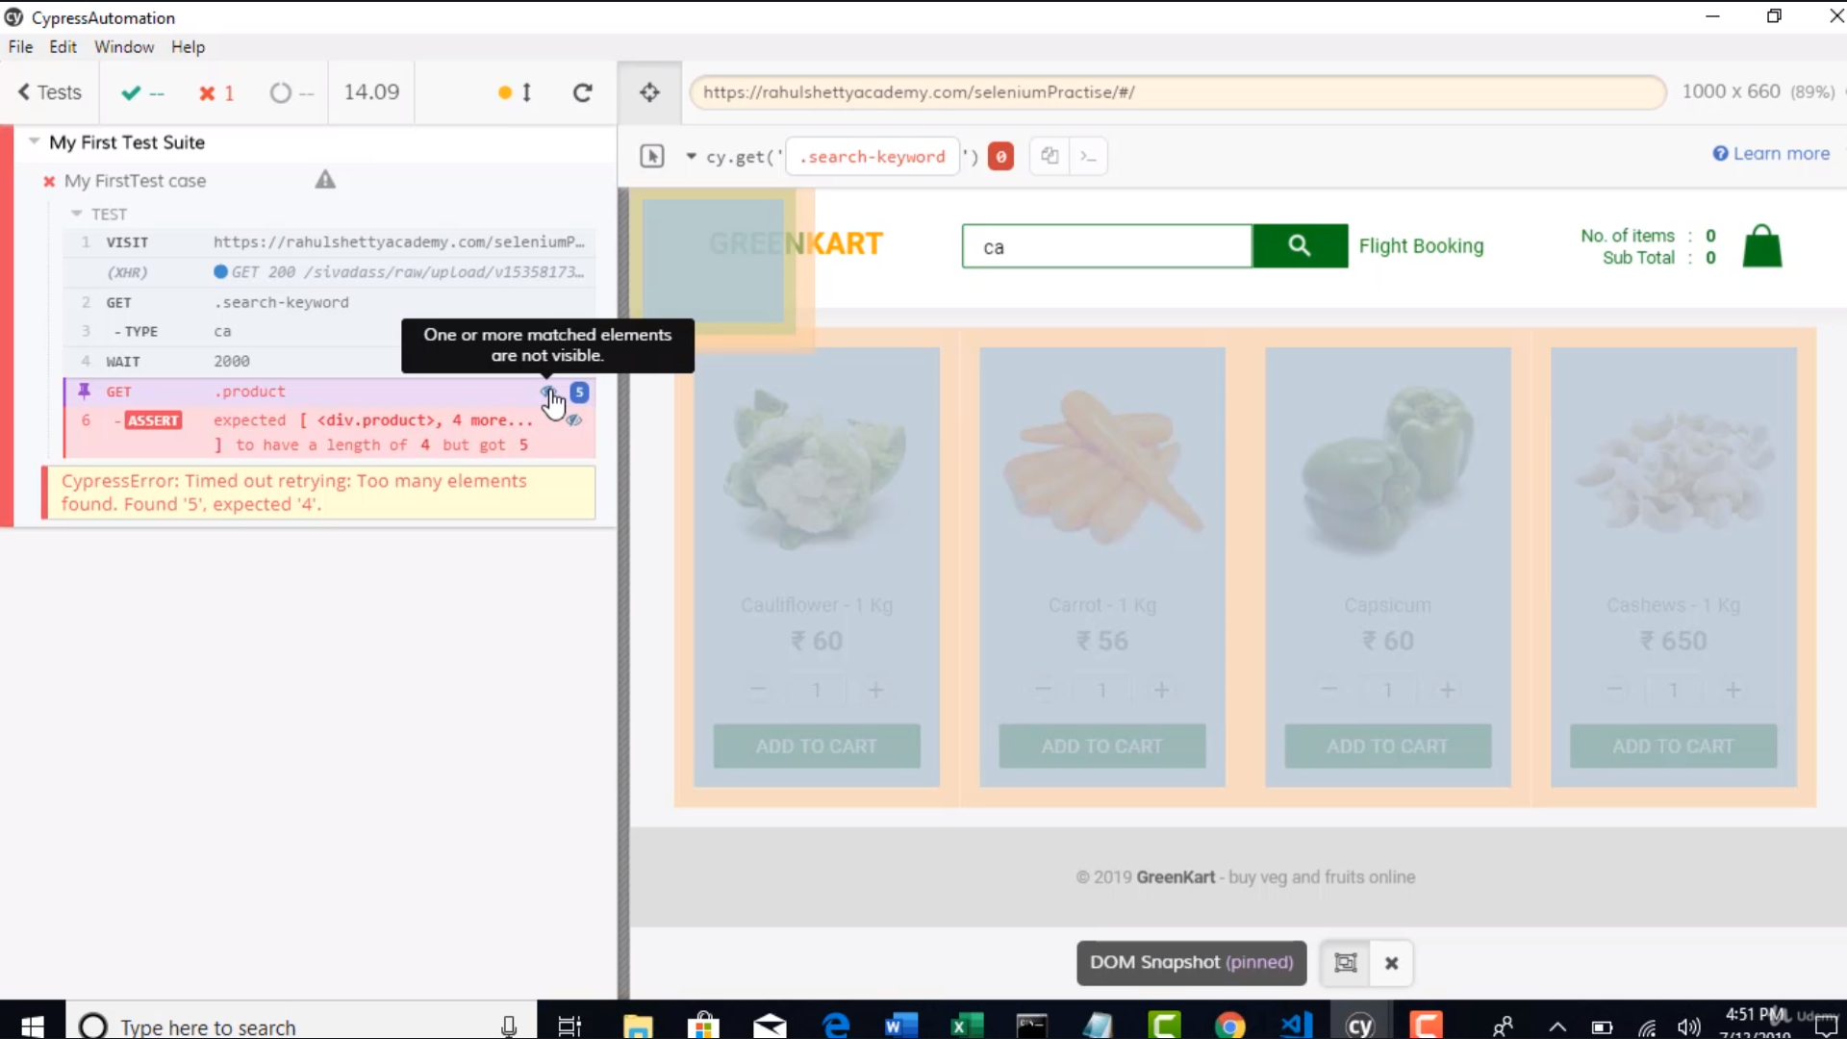

The above issue was since one of the products was not visible

Cypress also depends on jquery

So to avoid it we use visible – property

Cy.get(‘.product:visible’).

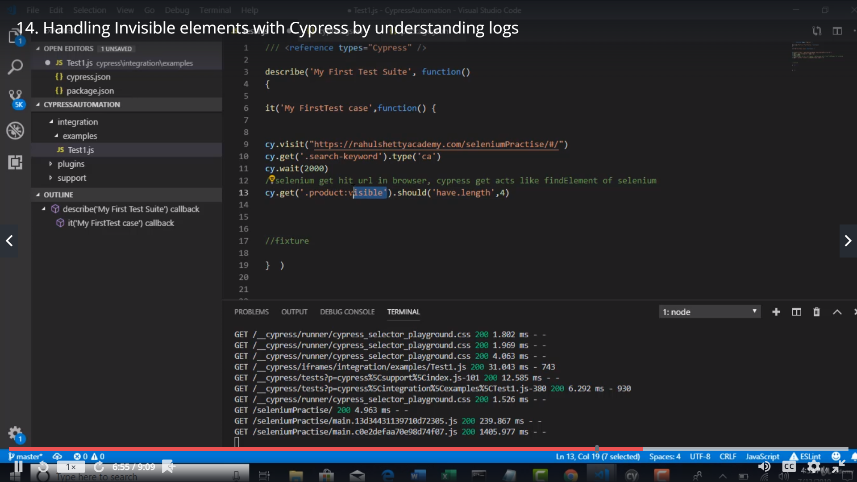

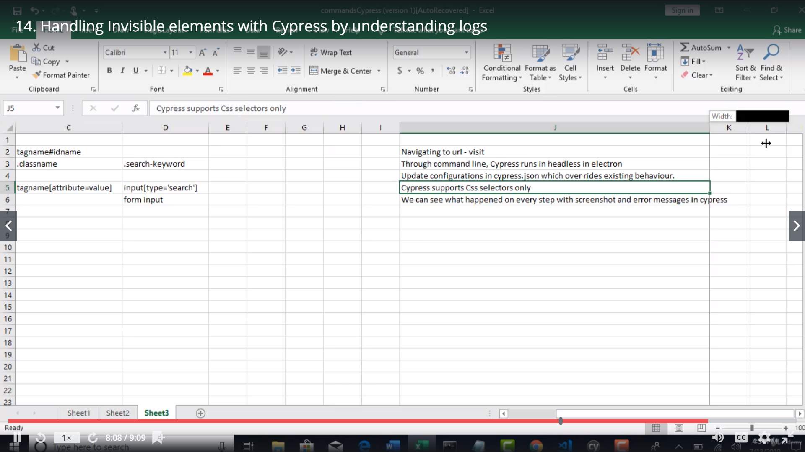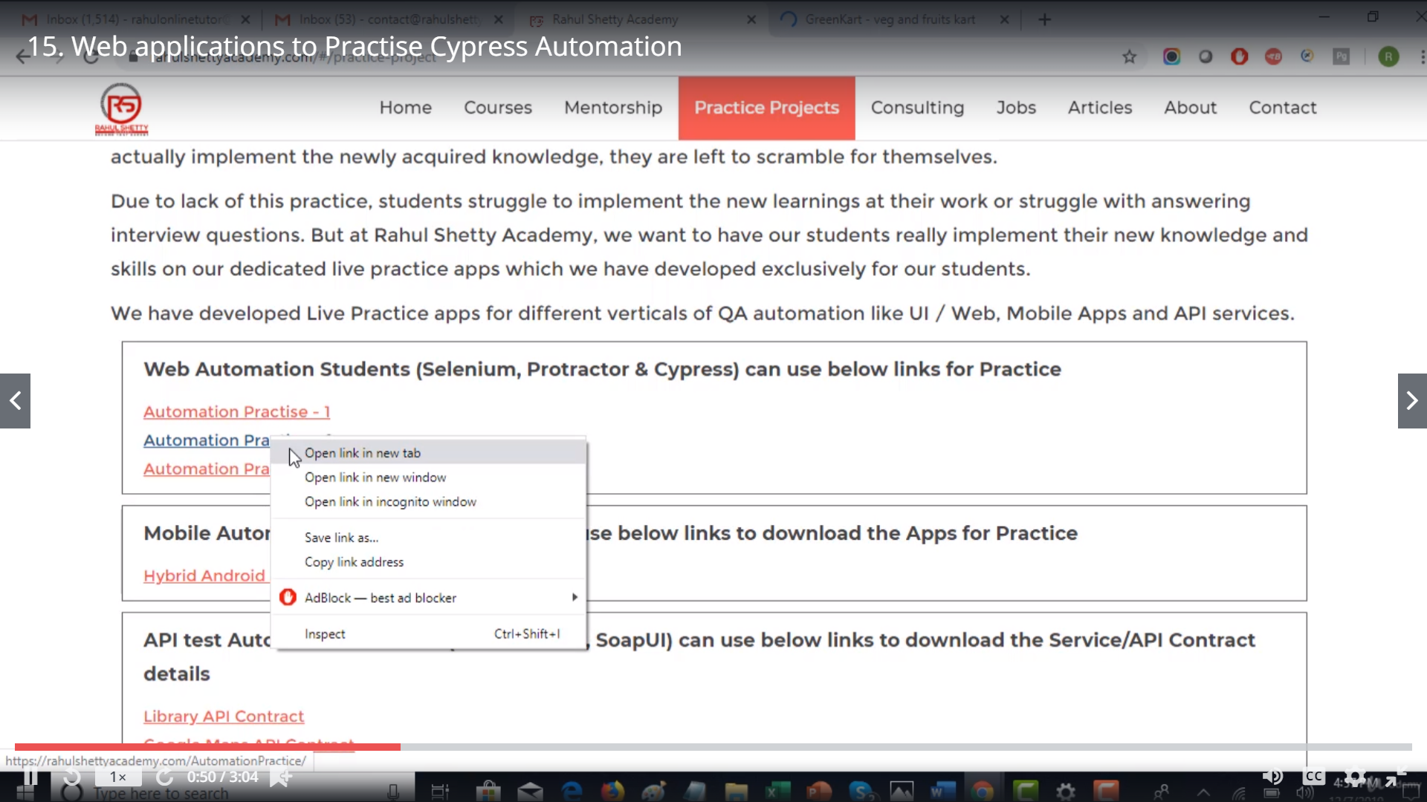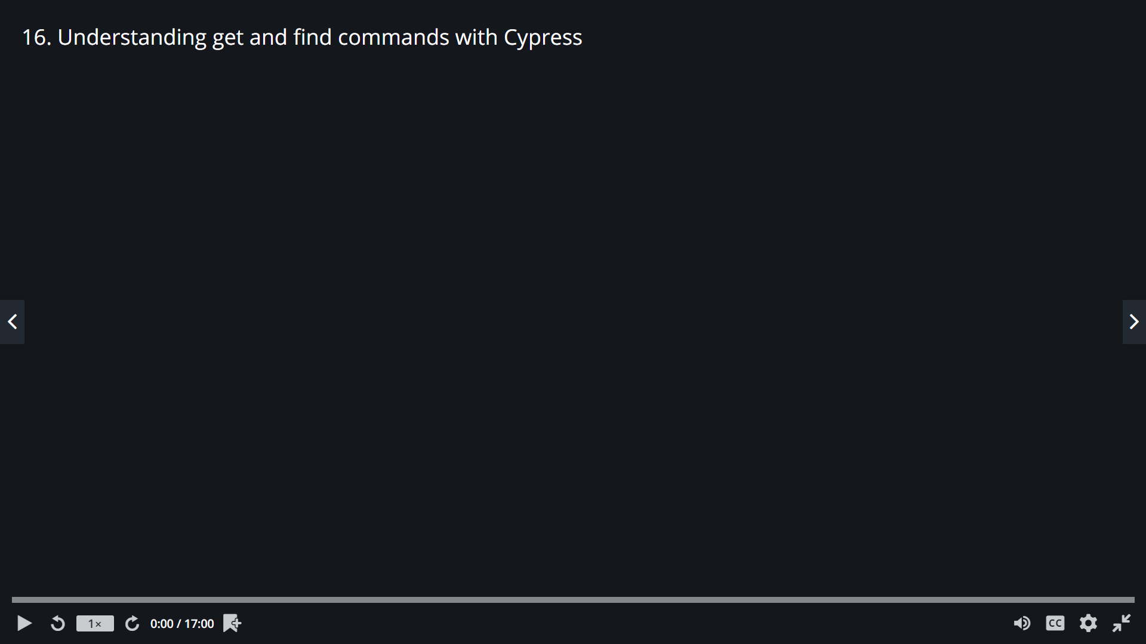

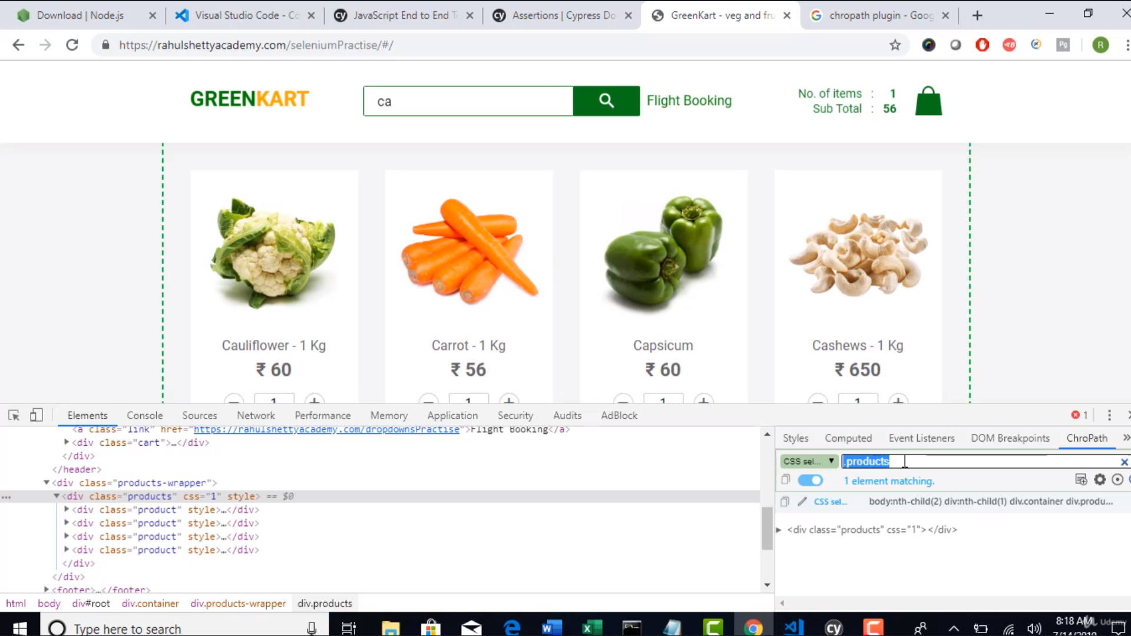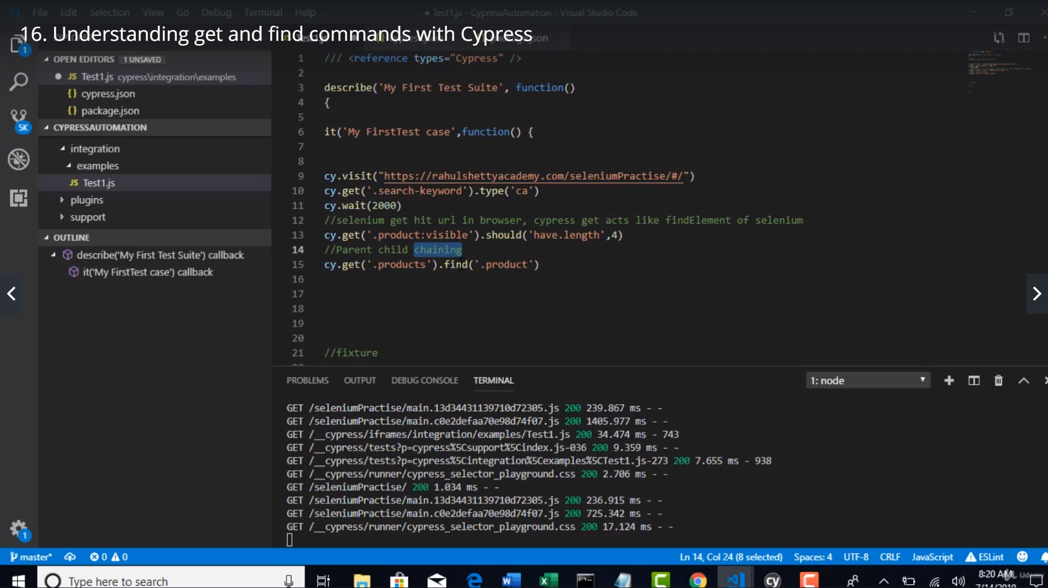

Get – will get the parent

Find will get the child

Using both get & find is called parent child chaining

Note: u can use this when there are extra objects of the same identifier

Eq – index in a collection of objects

Contains – object with text

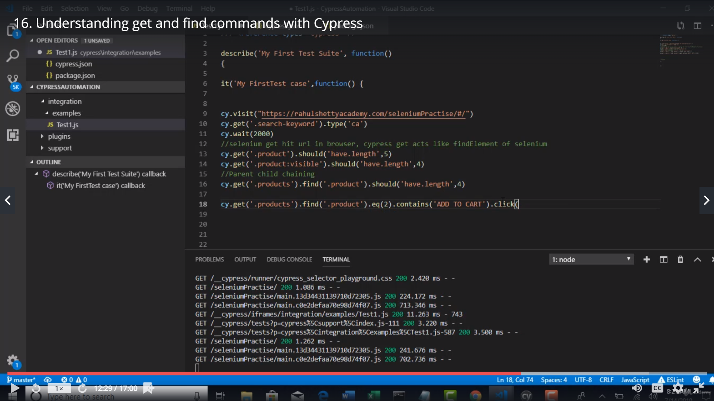

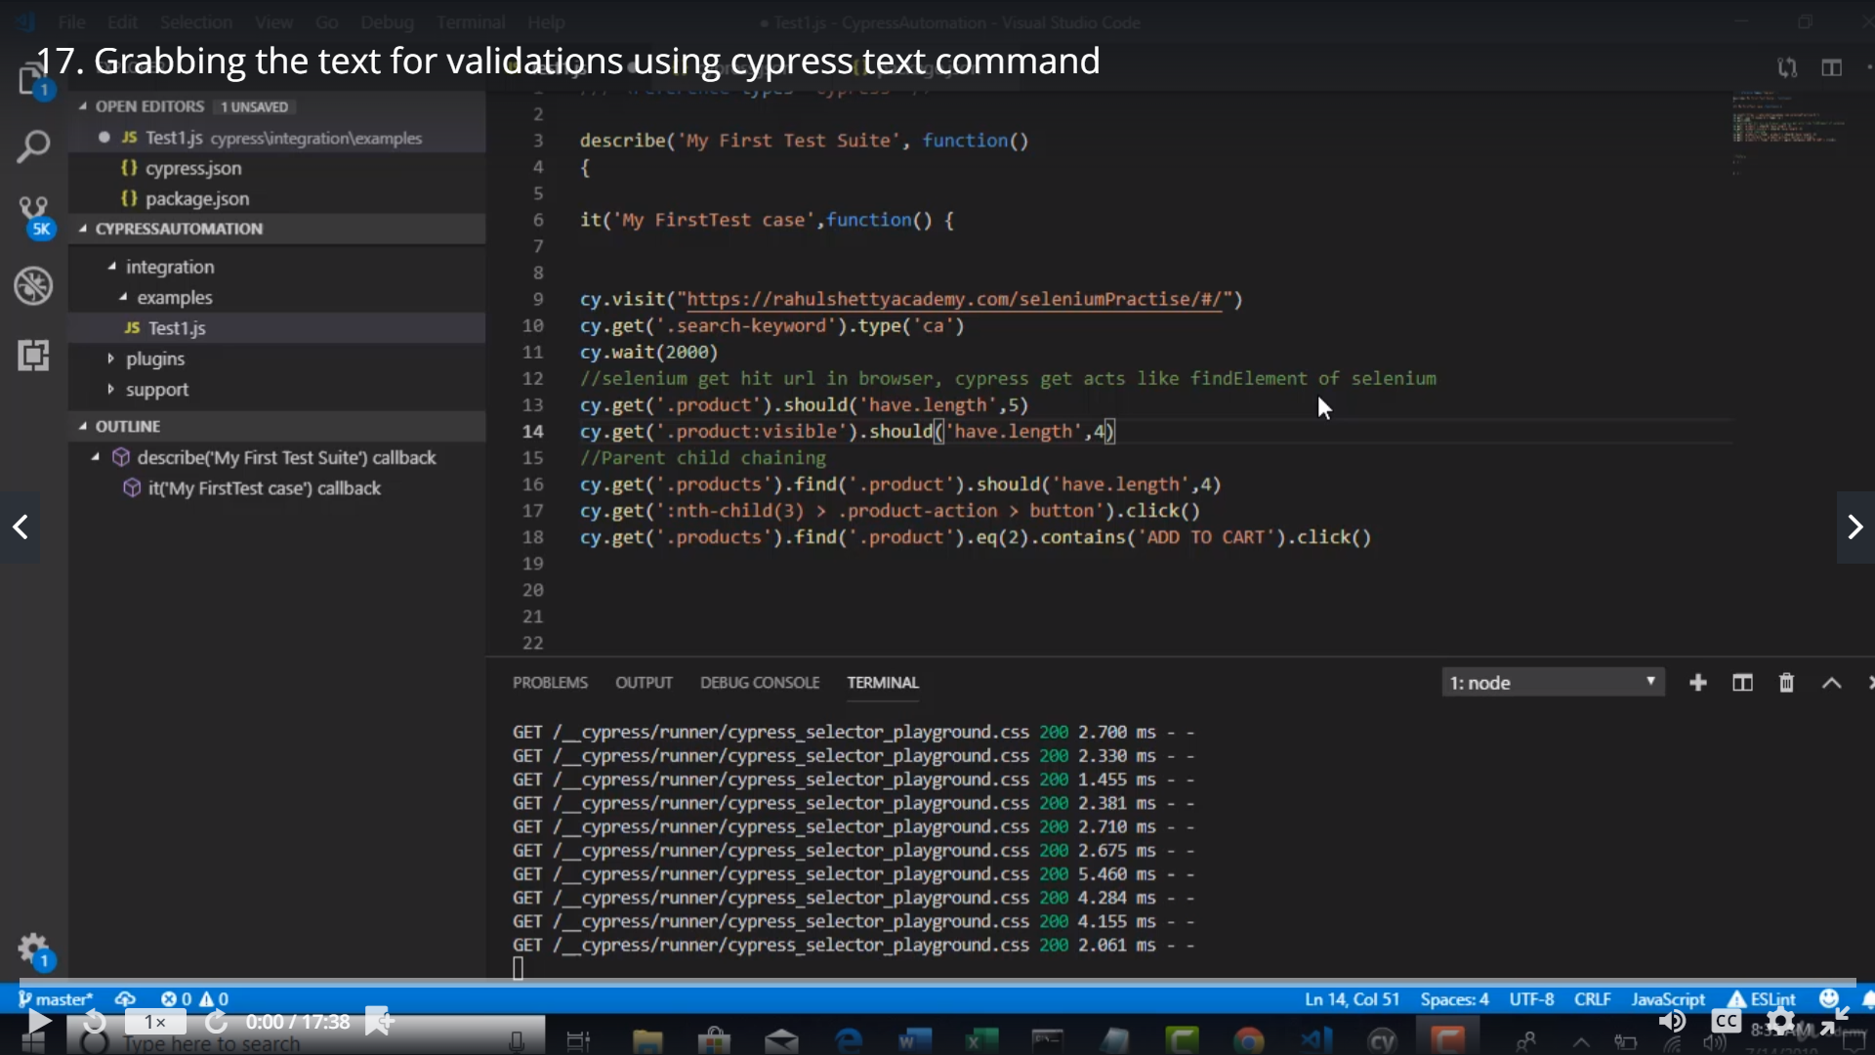

To itrate over an array

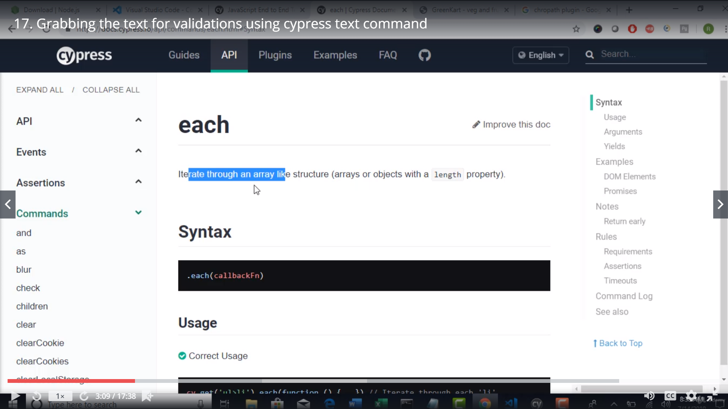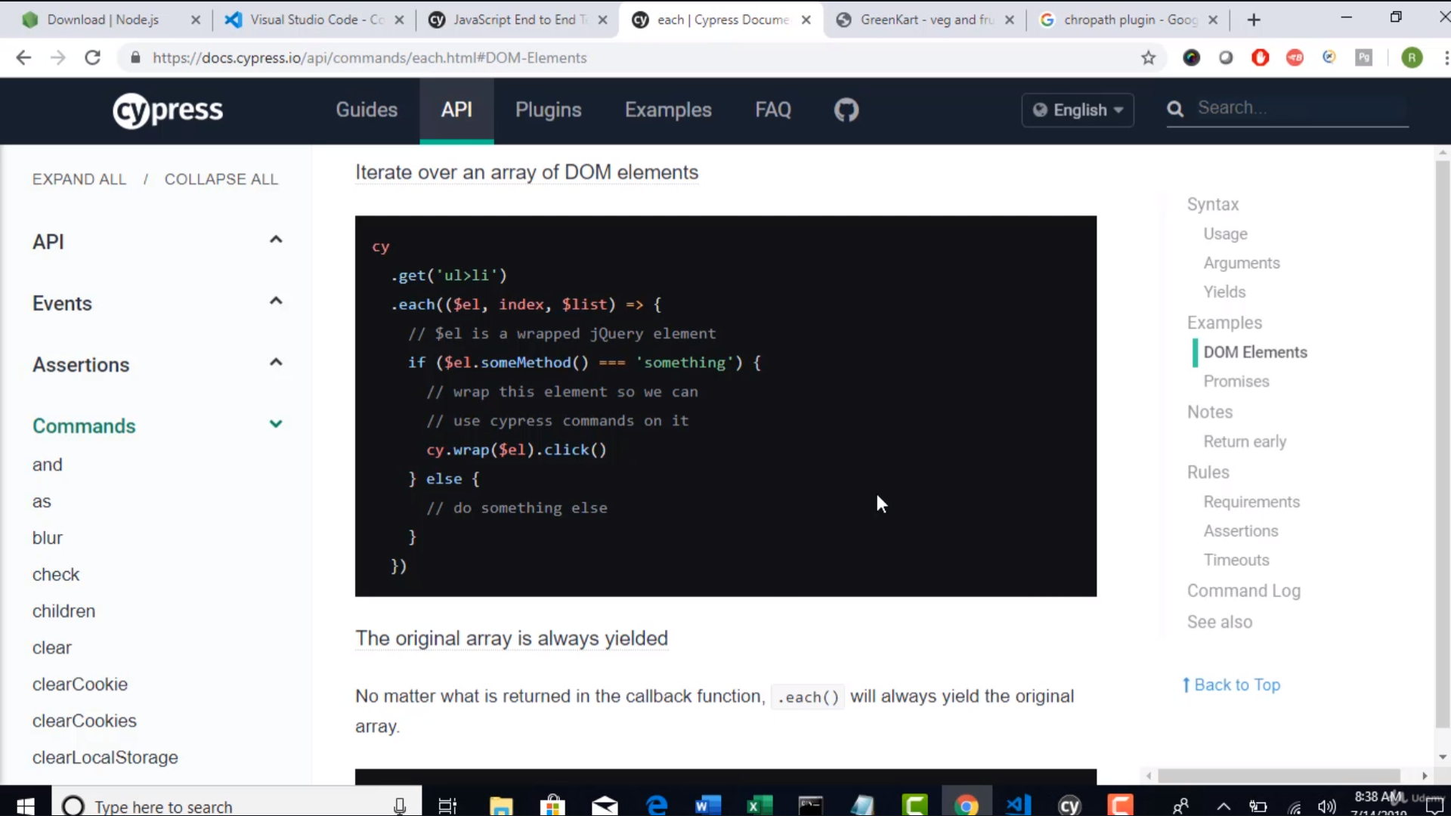

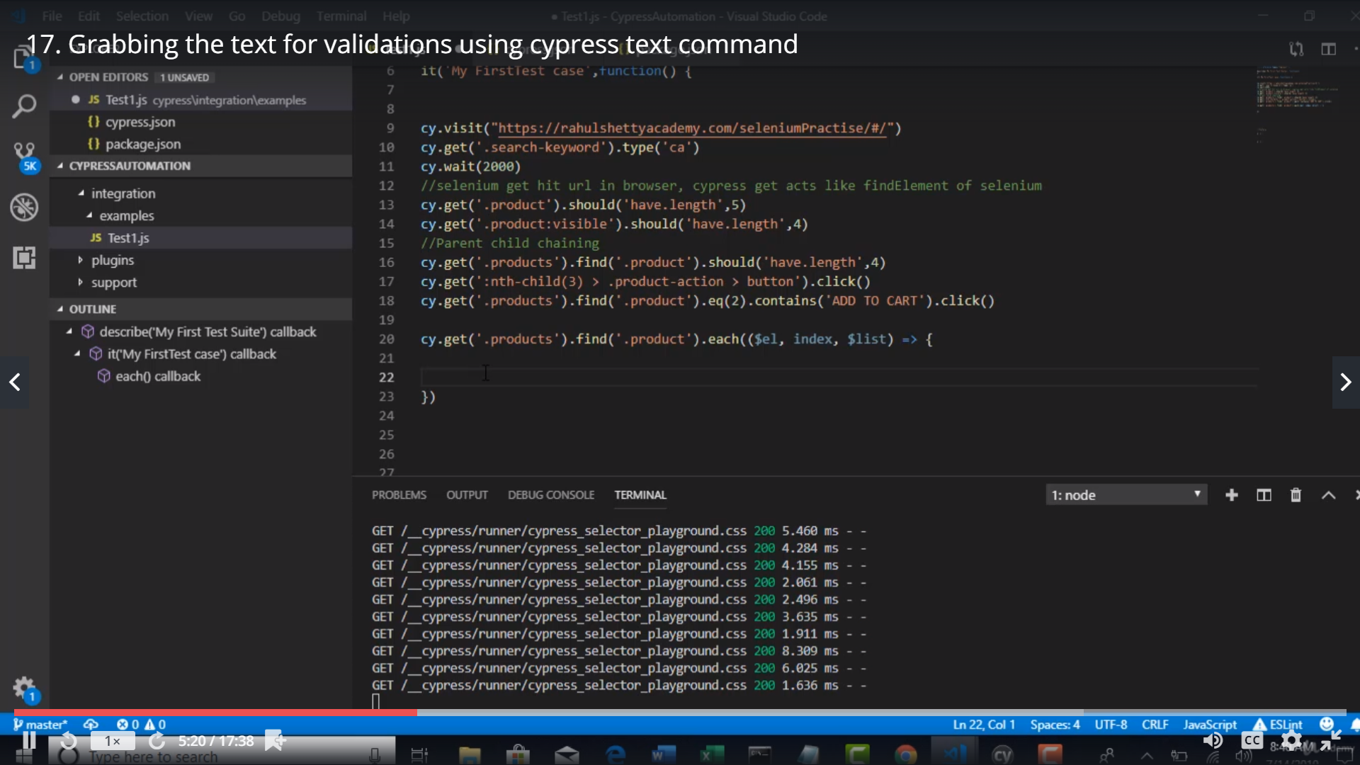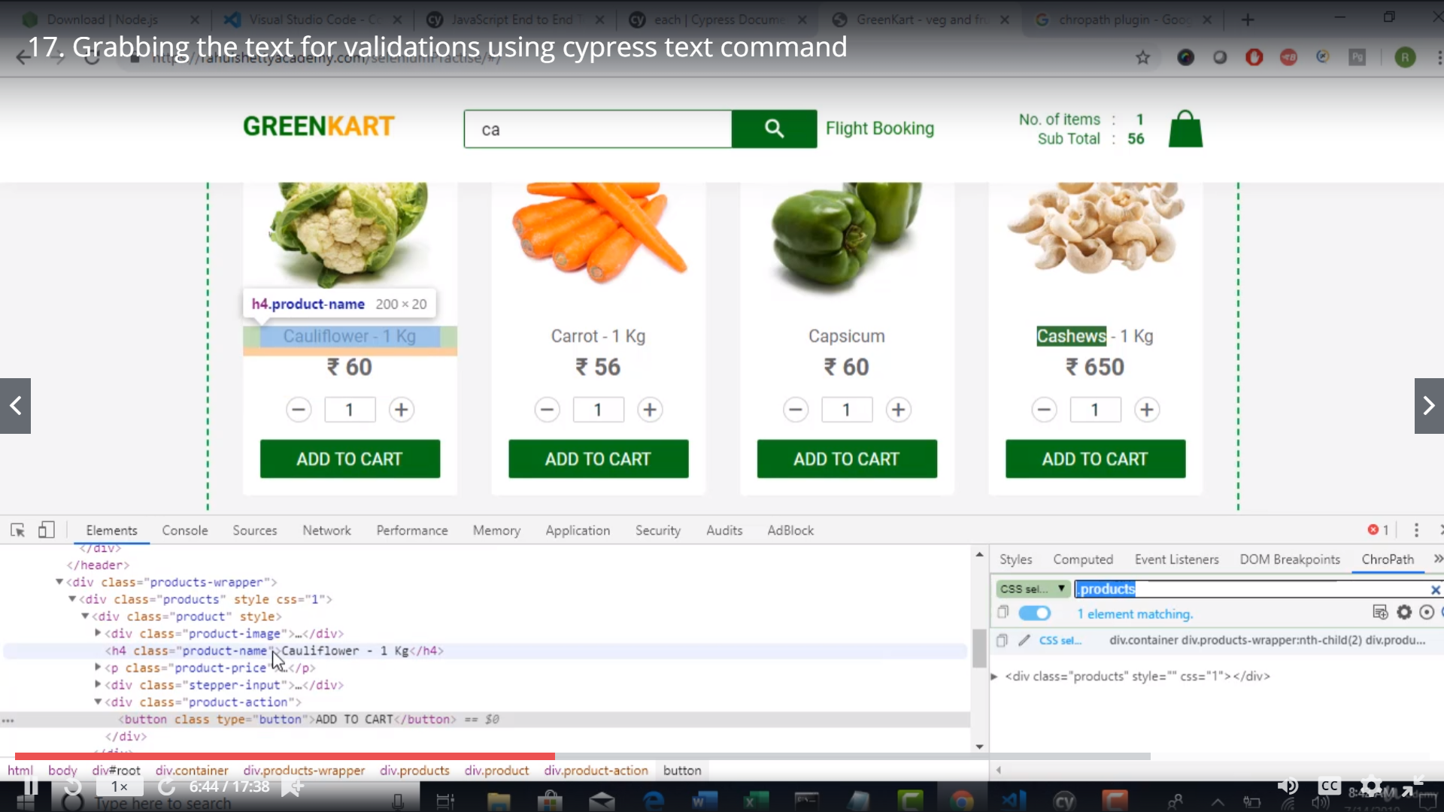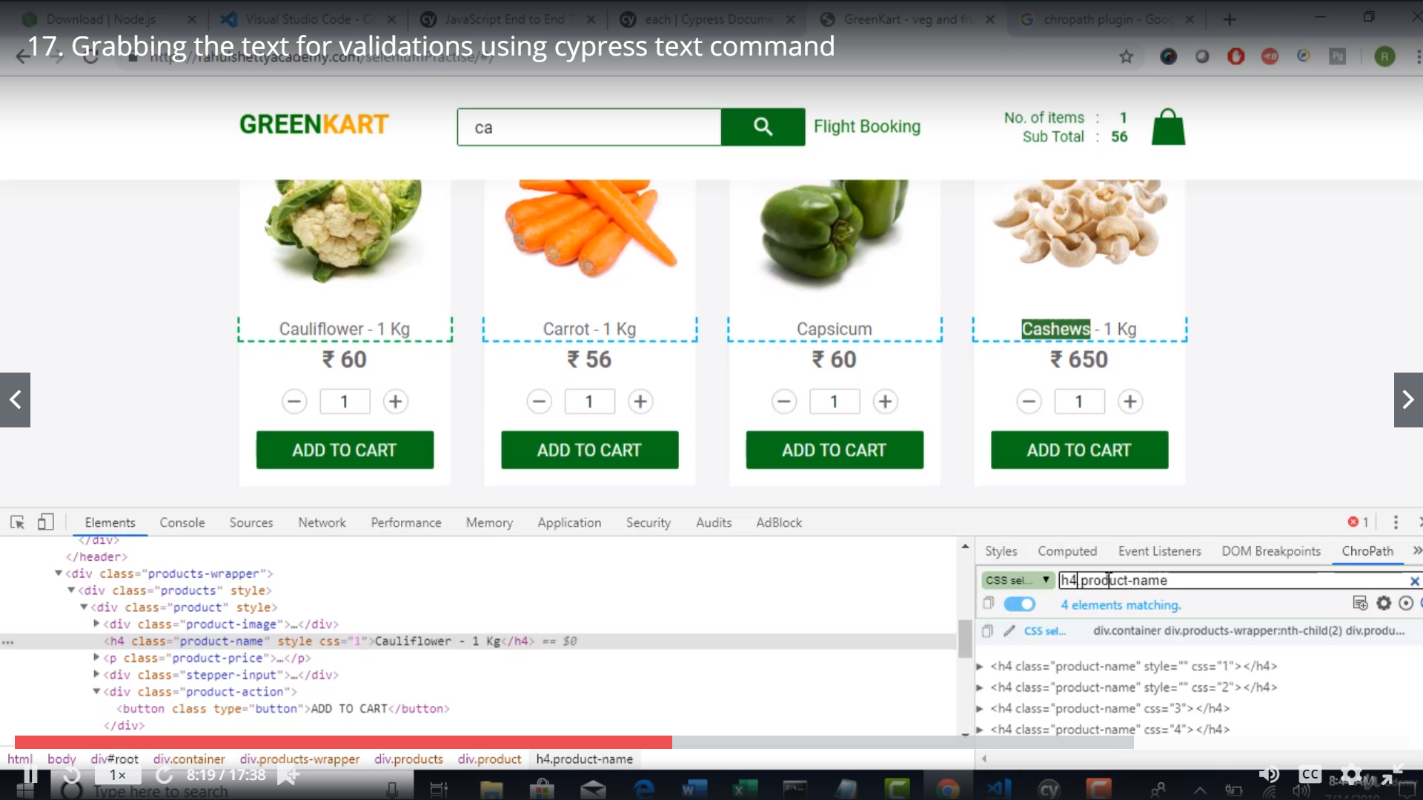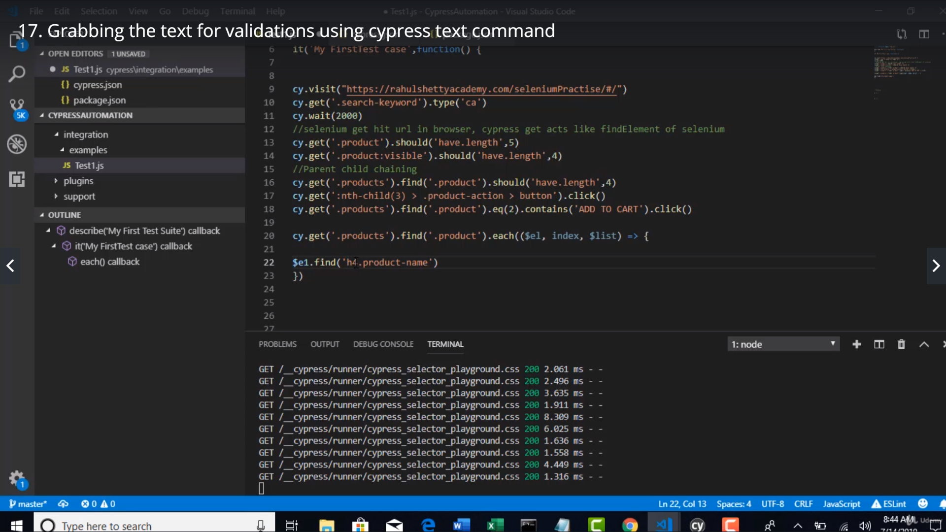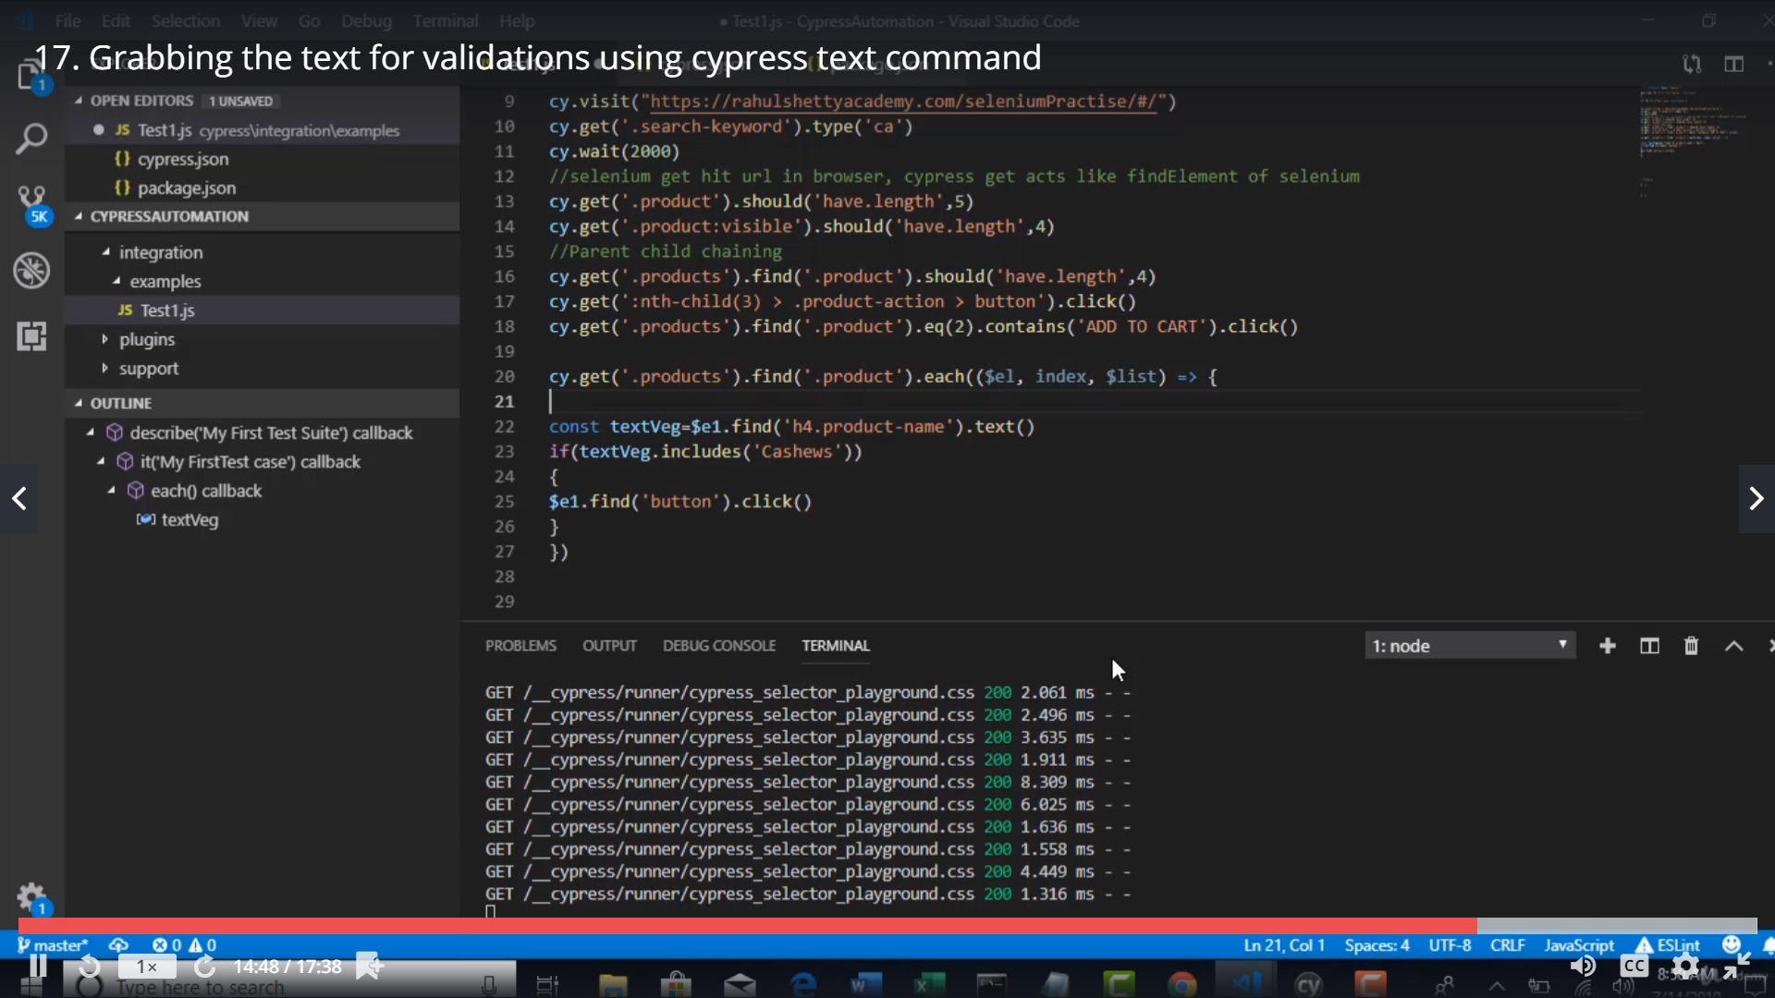

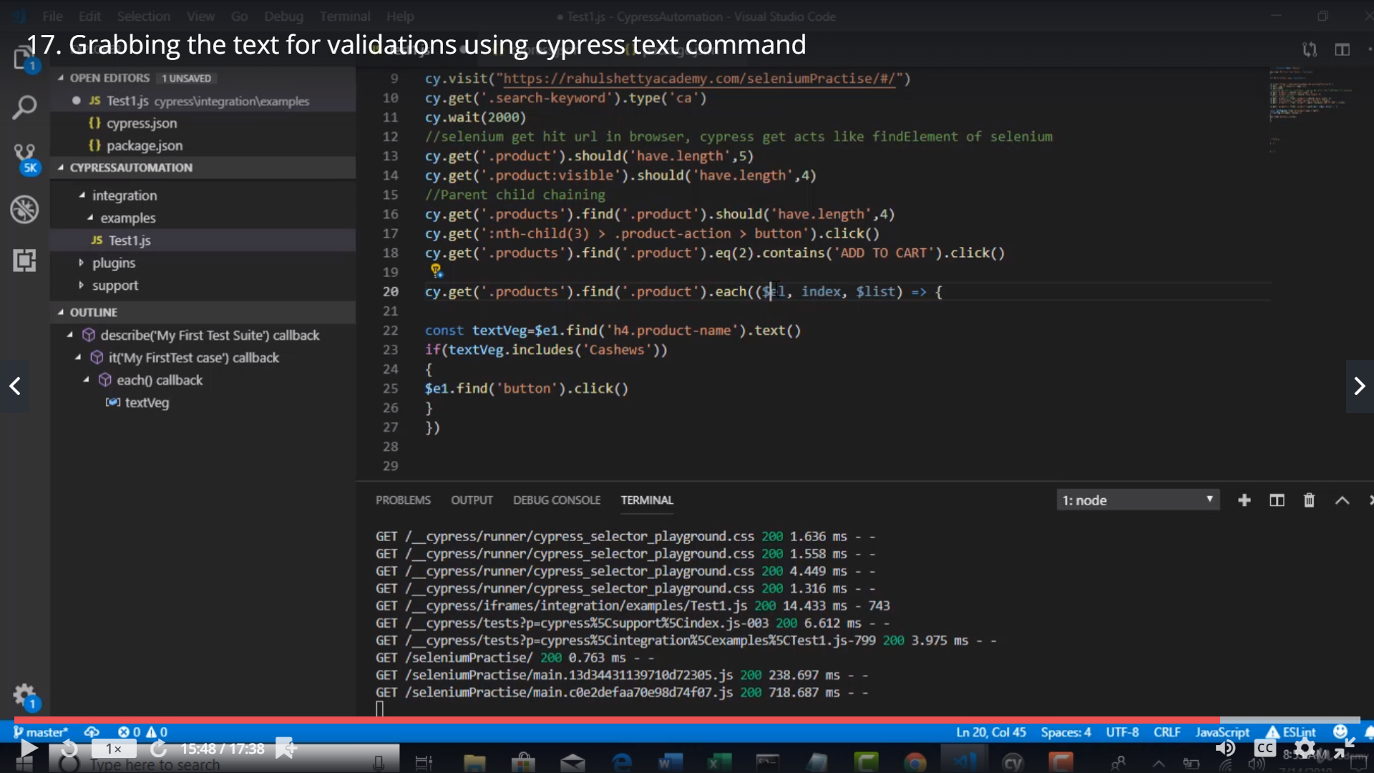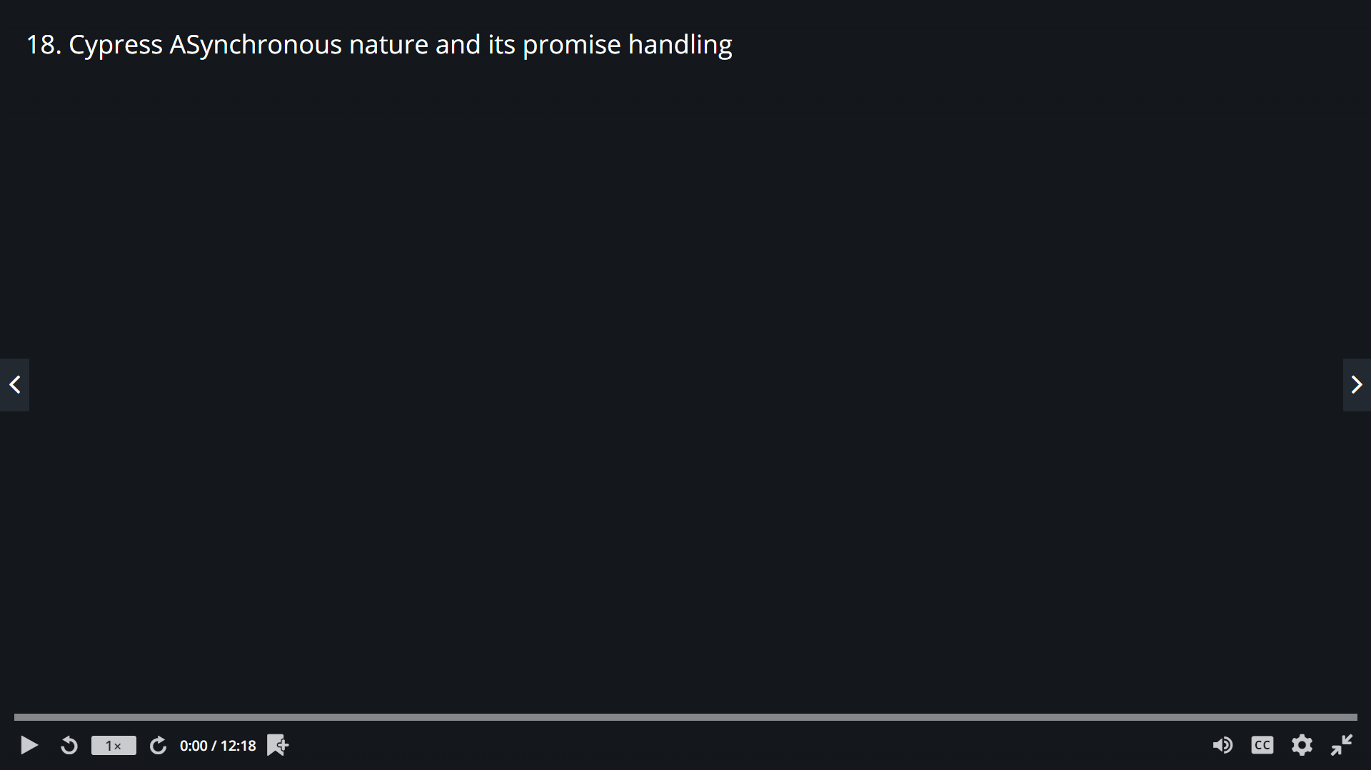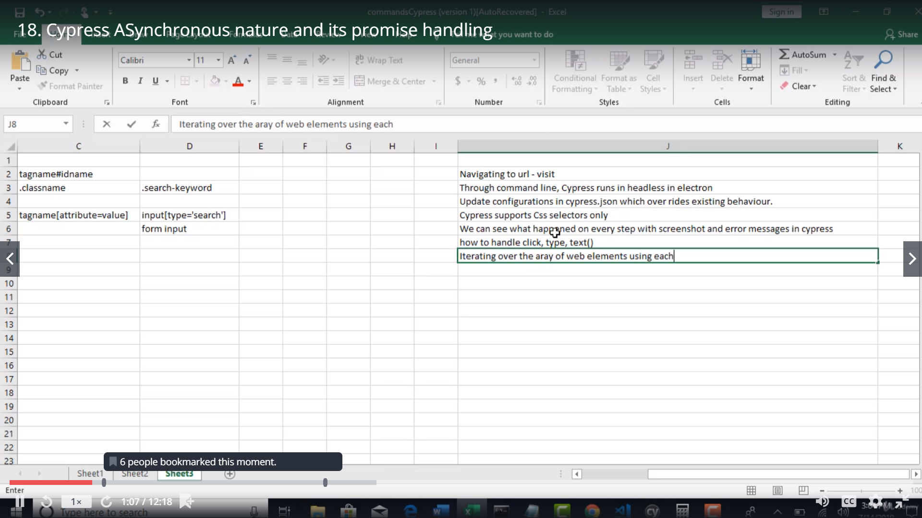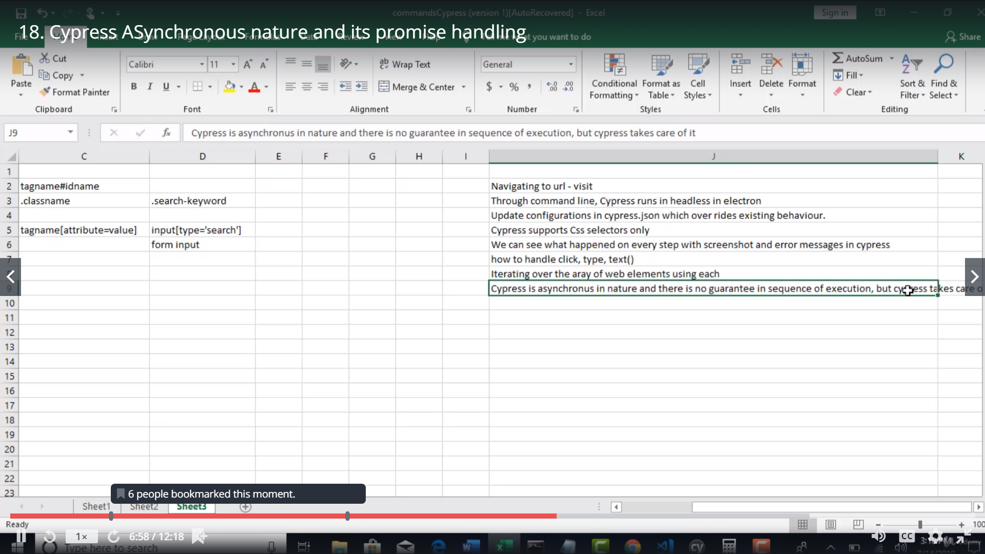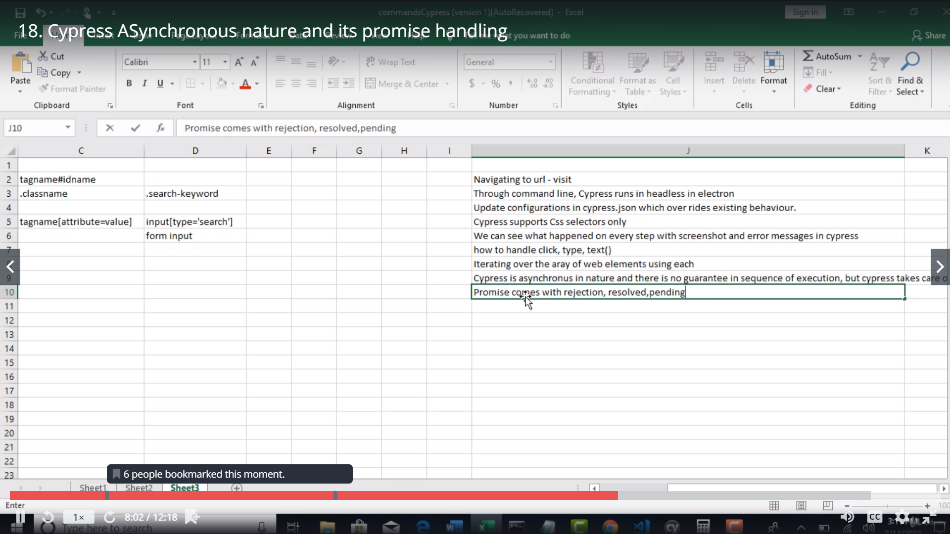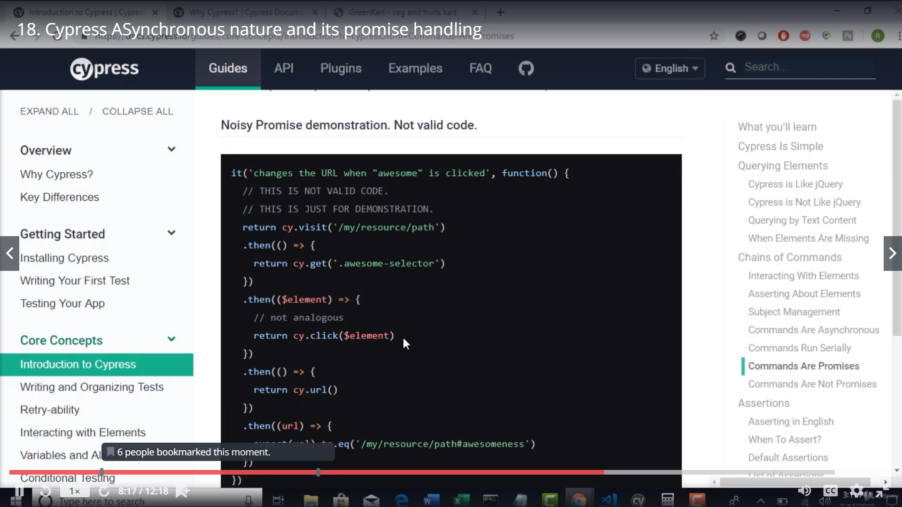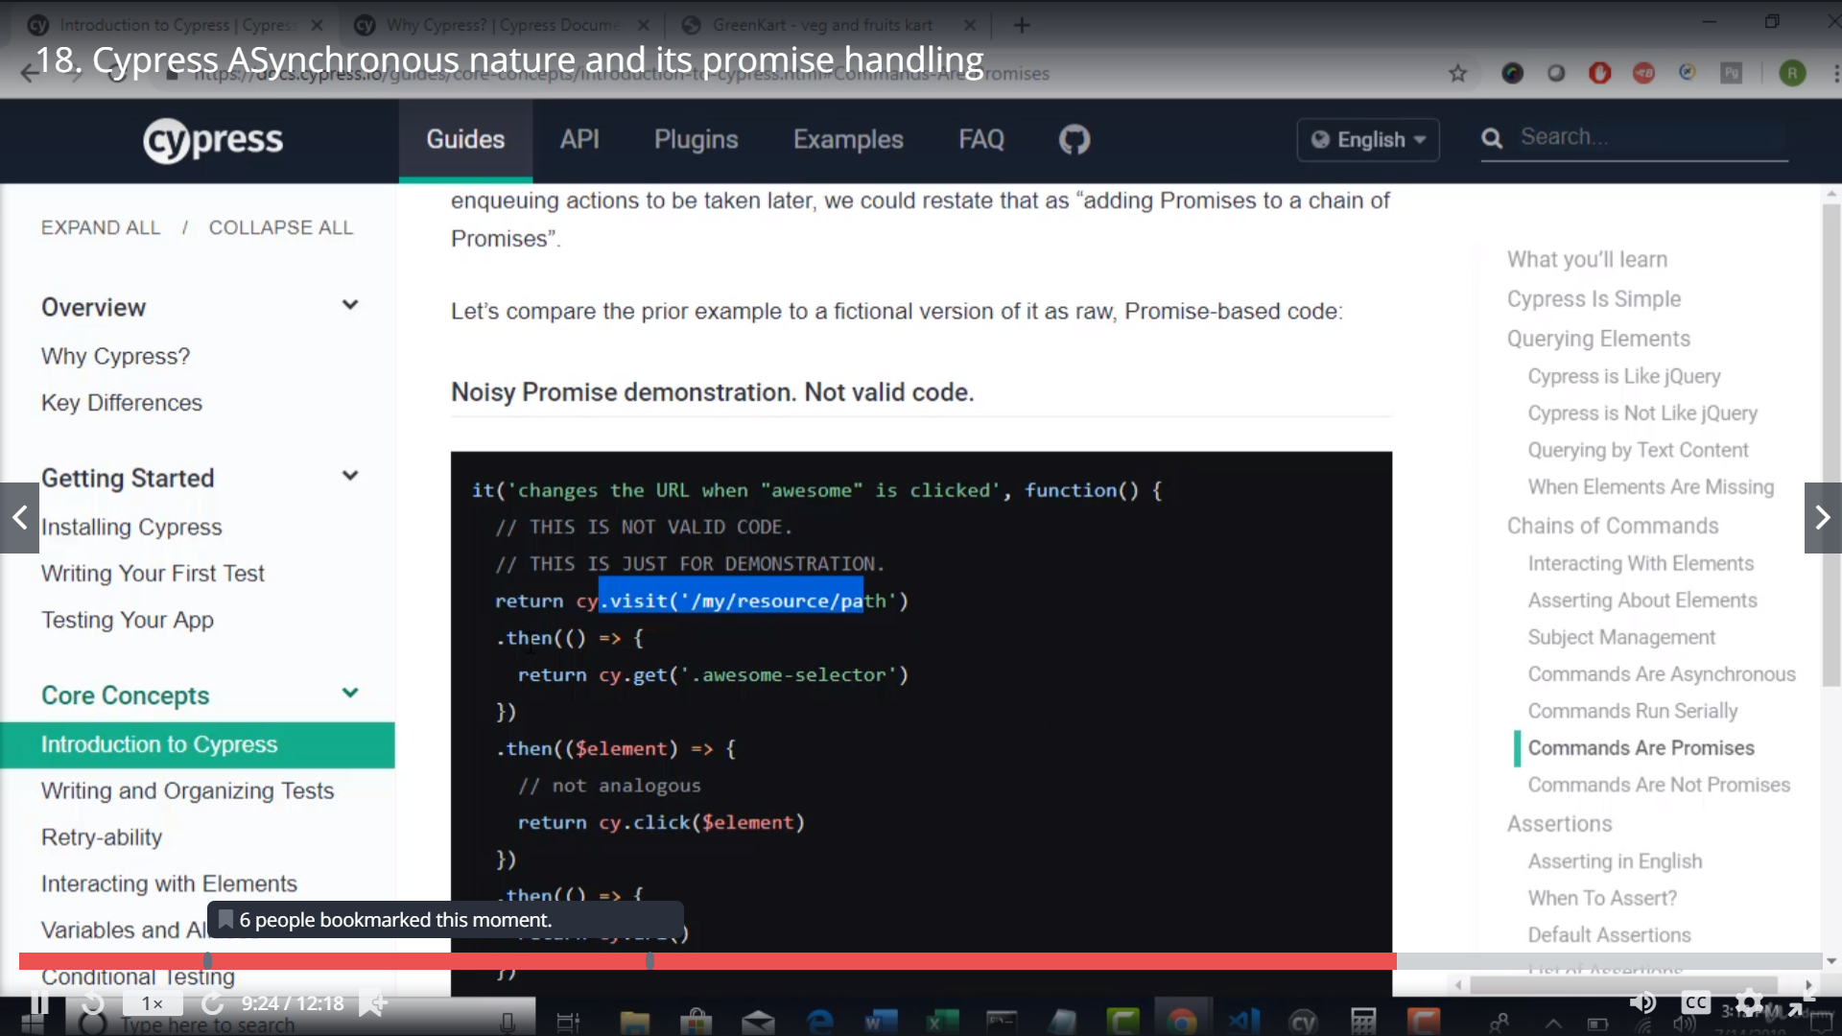

Javascript is asynchronous>> All the steps will run at a time.. second step will not wait until first step is completed[no sequence is followed]

Selenium Java is synchronous

Selenium Protractor is asynchronous.Protarctor is build using node.js

Any application which is built on node.js is asynchronous >> node.js is js >> so the application will be asynchronous

Cypress is built using node.js and its asynchronous

But cypress is internally handled to make sure all the steps run sequentially.

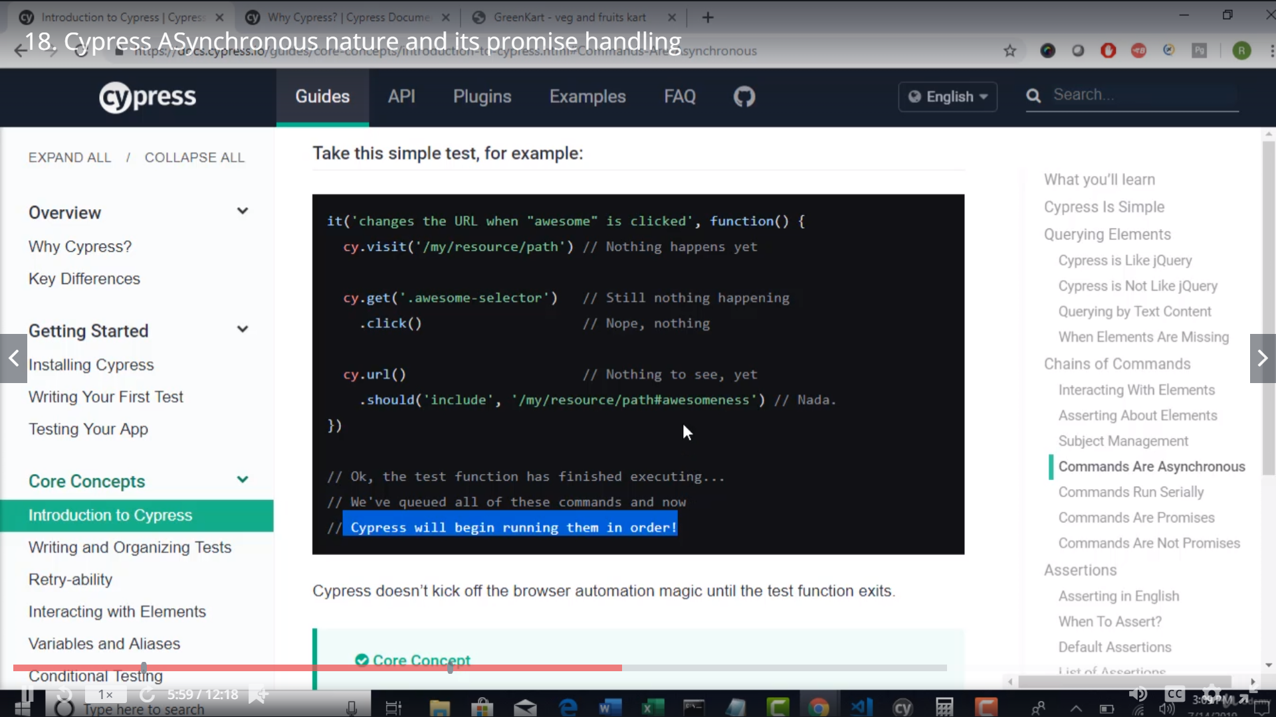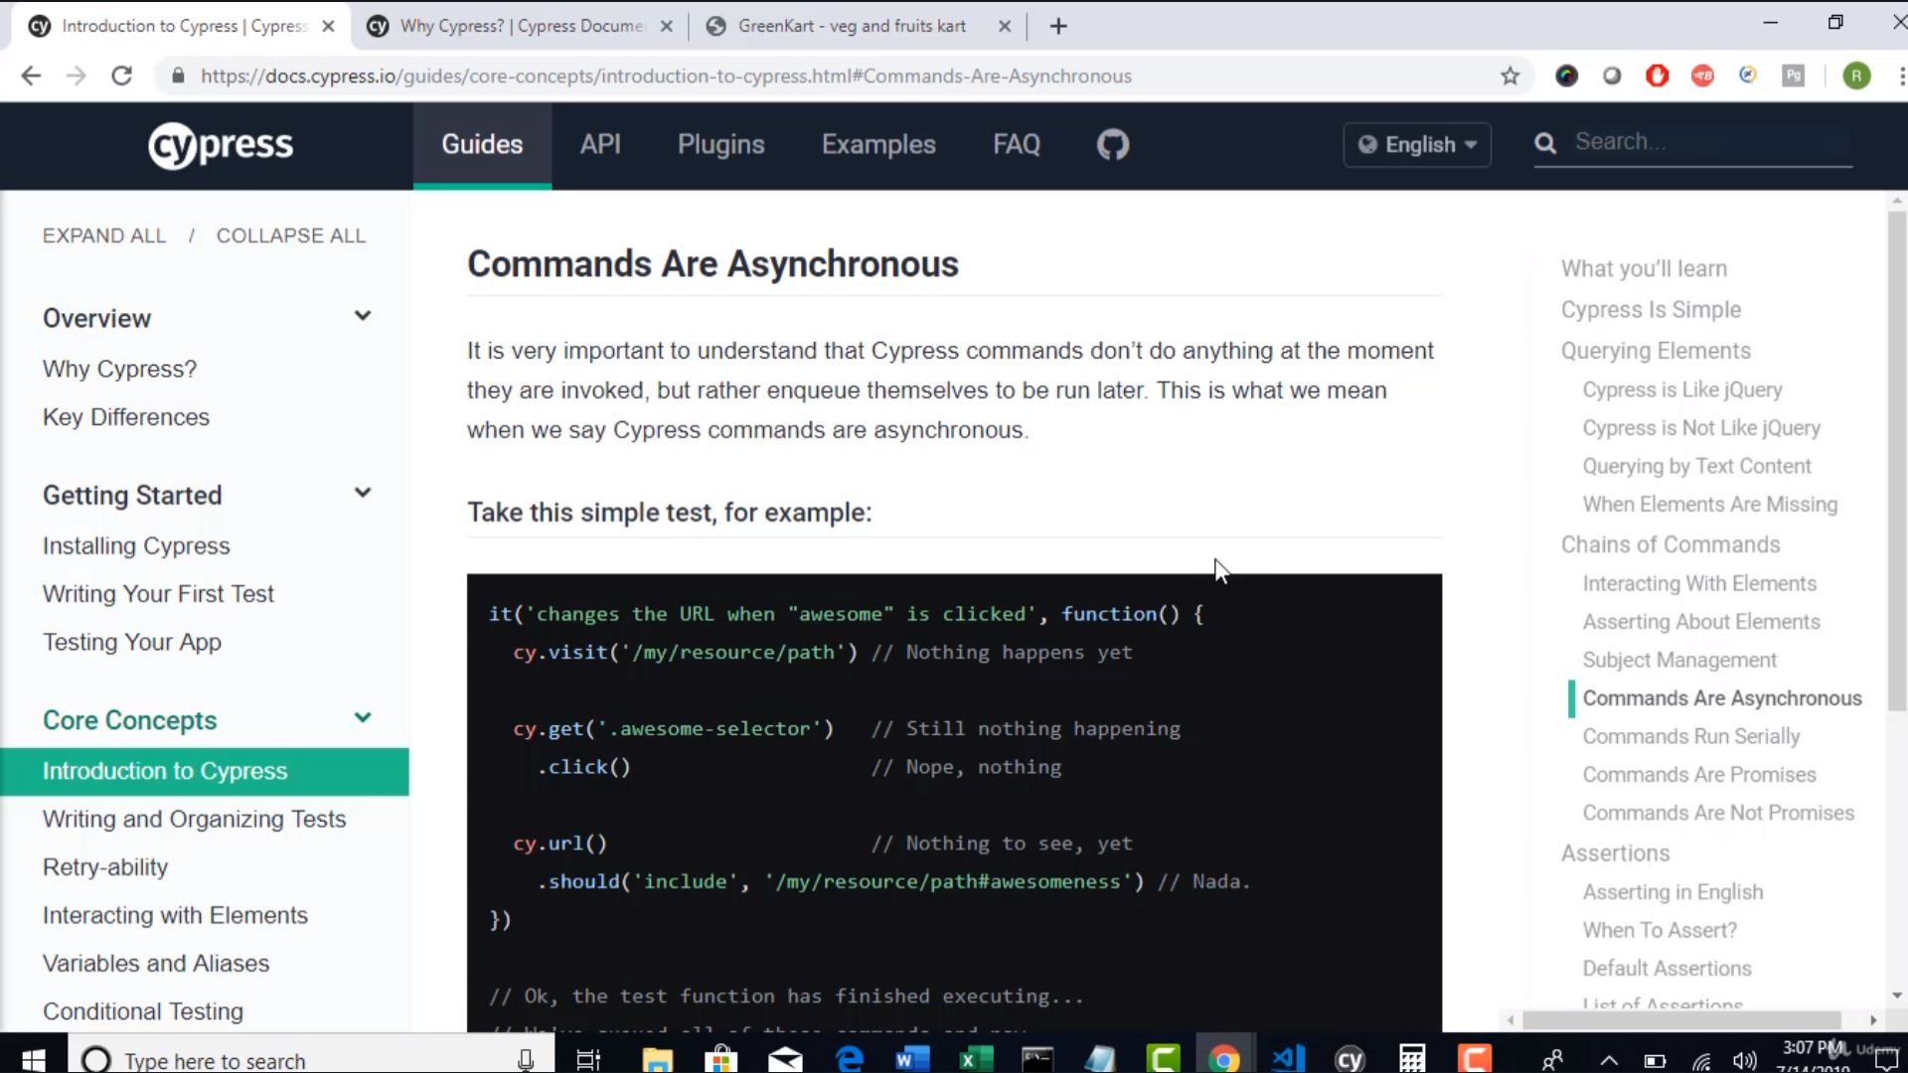

But user who uses cypress need not bother to make sure the script is handled in synchronous.Internally it handles by itself.

Promises: In a synchronous every step returns a promise.

Promise is state of the step.what state ur step execution is in.

Promise has 3 states

1. Resolved [the step is executed]
2. Pending
3. Rejected [error]

So how to handle the asynchronous nature in Protractor

We need to ensure for each step we wait until the step is resolved.

So how do u kknow a promise is resolved?

There is a property by name ‘.then()’ which u need to append to the step u r executing

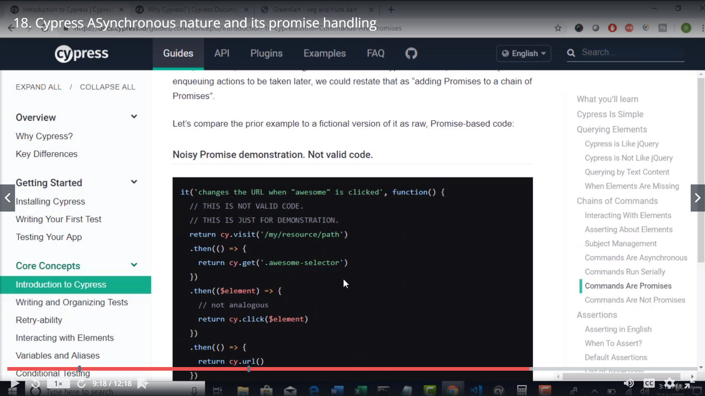

But Cypress declares tht the above implementation is all noisy

So cypress says internally it is going to .then() and waiting until the step is resolved .

